Faculty Member User Guide
Jones School Faculty System

Contents
Getting Started 3
Faculty System Overview 3
Manual Conventions 4
Headings 4
System Login 4
Command Center System Page 5
Command Center Menus 6
Expanding Menu Sections 6
General Menu 6
Home 7
Edit My Info 7
Logout 8
My Faculty Profile 9
Overview 9
Bio Statement 11
Creating and Editing the Bio Statement 11
Research Statement 12
Creating and Editing the Research Statement 12
Research Publications 14
Overview 14
Adding a Publication to Database 15
View Publication Information 15
Delete Publication 16
Research in Progress 18
Overview 18
Adding Research in Progress Information 19
View Research in Progress 19
Edit Research in Progress 20
Delete Research in Progress 21
Grants 22
Overview 22
Adding Research Grants 22
Viewing Grant Information 23
Editing Grant Information 23
Deleting Grants and External Funding 24
Teaching 25
Overview 25
Adding or Editing Course Overview Information 26
Adding Course Information 26
View Course Information 27
Edit Courses 27
Delete 28
Service to Profession 29
Overview 29
Adding Service to Profession Information 29
View Service to Profession 30
Edit Service to Profession 30
Delete Service to Profession 31
Administrative Positions 32
Overview 32
Adding Administrative Appointments Information 32
View Administrative Appointments 33
Edit Administrative Appointments 33
Delete Administrative Appointments 34
Awards 35
Overview 35
Adding Awards Information 35
View Awards 36
Edit Awards 36
Delete Awards 37
Faculty Areas 38
Overview 38
Websites 40
Overview 40
Adding Websites Information 40
Edit Websites 41
Delete Websites 41

Getting Started

Faculty System Overview
This software was designed as a tool to allow faculty members at the Jones Graduate School of Management to easily update their faculty profile. In addition, the Faculty System application is a reporting tool that automatically creates departmental and a Provost report as well as push information to the Jones web site and newsletters. The figure below represents a functional overview of the Faculty System.
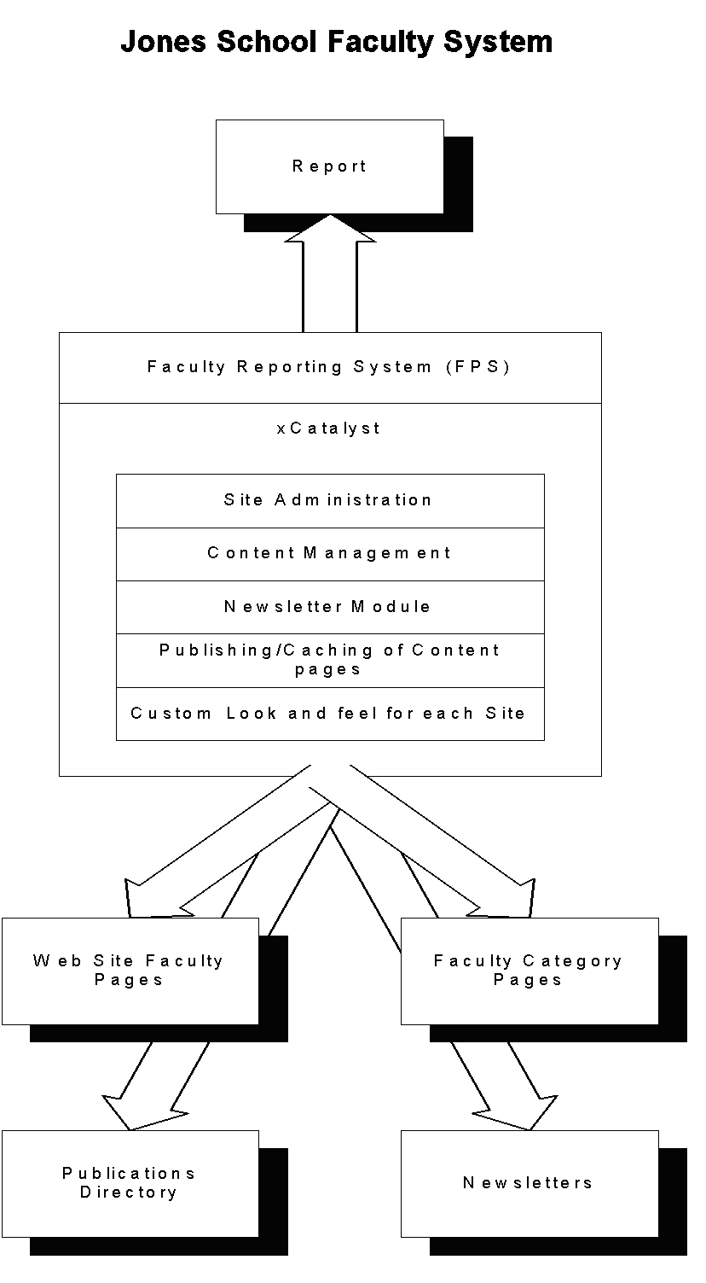

Manual Conventions
Certain conventions are maintained throughout this manual to provide you with the quickest access to the information you seek. In some instances, you may want to read the manual thoroughly and follow the detailed instructions carefully. In other cases, you may want to rely on the conventions to provide you with a quick reference for what you want to do.

Headings

- Important information and concepts will be marked or broken down by multiple heading levels.
NOTE: Important information will sometimes be indicated by a NOTE section.
- xCatalyst platform and Command Center menu items and pages are shown in Bold (for example, Login).
- Keyboard buttons and Windows application commands are shown in the same format as that of the button on the page.
- Instructions to be performed by the user are listed in numerical order.
- Occasionally, indented sentences, under the numbered step, modifies the instruction or provides further information.

Note: This is an example of a margin note. | Notes containing information that is particularly important will appear in the text body or within the left margin.

System Login
The Faculty System employs security features to prevent unauthorized use of the system or access to its related Web sites. Your system administrator will add you to the Faculty System authorized user list and provide you with a User ID and Password that will allow you to login to the System.
To log into the Faculty System main page (Command Center), follow these steps:

- From your Internet browser, enter the URL address below.
The Command Center’s Login page will be displayed. Be sure and add this URL to your Favorites using the Favorites browser utility.

- On the Command Center Login page, do one of the following:
- Enter your User ID and Password

- If you have forgotten your password, click the Email Me My Password link. Your password will be emailed to the email address that appears in your User Information.
- Click the Enter button.
Note: The complexity and availability of the feature set you see in the command center home page depends on security privileges that have been assigned to your account.

If you have logged in successfully, you will be prompted to change your password and then the Command Center System page will be displayed.

Command Center System Page
The Command Center System Page refers to the primary interface to the Faculty System. Information concerning the layout of this page is described below.

Command Center System Page
Display Pane

System Page Part Name | Description
Side Menu Pane | Contains the following menus and their associated items. Depending on your privileges, you may not see all menu items:  - General  - Faculty System  - My Faculty Profile  - Faculty System / Lookups  - Users
Display Pane | Any Command Center pages containing lists, forms, or information are displayed here.
Side Menu Pane

Command Center Menus
The side menu pane displays menus organized by functionality. Each menu contains navigation links to various xCatalyst functions and tools. For ease of use, these menus are displayed collapsed by default.

Expanding Menu Sections
To expand any menu, follow these steps:
- Locate the side menu pane.
This menu is organized into menu sections.
- Click the specific menu section you want to expand.
The menu expands to display a list of links.

Any or all main menu sections can be expanded when working in the Command Center. To collapse a menu, click on its title.

General Menu
The Command Center's General menu contains three items: the Home link and the Log Out link and Edit My Info links. You can access the General menu and its menu item links by locating and expanding this section in the side menu pane. How many menu items and links you see depends on your user privileges.
The links in this menu are also available from the General section of the Home page.

Home
The Home page contains access to all menu section links. When you first log into the xCatalyst Command Center, the Home page is displayed by default.

You can click any of the displayed menu section links to go to that particular item. When working in the Command Center, you can return to the Home page at any time by selecting the Home link from the side menu pane. How many links you see on the home page depends on your user privileges.

Edit My Info
The Edit My Info page is a report that lists your user information including your user ID and password. This report may not be edited. To edit your user information follows these steps:
- Click on the Edit User link located in the top right section of the display pane.
- When the Edit User screen opens, edit the user information in the fields provided.
- Click on the Save button to save your changes.

In the Edit User screen, you can change your password, edit personal information and update your e-mail address.

Logout
When working in the Command Center, you can log out of the Faculty System at any time by selecting the Log Out link from the side menu pane.

The Log Out link will log you out of the Faculty System and take you to the Command Center’s Login page where you can log back into the system or safely shut down your Internet browser.

My Faculty Profile

Overview
Your faculty profile is created and managed by adding and editing information from several different screens of the program that you can access by clicking on links from the Main screen. The Main screen is shown below.
Faculty System Main Screen

To access the Main screen to the following:
- Click on My Faculty Profile on the left menu to expand it.
- Click on the Edit My Profile link on the menu.
You can return to the main screen from any other screen when you are editing your profile by clicking on the Edit My Profile link on the left menu or by clicking on any Main hyperlink from editing screens.

The profile sections consist of the following sub-sections:
- Bio Statement
- Research Statement
- Research Publications
- Research in Progress
- Grants
- Teaching
- Service to Profession
- Administrative Positions
- Recognition and Relationships
- Research and Teaching Interests
- Websites
All of these sections in the application combine to create a comprehensive faculty report. Some of the information you enter may be pushed to your faculty web page or will be rolled up into departmental reports or the Provost report.
At any time you can view the information that you enter as it will appear in other faculty reports. To view the report do the following:
- From the Main profile page, click on the View Report link on the top right of the Main page. The Create Admin Report page will open.
- On the Create Admin Report page you can choose from several options to format and view your report that include:
              - Choose the reporting year for the report that you would like to view.
              - You can click on the radio button to select the option of opening a pop up screen to view the report. This screen will not contain a left menu and is suitable for printing from your browser.
              - A drop down field that enables you to choose if your report is in HTML format or a Microsoft Word documents.

Bio Statement

Creating and Editing the Bio Statement
The Bio Statement section enables you to enter a brief paragraph about you in free-form text. To view your current Bio Statement do the following:
- From your profile Main screen, click on the Bio Statement link located at both the top and bottom of the screen.
- The Bio Statement screen will open. This screen is not editable. It will show you your current Bio Statement and how it will appear on your report.
If you agree with the text in your current Bio Statement you can return to the Main screen of you faculty profile by clicking on the Main link located at the top right of the Bio Statement screen.
To edit the contents of your Bio Statement do the following:
- From the Bio Statement screen, click on the Edit Bio Statement link located at the top right of the Bio Statement screen.
- When the Edit Bio Statement screen opens, make the changes in the text that you would like to make. You can enter the text directly as you would in a word processor, hitting the Enter key for line breaks.
- When you have completed entering or editing the text. Click on the Save button located at the bottom of the screen to save your changes and to return to the Main profile screen.

Research Statement

Creating and Editing the Research Statement
The Research Statement section enables you to enter a brief paragraph about your research. To view your current Research Statement do the following:
- From your profile Main screen, click on the Research Statement link located at both the top and bottom of the screen.
- The Research Statement screen will open. This screen is not editable. The text on the screen represents your current Research Statement.
If you agree with the text in your current Bio Statement you can return to the Main screen of your faculty profile by clicking on the Main link located at the top right of the Research Statement screen.
To edit the contents of your Research Statement do the following:
- From the Research Statement screen, click on the Edit Research Statement link located at the top right of the Research Statement screen.
- When the Edit Research Statement screen opens, make the changes in the text that you would like to make. You can enter the text directly as you would in a word processor, hitting the Enter key for line breaks.
- When you have completed entering or editing the text. Click on the Save button located at the bottom of the screen to save your changes and to return to the Main profile screen.

Research Publications

Overview
The Research Publications section consists of a series of screens that enables you to enter or update information about your research publications. To access the Research Publications screens do the following:
- From the Main profile page click on the Research Publications link located at the top of the Main screen.
- The Find Research Publications screen will open. If there are publications in the database for the current year, they will be listed.
- The Report Year dropdown field will be defaulted to the current year. If you wish to view research publications for a year other than the current year, choose another year from the dropdown, click on the Search button and research publications entered in that year will be listed.

This screen enables you to access other screens where you can perform the following activities:
- Add a new publication
- View the information entered for a publication
- Edit the publication high-level information
- Upload the publication file
- View the publication.
- Delete the publication from the database

Adding a Publication to Database
To add a new publication to the database do the following:
- Click on the Add link located at the top right of the Find Research Publication screen and at the bottom of the list of publications.
- When the New Research Publication screen opens, enter the information requested for each of the fields on this screen. You should enter all the information requested on the screen.
- Note that you can choose to have this information pushed to your faculty page on the public web site by clicking on the Yes or No radio button located at the bottom of the screen.
- When you have entered the entire information click on the Save button located at the bottom of the screen.
- To return to the Main screen without saving your changes, click on the Main link located at the top right of the New Research Publication screen.
- To upload the publication file to the database, see View publication below.

View Publication Information
From the Find Research Publication screen you can view more detailed information about a particular publication by locating that publication in the list and then clicking on the View link. To View detailed information about a publication do the following:
- Click on the View link to open the Research Publication Information screen. Note that you can only view the information on this screen.
- If you need to Edit the information, click on the Edit link, make appropriate changes and then save them.
In addition to viewing detailed information about a publication, you can view the actual publication if you previously uploaded it to the database. If you would like to upload the publication to the database, do the following:
- From the Research Publication Information screen click on the Upload File link located at the bottom of the screen.
- When the New File Upload screen opens, click on the Browse button, locate the file on your computer or network then click on the Save button.
View Publication Information Screen
Upload Publication Screen
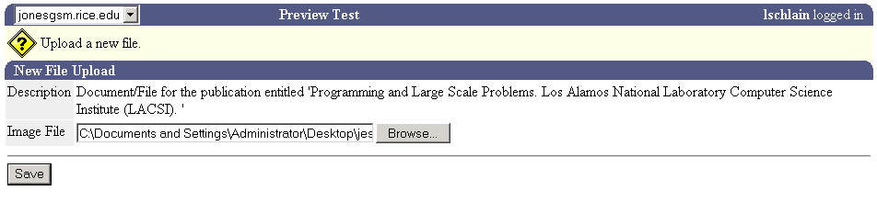

Delete Publication
To delete a publication from the database do the following:
- From the Find Research Publications screen, locate the publication that you want to delete from the database.
- Click on the Delete link to the right of the publication information.
- A popup screen asking you to confirm the deletion will open. To delete the publication, click on the OK button.

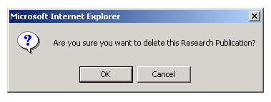

Research in Progress

Overview
The Faculty System has a series of screens that enable you to enter and edit information about your Research in Progress. To access the Research in Progress screens do the following:
- From the Main profile page click on the Research in Progress located at the top of the Main screen.
- The Find Research in Progress screen will open. If data about research in progress is in the database for the current year, it will be listed.
- The Report Year dropdown field will be defaulted to the current year. If you wish to view Research in Progress data for a year other than the current year, choose another year from the dropdown, click on the Search button and the List of Research in Progress screen will open.
This screen enables you to access other screens where you can perform the following activities:
- Add Research in Progress to the database
- View information previously entered for a database entry
- Edit research in progress information for a database entry
- Choose to push Research in Progress information to the department web pages.
- Delete the entry from the database

Adding Research in Progress Information
To add research in progress to the database do the following:
- From the Search Research in Progress screen, click on the Add hyperlink located at the top of the research in progress screen.
- When the Create Research in Progress screen opens enter data into each field. Note that you can choose to push the information for this entry to the web site by clicking on the Yes radio button.
- When you have finished entering your information, click on the Save button to save the information to the database.

New Research in Progress Screen

View Research in Progress
To view information that has been previously entered for a Research in Progress entry do the following:
- From the Find Research in Progress screen locate the database entry that you would like to view.
- Click on the View link to the right of the entry.
- When the Research in Progress Information screen opens you can review the information that has been entered for a particular entry.
- If you would like to view a file that has been associated with this research in progress entry, click on the View File link at the bottom of the screen.
- If you would like to upload a file that will be associated with this research in progress entry, click on the Upload File link located at the bottom of the screen. The upload file screen will open. Click on the Browse button to locate the file you want to upload and then click on save. The file will be uploaded to the database.

View Research in Progress Information Screen

Edit Research in Progress
To edit information for a Research in Progress database entry do the following:
- From the Find Research in Progress screen locate the database entry you would like to edit.
- Click on the Edit link to the right of the entry.
- When the Edit Research in Progress page opens make the changes to the information and click on the Save button.

Delete Research in Progress
To delete a research in progress entry from the database do the following:
- From the Find Research in Progress screen, locate the database entry that you want to delete from the database.
- Click on the Delete link to the right of the entry information.
- A popup screen asking you to confirm the deletion will open. To delete the database entry, click on the OK button.

Grants

Overview
The Faculty System has a series of screens that enable you to enter information about your grants. To enter or edit information about a grant do the following:
- From the Main screen, click on the Grants link. The Research Grants and External Funding screen will open.

Adding Research Grants
To create a new database entry do the following:
- From the Research Grants and External Funding screen, click on the Add link located at the top of the screen.

- The New Grants screen will open.

- Enter information in the fields provided on the screen then click the Save button.

Viewing Grant Information
To view information about a specific grant do the following:
- From the Research Grants and External Funding screen, click on the search button to list the grants and external funding database entries for the year chosen using the drop down field.
- Locate the Grant that you would like to view information on and then click on the View link to the right of the entry.

Editing Grant Information
To edit Grant and External funding information do the following:
- From the Search Grants and External Funding screen or from the View Research Grants and External Funding screen click on the Edit link.
- Edit the information in the available fields and click on the Save button to post the information to the database.

Deleting Grants and External Funding
To delete Grant and External funding information do the following:
- From the Search Grants and External Funding screen click on the Delete link.
- When the popup screen asking you to confirm the deletion opens, click on the OK button to delete the record.
.

Teaching

Overview
The Faculty System enables you to manage general information about your course load and detailed information about specific courses for a report year. To enter or edit information pertaining to course work do the following:
- From the Main screen, click on the Teaching link located at the top and bottom of the screen.
- The Courses screen will open.
The Course screen is divided into two main sections:
- Course Overview Section
- Courses Section
The Course Overview section lists specific information that you need to enter. The Courses section has detailed information about specific courses.

Courses Information Screen

Adding or Editing Course Overview Information
To add or edit course overview information do the following:
- From the Courses Information screen, click on the Edit Course Overview.
- The Edit Course Overview screen will open. Locate the information that you want to edit. When you have finished making the changes, click on the Save button to post the changes to the database.

Edit Course Overview Screen

Adding Course Information
To add a Course to the database do the following:
- From the Search Course screen, click on the Add hyperlink located at the top of the Course screen.
- When the Create Course screen opens enter data into each field. Note that you can choose to push the information for this entry to the web site by clicking on the Yes radio button.
- When you have finished entering your information, click on the Save button to save the information to the database.

View Course Information
To view information that has been previously entered for a Course entry do the following:
- From the Find Course screen locate the database entry that you would like to view.
- Click on the View link to the right of the entry.
- When the Course Information screen opens you can review the information that has been entered for a particular entry.

Edit Courses
To edit information for a Course database entry do the following:
- From the Find Course screen locate the database entry you would like to edit.
- Click on the Edit link to the right of the entry.
- When the Edit Course page opens make the changes to the information and click on the Save button.

Delete
To delete a Course entry from the database do the following:
- From the Find Course screen, locate the database entry that you want to delete from the database.
- Click on the Delete link to the right of the entry information.
- A popup screen asking you to confirm the deletion will open. To delete the database entry, click on the OK button.

Service to Profession

Overview
The Faculty System includes a series of screens that enable you to enter information about services to profession in the reporting year. To access the Services to Profession main screen do the following:
- From the Main screen click on the Services to Profession link located at the top and bottom of the Main screen.

Adding Service to Profession Information
To add Service to Profession to the database do the following:
- From the Search Service to Profession screen, click on the Add hyperlink located at the top of the Service to Profession screen.
- When the Create Service to Profession screen opens enter data into each field. Note that you can choose to push the information for this entry to the web site by clicking on the Yes radio button.
- When you have finished entering your information, click on the Save button to save the information to the database.

View Service to Profession
To view information that has been previously entered for a Service to Profession entry do the following:
- From the Find Service to Profession screen locate the database entry that you would like to view.
- Click on the View link to the right of the entry.
- When the Service to Profession Information screen opens you can review the information that has been entered for a particular entry.

Edit Service to Profession
To edit information for a Service to Profession database entry do the following:
- From the Find Service to Profession screen locate the database entry you would like to edit.
- Click on the Edit link to the right of the entry.
- When the Edit Service to Profession page opens make the changes to the information and click on the Save button.

Delete Service to Profession
To delete a Service to Profession entry from the database do the following:
- From the Find Service to Profession screen, locate the database entry that you want to delete from the database.
- Click on the Delete link to the right of the entry information.
- A popup screen asking you to confirm the deletion will open. To delete the database entry, click on the OK button.

Administrative Positions

Overview
The Faculty System will track administrative positions that you perform in a report year. To access the main screen for adding and editing administrative position information do the following:
- From the Main screen click on the Administrative Positions link.
The Administrative information screen will open. You can access all other screens in this module section from this screen.

Adding Administrative Appointments Information
To add Administrative Appointments to the database do the following:
- From the Search Administrative Positions screen, click on the New hyperlink located at the top of the Administrative Positions screen.
- When the Create Administrative Positions screen opens enter data into each field. Note that you can choose to push the information for this entry to the web site by clicking on the Yes radio button.
- When you have finished entering your information, click on the Save button to save the information to the database.

View Administrative Appointments
To view information that has been previously entered for an Administrative Positions entry do the following:
- From the Find Administrative Positions screen locate the database entry that you would like to view.
- Click on the View link to the right of the entry.
- When the Administrative Positions Information screen opens you can review the information that has been entered for a particular entry.

Edit Administrative Appointments
To edit information for an Administrative Positions database entry do the following:
- From the Find Administrative Positions screen locate the database entry you would like to edit.
- Click on the Edit link to the right of the entry.
- When the Edit Administrative Positions page opens make the changes to the information and click on the Save button.

Delete Administrative Appointments
To delete an Administrative Positions entry from the database do the following:
- From the Find Administrative Positions screen, locate the database entry that you want to delete from the database.
- Click on the Delete link to the right of the entry information.
A popup screen asking you to confirm the deletion will open. To delete the database entry, click on the OK button.

Awards

Overview
The Faculty System will track awards that you may receive during a reporting year. To access the Awards section of the program do the following:
- From the Main screen click on the Recognition and Relationships link.
The Awards Information screen will open. You can access all other screens in this section from the Awards screen.

Adding Awards Information
To add Awards to the database do the following:
- From the Search Awards screen, click on the Add hyperlink located at the top of the Awards screen.
- When the Create Awards screen opens enter data into each field. Note that you can choose to push the information for this entry to the web site by clicking on the Yes radio button.
- When you have finished entering your information, click on the Save button to save the information to the database.

View Awards
To view information that has been previously entered for an Awards entry do the following:
- From the Find Awards screen locate the database entry that you would like to view.
- Click on the View link to the right of the entry.
- When the Awards Information screen opens you can review the information that has been entered for a particular entry.

Edit Awards
To edit information for a Awards database entry do the following:
- From the Find Awards screen locate the database entry you would like to edit.
- Click on the Edit link to the right of the entry.
- When the Edit Awards page opens make the changes to the information and click on the Save button.

Delete Awards
To delete an Awards entry from the database do the following:
- From the Find Awards screen, locate the database entry that you want to delete from the database.
- Click on the Delete link to the right of the entry information.
A popup screen asking you to confirm the deletion will open. To delete the database entry, click on the OK button.

Faculty Areas

Overview
The Faculty System enables you to choose from a choice of Scholarly Areas that you are interested in to appear on your annual report. To access the main page for adding or editing the Faculty Areas main information page do the following:
- From the Main page click on the link Research and Teaching Areas link to access the main page for data entry and editing.

There are three primary areas that you may select from:
- Scholarly Areas
- Research Interests
- Teaching Interests
As you choose each area from the dropdown menu on the main page a list of choices will appear from which you can select by clicking on the checkboxes provided.
Each time that you reach the bottom of a list of selections to choose from, click on the Save button to post your selections to the database.

Sample Screen with list of Scholarly Areas to choose from

Websites

Overview
The Websites feature enables you to create, edit and post links to the public web site. To access the Websites main screen do the following:
- From the Main screen, click on the Websites link located at the top and bottom of the main screen.

Adding Websites Information
To add Websites to the database do the following:
- From the Search Websites screen, click on the Add hyperlink located at the top of the Websites screen.
- When the Create Websites screen opens enter data into each field. Note that you can choose to push the information for this entry to the web site by clicking on the Yes radio button.
- When you have finished entering your information, click on the Save button to save the information to the database.

Edit Websites
To edit information for a Websites database entry do the following:
- From the Find Websites screen locate the database entry you would like to edit.
- Click on the Edit link to the right of the entry.
- When the Edit Websites page opens make the changes to the information and click on the Save button.

Delete Websites
To delete a Websites entry from the database do the following:
- From the Find Websites screen, locate the database entry that you want to delete from the database.
- Click on the Delete link to the right of the entry information.
- A popup screen asking you to confirm the deletion will open. To delete the database entry, click on the OK button.

