Overview of Enron’s Generation
Preliminary Terms and Operating Information

Certain information included in this Information Memorandum contains forward-looking statements identified by such words as “expect”, "anticipate”, or “project.” Such statements are based on current expectations and involve a number of known and unknown risks and uncertainties that could cause the actual results and performance of the power generation plants (“Plants”) to differ materially from any expected future results or performance, expressed or implied, by the forward-looking statements, including expectations regarding the future results of operations of the Plants. Enron North America Corp. (“ENA”) has identified important factors that could cause actual results to differ materially from such expectations, including development uncertainty, operating uncertainty, acquisition uncertainty, uncertainties relating to power and gas markets, weather, uncertainties relating to domestic and international economic and political conditions and uncertainties regarding the impact of regulations, changes in government policy, industry deregulation and competition. You have an obligation to evaluate all such risks for itself. ENA does not assume responsibility to update forward-looking information contained herein.
Although in furnishing the enclosed information ENA has endeavored to include materials which ENA believes to be reliable and relevant for your evaluation, ENA makes no representation or warranty as to the accuracy or completeness of any such provided information. Furthermore, neither ENA nor its representative shall have any liability to any party whatsoever resulting from the use of any such information.

Portions of this Information Memorandum contain term sheets which contemplate potential agreements. Be advised that such term sheets are for discussion purposes only and are not complete or inclusive of all terms that would need to be agreed upon before a definitive and binding agreement could be reached. These term sheets are not intended to create and do not create a binding or enforceable contract or a duty to negotiate toward a binding contract. A binding commitment can only arise from the negotiation, execution, and delivery of a final written definitive agreement.

Table of Contents

1. General Terms

2. Preliminary Terms of Power Purchase Agreement

3. The Power Markets

4. Operating Information

1. General Terms

DRAFT FOR REVIEW AND DISCUSSION PURPOSES ONLY

GENERAL TERMS
- NewCo:

NewCo will be a newly created generation company. The owners of NewCo would be FPL Energy, L.L.C. (“FPL Energy”) and ENA, and other persons buying shares of NewCo in an IPO of NewCo.

- Marketing and Risk Management:

The marketing, operations, development and risk management capability for NewCo would be managed within the new entity subject to a risk management policy agreed to by ENA, FPL Energy and the newly formed board of directors.

Our suggestion would be that employment candidates for key positions including risk management, trading, development and origination be submitted by both ENA and FPL Energy and that offers of employment be given only to those people who are successfully interviewed by both FPL Energy and ENA. Those candidates that are hired would become employees of the NewCo.

There would be no exclusivity or non-compete clauses between NewCo and the parent companies.

ENA and FPL Energy would each retain a right of first refusal on 50% in the aggregate of NewCo’s fuel and output volumes with a term greater than 3 months.

- Risk Management Systems and Back Office Services (Administrative Services):

ENA would provide NewCo, for a fee, risk management and back office services (“Administrative Services”) under a contractual arrangement for a term of five years from the closing of the IPO/merger. If not terminated by either party with ninety days notice prior to the end of the initial term, it shall remain in effect for an additional twelve months on an evergreen basis. Every year after the initial term, either party would have the right to cancel the agreement by providing written notice to the other party no less than 90 days prior to the end of that term. ENA would provide all the services described herein with respect to all quantities of electric energy, electric capacity, ancillary services and fuel procurement generated, dispatched or scheduled for purchase and sale related to NewCo’s assets and any related contracts. ENA will provide the necessary resources and systems to execute the following services:

- Risk Management System and Controls: Provides daily positional reporting including daily profit and loss, deal and curve entry, VAR reporting and limits monitoring;
- Deal Clearing: Prepares customer confirmations, contracts and broker check-outs; interfaces with NewCo’s credit/legal groups; and monitors deal integrity;
- Settlements: Provides reconciliation of invoices and payments to general ledger, cash management and cash settlements with counterparties;
- Scheduling and Nominations: 24 Hour OASIS transmission scheduling, tagging, schedule verification and monitoring, fuel nominations and balancing.

- Proposed NewCo Capital Structure:

- Debt: TBD
- Equity: Public float up to 40%

ENA and FPL Energy would each receive cash and the remaining 60% of NewCo’s stock in exchange for contributing plants, turbines and development projects to NewCo.

- Development:

ENA and FPL Energy would staff a fully functional development capability inside NewCo. ENA and FPL Energy would initially provide sites, turbines and other capabilities necessary to demonstrate a backlog of projects and a greenfield development capability.

- ENA Contributed Assets:

Value

- Peakers: $1,100 million
- Moore project: TBD¹
- Pastoria and LV Cogen II development projects: $136 million² plus LM 6000’s and 3 GE 7 FA commitments
- Other Sites and Turbines: TBD¹

- To be determined at a later date.
- Includes approximately $115 million for Pastoria and $21 million for LV Cogen II, and is subject to completion of certain agreed upon development milestones including execution of gas supply and transportation agreements, interconnection agreements, receipt of air permits (CEC permit in California), ERC’s and EPC agreements.

- PPA’s:

ENA would like to retain a three year tolling agreement on the 1999 and 2000 Peakers beginning 2001. Further, ENA would like to retain a five year tolling agreement on Project Moore beginning Summer 2001. A proposed tolling contract is attached. ENA would potentially like to discuss offtake agreements on Pastoria and LV Cogen II at a future date.

- FPL Energy Contributed Assets:

To be determined

2. Preliminary Terms of

Power Purchase Agreement

DRAFT: FOR REVIEW AND DISCUSSION PURPOSES ONLY

Power Purchase Agreements

Buyer | Enron Power Marketing, Inc.
Seller | NewCo.
Fixed Price Period  See Attached PPA Summary Table | Buyer must pay a fixed monthly Demand Charge* in exchange for its right to capacity, energy and ancillary services. When energy or ancillary services are scheduled, Buyer must supply fuel, take output and pay an Energy Charge* plus a Start Charge*.
Quantity | Actual output level of each plant as established initially by a performance test and calculated annually based upon agreed upon curves (subject to either party’s right to request a re-test with the cost thereof to be shared equally by both parties).  In each hour, quantity is adjusted for ambient conditions to calculate the amount of available output.
Hours in which Buyer can Schedule | On Peak Hours* are those listed on the PPA Summary Table.  During Off Peak Hours (those other than On Peak Hours), Seller has a best efforts obligation to supply but there are no penalty provisions associated with a failure to deliver.
Minimum Block Size, Duration | Size* – See Attached PPA Summary Table  Minimum Duration = 2 hours.
Guaranteed Availability for Damages | See Attached PPA Summary Table for Availability Requirements.  Summer Months = May, June, July, August, September  Shoulder Months = March, October  Winter Months = April, November, December, January, February
Damages | Cost of cover damages.

* Terms are defined on the PPA Summary Table attached hereto

DRAFT: FOR REVIEW AND DISCUSSION PURPOSES ONLY

Gas Transportation | During Fixed Price Period, Seller shall own the gas transportation rights but Buyer shall be entitled to exclusive use thereof and must pay all costs.
Automatic Generating Control | Buyer has right to install, pay for and utilize automatic generation control.
Payment | Demand Charges and Energy Charges paid monthly.  Start Charges paid annually.
Event of Default | Typical events of default, including if the average monthly actual availability is below: (1) 80% for any consecutive twelve month period, (2) 85% for any consecutive twenty-four month period or (3) 90% for the Summer Months in any calendar year.
Heat Rate Guaranty | The heat rate of each plant shall not exceed the Guaranteed Heat Rate*.
Heat Rate Penalty | Seller shall pay the actual fuel costs (based on Buyer’s cost therefor) for any additional fuel required because the actual plant heat rate exceeds the Guaranteed Heat Rate.
Scheduling | Buyer shall be able to call on each plant after providing the Minimum Dispatch Notice prior to when the energy or ancillary services are needed.  Buyer’s ability to Schedule shall be limited to the Maximum Annual MWh’s* for each plant.

* Terms are defined on the PPA Summary Table attached hereto

DRAFT: FOR REVIEW AND DISCUSSION PURPOSES ONLY

PPA SUMMARY TABLE
 | Brownsville | Caledonia | New Albany | Wilton Center | Wheatland | Gleason | Moore
Output** | 458 | 446 | 356¹ | 608 | 470 | 510 | 342
On Peak Hours  (Central Prevailing Time) | HE 0700 –  HE 2200 | HE 0700 –  HE 2200 | HE 0700 –  HE 2200 | HE 0700 –  HE 2200 | HE 0700 –  HE 2200 | HE 0700 –  HE 2200 | HE 0700 –  HE 2200
Guaranteed Heat Rate** (HHV, Btu/kWh) | 11,406 | 12,064 | 12,500 | 11,973 | 11,734 | 10,592 | 11,816
Fixed Price Period | Three years beginning 1/1/2001 | Three years beginning 1/1/2001 | Three years beginning 1/1/2001 | Three years beginning 1/1/2001 | Three years beginning 1/1/2001 | Three years beginning 1/1/2001 | Five years beginning 6/1/2001
Demand Charge ($/Kw-mo) | $4.00 | $4.00 | $4.00 | $4.00 | $4.00 | $4.00 | $4.00

** Output and Heat Rate figures assuming new and clean 90º F, 14.524 p.s.i.a., 60% relative humidity.
DRAFT: FOR REVIEW AND DISCUSSION PURPOSES ONLY

 | Brownsville | Caledonia | New Albany | Wilton Center | Wheatland | Gleason | Moore
Energy Charge ($/MWh) | $1.50 | $1.00 | $1.00 | $2.00 | $3.00 | $1.50 | TBD
Start Charge ($/Start/Turbine) | $1,500 | $1,000 | $1,000 | $1,000 | $1,500 | $1,500 | TBD
Maximum Annual MWh’s | 624,992 | 544,140 | 410,270 | 2,002,000 | 461,313 | 532,992 | TBD
Minimum Availability:  - Summer Months  - Shoulder Months  - Winter Months | 98%  95%  95% | 98%  95%²  95% | 98%  95%  95% | 98%  95%³  95% | 98%  95%²  95% | 98%  95%³  95% | 98%  95%³  98%
Minimum Block Size (MW) | 50 | 50 | 50 | 50 | 50 | 50 | 50
Min Dispatch Notice (minutes) | 35 | 25 | 20 | 30 | 30 | 30 | TBD

3. The Power Markets

The Power Markets

I. GENERAL OVERVIEW
The following table provides a summary outline of certain criteria with respect to the relevant markets for the 1999 and 2000 peaker assets (“Peaker Assets”). The specific markets as identified by ICF Resources are TVA, a subregion of SERC, ComEd, a subregion of MAIN and Southern ECAR, a subregion of ECAR.

Key parameters | ComEd | Southern ecar | tva
Market Maturity | Robust Wholesale Market  Futures Contract (CBOT)  Active Bilateral Market | Robust Wholesale Market  Futures Contract (NYMEX)  Active Bilateral Market | Robust Wholesale Market  Futures Contract (CBOT)  Active Bilateral Market
Annual Load Growth | 1.5% | 1.6% | 2.4%
Planning Reserve Margin | 17% | 15% | 12%
Average Age of Generation¹ | +28 years | +26 years | +40 years
Nuclear Generation | Historically, largest nuclear fleet in U.S., older fleet to be retired, younger assets maintained/sold | Minimal nuclear exposure | Existing assets to be maintained and dispatched through life of nuclear license
Environmental Compliance | Significant NOX reductions may be needed | Heavy reliance on coal may result in significant exposure to NOx regulations | TVA spending > $2.5BN on controlling emissions at 11 coal-fired plants
- Average age for fossil-fuel fired generation units only.

II. INTER REGIONAL TRANSMISSION ACCESS
MAIN, ECAR and TVA are neighboring systems within the Eastern Interconnect. The map below summarizes the total transfer capability within the Eastern Interconnect.

Eastern Interconnect Total Transfer Capability (GW)
Source: NERC Summer Transmission Assessment and FERC Form 715; 1996-1998
III. MID-AMERICA INTERCONNECTED NETWORK (“MAIN”)

A. MAIN Regional Overview
- MAIN includes utility systems covering all of Illinois, the upper peninsula of Michigan, eastern Wisconsin and much of eastern Missouri, including St. Louis. The MAIN region contains three planning sub-units: (1) Commonwealth Edison (“ComEd”), formerly operated as a single utility entity, however now with asset owners including Edison Mission Energy, Southern Company, and Dominion Resources; (2) Wisconsin Upper Michigan System (“WUMS”), which includes most of the large utilities in eastern Wisconsin and the upper peninsula of Michigan; and (3) Illinois-Missouri Pool (“ILMO”), including its largest member, Ameren.

K:\adobe\tif_april\enron\....tif,gif,jpg
- Relative to other U.S. regions, deregulation is moderately advanced in MAIN. Illinois passed a comprehensive deregulation bill that provides for open access beginning in 1999. Asset divestitures have begun in MAIN. Commonwealth Edison, the largest utility within MAIN, has recently sold off its remaining coal and oil/gas steam units to Edison Mission Energy after having sold its Kincaid and State Line coal units to Dominion Resources and Southern Company respectively.
- Wisconsin and Missouri are still considering legislation to deregulate the power industry. Retail access in Missouri is expected to begin by 2002.
- No new legislation was passed in 1999. However, the markets continue to move towards unregulated activity. For example, the merger of Dynegy and Illinova was complete as of February 2000 and Commonwealth Edison is in the process of merging with PECO.

MAIN Market Size – 2000
Total Installed Capacity | 57 GW
Peak Load | 46 GW
Capacity Within One Wheel | 340 GW
Import Capability | 8 GW
Export Capability | 12 GW
Net Annual Energy | 235,149 GWh
Average Demand | 27 GW
Net Exports | 8,671 GWh
Source: ICF Base Case Forecasts for the year 2000.

B. MAIN Capacity Mix
MAIN is dominated by coal and nuclear generating capacity. Combined, these units accounted for 81% of total capacity and 96% of generation in MAIN in 1997. Generation totals beyond 1997 are not available from NERC.
- The large nuclear concentration creates supply uncertainty especially in the near term. In the summer of 1998, MAIN experienced extreme capacity shortages in part due to a widespread shortfall in nuclear availability. However, the need for capacity in MAIN extends beyond the reliability of the nuclear units. Even with the return of nuclear capacity, shortages continued in the summer of 1999:
- Commonwealth Edison has one of the largest concentrations of nuclear capacity in the U.S. and experienced significant nuclear availability problems in 1998. Units 1 and 2 of the 2,000 MW La Salle plant were off-line during the summer. The Quad Cities plant was down for much of the year and was on the “watch list” of the U.S. Nuclear Regulatory Commission. In 1997, ComEd announced permanent retirement plans for its 2,080 MW Zion nuclear plant. The 1999 nuclear situation returned to more normal conditions, with LaSalle and Clinton at full availability.
- Illinois Power Company’s Clinton nuclear plant was off-line starting September 6, 1996. On December 15, 1999, Amergen Energy Company and Illinois Power Company completed a transaction for the sale of the Clinton Power Station to Amergen. The plant is now back on-line.
- The Illinois Basin, covering southern Illinois, western Kentucky and Indiana, has historically been a major source of coal. As a consequence, numerous coal plants were built in MAIN and surrounding areas. Because this coal is generally of high-sulfur content, low-sulfur Wyoming Powder River Basin coal has penetrated the market and currently accounts for more than half of the coal utilized in Illinois:

MAIN Capacity and Generation Mix – 2000
CAPACITY |  | GENERATION
Total Capacity = 56 GW |  | Total Generation = 244 BkWh

Note: Totals may not add due to rounding.
Source: ICF Base Case Forecasts for the year 2000.

C. MAIN Transmission Overview

Inter-Regional Transmission
- The MAIN Region is highly interconnected with neighboring regions, providing significant opportunities for trading between MAIN and surrounding regions.
- The primary physical interconnections between MAIN and its neighboring systems consist of:
- Two 765 kV and four 345 kV connections and several sub-stations connecting the Chicago metropolitan portion of Illinois to the adjacent northwest portion of Indiana in ECAR.
- Four 345 kV connections into MAPP, only one of which is in the capacity-constrained upper Midwest region.
- One 500 kV and two 345 kV ties connecting the MAIN portion of Missouri into Kansas and Arkansas in SPP.

Intra-Regional Transmission
The map below shows the major interconnections within MAIN.

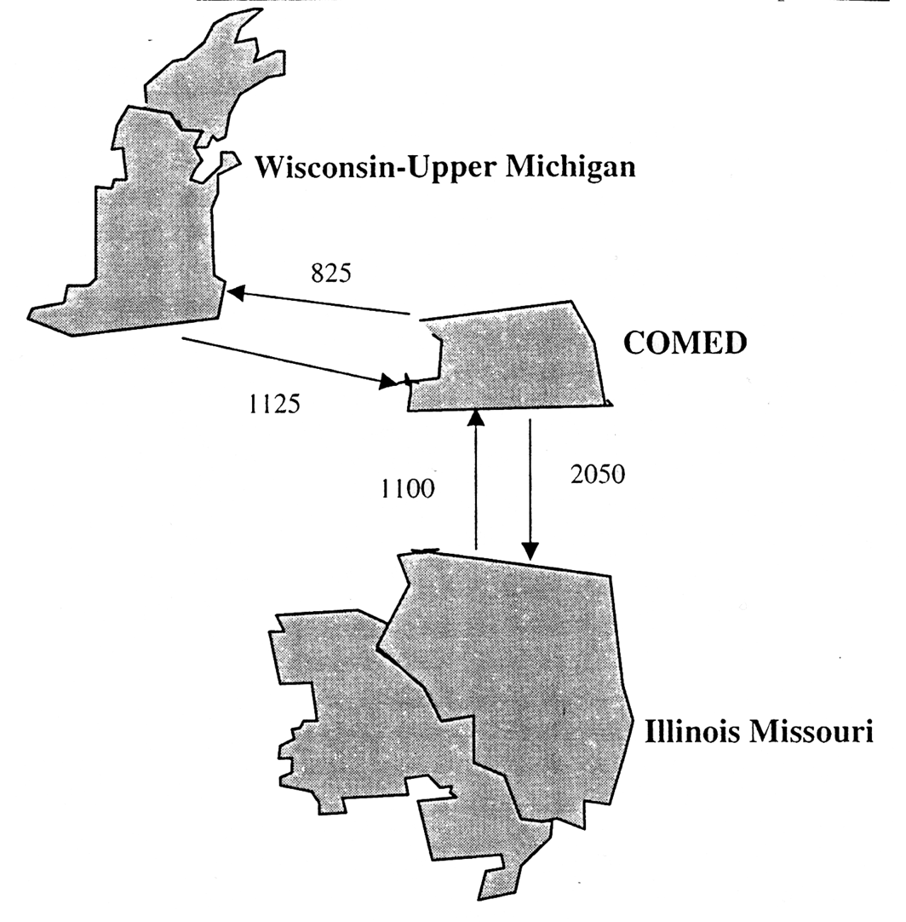
Within MAIN, transmission constraints exist going into the WUMS region.

D. MAIN Historical Prices
- Energy prices in MAIN have historically been among the lowest in the country due to an abundance of low variable cost resources, namely nuclear and coal.
- The amount of low variable cost baseload capacity has been sufficient to serve load in MAIN during most hours of the year.
- As a result, the marginal source of electrical energy has typically been coal fired power plants on-peak and occasionally nuclear plants during very deep off-peak hours.

ComEd/MAIN Historical Energy Prices
(1998$/MWh)
 | 1996 | 1997 | 1998 | 1999
PMW–Into ComEd
Average Peak¹ | NA | 28.7 | 49.8 | 57.9
High | NA | 104.3 | 690.4 | 1,365.7
Average Summer² Peak | NA | 33.6 | 115.3 | 166.8
PMW–MAIN
Average Peak¹ | 22.4 | 26.2 | 49.3 | 45.0
High | 39.9 | 114.7 | 690.4 | 922.3
Average Summer² Peak | 24.8 | 34.9 | 113.9 | 104.0
Megawatt Daily – ComEd
Average Peak¹ | NA | 26.2 | 46.0 | 43.2
High | NA | 192.2 | 2,700.0 | 1,784.5
Average Summer² Peak | NA | 31.3 | 118.6 | 108.8
¹ Includes weekday hours 6 through 22.
² Includes months June, July and August.
Source: Power Market Week (PMW) weekly index and Megawatt Daily daily index.

- While Midwest peak demand growth has been strong recently, capacity expansion has not kept pace. This is attributable, in part, to both the excess capacity that followed tremendous capacity expansion in the 1980s and to the regulated structure of rate base expansion. Over the last two years, the supply/demand balance for peak hours has tightened significantly, mainly due to nuclear shutdowns and lack of new construction.
- The progressive tightening of the capacity situation in ComEd/MAIN was reflected in the difference in the price spikes in 1997 and that in 1998 and 1999. The daily price index in the summer of 1997 reached as high as $192/MWh.
- The picture changed dramatically in the summer of 1998. Outages of key nuclear units led to daily prices reaching as high as $2,700/MWh in 1998 with hourly prices being reported to be as high as $7,000/MWh.
- Capacity situation in 1999 continued to be grim as higher than expected summer demand pushed daily prices as high as $1,785/MWh. MAIN as a whole reported peak demand at approximately 5 percent higher than forecasted, while many utilities reported peaks at about 10 percent higher than forecasted. ComEd region experienced extensive outages between late July and early August.

MAIN Weekly Indexes – Recent Price Spikes in MAIN

Source: Power Markets Week.

IV. EAST CENTRAL AREA RELIABILITY COORDINATION AGREEMENT AREA (“ECAR”)
A. ECAR Regional Overview
- ECAR covers all or portions of Indiana, Kentucky, Michigan, Ohio, Pennsylvania, Virginia, Maryland, and West Virginia.
k:\adobe\tif_april\enron\....tif,gif,jpg

- ECAR is not a centrally dispatched or “tight” power pool. Several sub-areas of ECAR have historically operated on a tight basis. These include the American Electric Power System (“AEP”), the Allegheny Power System (“APS”), and the Michigan Electric Coordinated System (“MECS”). Although total sales for individual utilities such as AEP are significant, ECAR is not dominated by one or more utilities. Competition is further augmented by ECAR’s extensive transmission which allows for large amounts of imports and exports.
- Laws concerning deregulation have been passed in Ohio, Virginia, West Virginia and Maryland. These states require full retail access by January 2004 at the latest. Kentucky has decided not to pursue any legislation requiring deregulation in 2000, citing its low cost of power. A deregulation bill in the Indiana legislature was defeated in 1999 due to opposition from utilities, labor and environmental groups.
- There has not been much in the way of asset divestiture in ECAR with the exception of Duquesne in Pennsylvania. Most of the deregulation legislation in the states in the region does not require divestiture. Both Ohio and West Virginia require all generating assets belonging to a utility to be transferred to a separate unregulated subsidiary by 2005.

ECAR Market Size – 2000
Total Installed Capacity | 110 GW
Peak Load | 93 GW
Capacity Within One Wheel | 375 GW
Import Capability | 17 GW
Export Capability | 10 GW
Net Annual Energy for load | 569,713 GWh
Average Demand | 65 GW
Net Exports | 32,030 GWh
Source ICF Base Case Forecasts for 2000

B. ECAR Capacity Mix
- ECAR is heavily dominated by coal with some nuclear generating capacity. Combined coal and nuclear in 1997 accounted for 86% of total capacity and 95% of total generation.

ECAR Capacity and Generation Mix – 2000
CAPACITY |  | GENERATION
Total Capacity = 110 GW |  | Total Generation = 602 BkWh
Source: ICF Base Case Forecast for the year 2000.
Note: Totals may not add due to rounding errors. The difference between the total generation depicted in the pie chart and the Net Energy for load in the Table is due to net exports from ECAR

C. ECAR Transmission Overview
While there is considerable transmission capability within ECAR, the connections with the rest of the Northeast are somewhat limited.

Inter-Regional Transmission
The primary interconnections between ECAR and neighboring systems consist of:
- Two 500 kV interconnections in southwestern PJM with APS in ECAR.
- Two 345 kV interconnections in northwestern PJM with Centerior in ECAR.
- Two 345 kV interconnections with Ontario in MECS.
- Four 500 kV interconnections with VEPCO and one 500 kV interconnection with Duke in VACAR.
- Two 500 kV interconnections with TVA.
- One 765 kV and several 345 kV interconnections with MAIN (primarily at Commonwealth Edison).

Intra-Regional Transmission

- Southern ECAR has extensive transmission interconnections including AEP's 765 kV line, the largest in the U.S. MECS is well integrated on an internal basis but is not connected with AEP's 765 kV line.

D. ECAR Historical Prices
- Electrical energy prices in ECAR have historically been lower than neighboring regions to the East, especially the Northeast, but higher than MAPP and MAIN.
- While ECAR has significant coal capacity as part of its supply mix, delivered coal costs in this region are higher than in MAIN and MAPP. Due to ECAR’s geographic location, ECAR has relatively easy access to high cost Appalachian coal but is fairly remote from the cheaper Powder River Basin coals, which adds to delivered cost due to transportation.

ECAR Historical Energy Prices
(1998$/MWh)
 | Historical
 | 1996 | 1997 | 1998 | 1999
PMW– Northern ECAR
Average Peak¹ | 23.5 | 24.8 | 56.3 | 43.5
High | 40.3 | 139.8 | 656.0 | 609.2
Average Summer² Peak | 27.3 | 37.0 | 146.1 | 108.2
PMW–Into Cinergy
Average Peak¹ | NA | 24.5 | 56.4 | 50.5
High | NA | 138.4 | 656.0 | 988.7
Average Summer² Peak | NA | 37.0 | 146.1 | 139.0
¹ Includes weekday hours 6 through 22.
² Includes June, July and August.
Source Power Market Week (PMW) weekly index

- ECAR’s baseload capacity is sufficient to meet its average needs.
- Capacity becomes quite scarce during peak periods.
- ECAR has become increasingly capacity short, causing higher price volatility.
- Southern ECAR experienced explosions in peak power prices in the summers of 1997 and more so in 1998. As in MAIN, these spikes help account for the high 1998 average and on peak Power Markets Week prices.
- In 1999, Southern ECAR again experienced high prices, with the weekly index reaching as high as $600/MWh in August.

ECAR Weekly Indexes – Recent Price Spikes in ECAR

!Sheet1 Size: 4.10" x 6.00" Original Size: 4.50" x 5.99" Crop: .11" Top .29" Bottom

Source: Power Market Week.

V. TENNESSEE VALLEY AUTHORITY (“TVA”)
While TVA is not an independent reliability council, it is discussed here separately from the rest of the Southeast Electric Reliability Council (“SERC”) for several reasons:
- SERC is extremely large and diverse, and it is therefore less meaningful to examine SERC as a single marketplace (e.g. TVA has significantly more hydropower generation than the rest of SERC).
- TVA has significant independence from SERC for planning and operations.
- There are transmission constraints between TVA and the rest of SERC.

A. TVA Regional Overview
- TVA is primarily a wholesaler, selling about 80 percent of its output to about 160 municipal utilities and cooperatives, and also sells directly to 60 large industrial customer and government installations.
- TVA encompasses a 200,000-square kilometer area including all of Tennessee, sizeable portions of northern Alabama, northern Mississippi, and southern Kentucky and small portions of Georgia, North Carolina, and Virginia.
- TVA is planned and dispatched as one system with peak loads in excess of 27 GW.

TVA Market Size – 2000
Total Capacity | 30 GW
Peak Load | 27 GW
Capacity Within One Wheel | 350 GW
Import Capability | 11 GW
Export Capability | 9 GW
Net Annual Energy | 161,604 GWh
Average Demand | 18 GW
Net Imports | 2,496 GWh
Source: ICF Base Case Forecasts for 2000.

B. TVA Capacity Mix
- The TVA capacity and generation mix is dominated by coal, which accounted for about 50% of installed capacity and approximately 65% of total generation in 1997.
- Nuclear and hydro (including pumped storage) account for roughly 22% and 21%, respectively, of the total capacity. The remaining capacity in TVA is comprised mainly of combustion turbines which are relied on for peak hours.
- TVA has more hydro than any other major U.S. sub-region in the Eastern Interconnect.

TVA Capacity and Generation Mix – 2000
CAPACITY |  | GENERATION
Total Capacity = 30 GW |  | Total Internal Generation = 159 BkWh
Note: Capacity physically located in TVA region, but counting toward other regions is not included in the capacity mix. Totals may not add due to rounding.
Source: ICF Base Case Forecast for the year 2000.

C. TVA Transmission Overview
- TVA is the most centrally located power market area in the U.S. and has the greatest interconnections with other regions in the Eastern Interconnect.

PresTech K:\Adobe\April_tif\Project Finance Emron.tif

- The primary interconnections between TVA and neighboring systems consist of ties to the following utilities:
- ECAR – AEP/Appalachian Power, Big Rivers, Kentucky Utilities, East Kentucky Power Coop, and Louisville Gas & Electric
- VACAR – Duke Power, Carolina Power & Light
- ENTERGY – Arkansas Power & Light, Mississippi Power & Light
- MAIN – Central Illinois Public Service, Illinois Power and Union Electric
- Southern – Alabama Power and Georgia Power

D. TVA Historical Prices
- Electrical energy prices in all of SERC have historically been lower than neighboring regions to the North.
- TVA has relatively large total interconnections associated with its central location. Import and export capability is about two thirds of average demand and some lines may be upgraded, further increasing transmission access.
- Prices jumped between the summers of 1997 and 1998 as the market has come into full balance. In 1999, prices were again high.
- The impact of the capacity situation in MAIN and Southern ECAR is also reflected in the peak prices in TVA.

TVA/ SERC Historical Energy Prices
(1998$/MWh)
 | HISTORICAL
 | 1996 | 1997 | 1998 | 1999
PMW–Into TVA
Average Peak¹ | NA | 27.6 | 55.8 | 51.0
High | NA | 130.7 | 697.7 | 1,012.2
Average Summer² Peak | NA | 36.1 | 145.0 | 139.4
PMW–SERC
Average Peak¹ | 25.0 | 26.3 | 51.2 | 50.6
High | 37.9 | 118.7 | 636.3 | 926.5
Average Summer² Peak | 28.4 | 37.0 | 123.2 | 131.9
Megawatt Daily – TVA
Average Peak¹ | NA | 25.4 | 47.2 | 48.6
High | NA | 232.5 | 1,816.7 | 1,765.4
Average Summer² Peak | NA | 32.3 | 106.7 | 120.2
¹ Includes weekday hours 6 through 22.
² Includes June, July and August.
Source: Power Market Week (PMW) weekly index and Megawatt Daily daily index.

SERC Weekly Indexes – Recent Price Spikes in TVA

Source: Power Market Week

VI. OTHER RELEVANT DEVELOPMENTS
There are several transmission-related developments that can further facilitate market access for the Peaker Assets. These include a move to a more regional ISO structure with a gradual elimination of pancaking of transmission rates and thus, a more integrated marketplace.

A. Midwest ISO and Transmission Charges
- Recently, FERC conditionally approved the Midwest ISO (“MISO”), which includes members from MAIN, ECAR and MAPP. The implementation of the ISO would serve largely to eliminate the pancaking of rates by establishing a zonal pricing system.
- Members of the MISO include: Allegheny Power, Ameren, CILCO, Cinergy, Commonwealth Edison, Hoosier Energy Rural Electric Cooperative, Illinois Power, Louisville Gas & Electric, Wabash Valley Power, SIGECO, Alliant Energy, So. Illinois Power Cooperative, and Wisconsin Electric. A total of twelve transmission owners in the region are members of MISO. Recently, Northern States Power joined MISO expanding the organization into MAPP.
- Recently, members of MAPPCOR, the contractor that operates the Mid-Continental Power Pool (MAPP), agreed to sell its assets to MISO. The agreement will not be complete unless members representing two-thirds of the load in MAPP agree to join MISO.
- The pricing structure agreed to by the participants allows for a six year transition period, during which time the members of MISO are divided into zones existing at the time of filing the agreement. For point-to-point transmission to a customer within the ISO, the rate charged will be the zonal rate where the load is located.
- For point-to-point transmission through the ISO or for point-to-point transmission out of the ISO, the rate charged will be a single system-wide ISO rate.
- After the transition period the zonal pricing structure may be retained or a single, MISO rate adopted.
- More recently Commonwealth Edison, Mid American Energy, Interstate Power and IES Utilities have proposed forming a for-profit independent transmission company (ITC) within the jurisdiction of MISO. They have filed their plan with FERC in December 1999 and the proposal is pending review. The proposed ITC would have a governing body independent of buyers and sellers and any major rate-funded transmission expansion would need to be approved by MISO.
- Currently negotiations are underway to expand MISO to include SPP. This expansion is targeted to include both the northern and western sections of SPP.

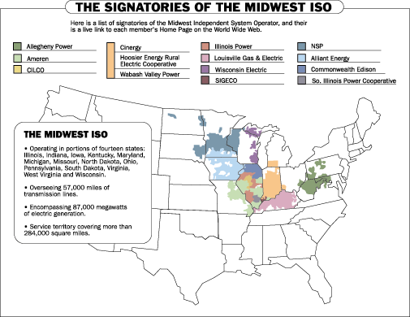
source: www.midwestiso.com

B. Alliance RTO
- A competing ISO-type regional transmission organization (“RTO”) is under development by companies in ECAR and VACAR.
- Discussions with multiple parties have been ongoing since early 1998. The Alliance is currently in Phase III.
- Currently, five companies have agreed to develop a FERC filing:
- AEP
- First Energy
- Consumers Power
- Detroit Edison
- Virginia Power
- The exact form of the RTO (full ISO or Transco) will remain flexible.
- If no one divests by day one of operations, the Alliance would function like a non-profit ISO. If one or more members sells transmission assets into the Alliance, the RTO would automatically become a transmission company.
- Members can sign an operational agreement with the Alliance relinquishing control of transmission assets, or sell or lease assets to the Alliance.
- The proposed pricing structure includes a transition period in which each member’s existing transmission system would comprise a zone.
- Customers could pay one zone rate to access a zone and then would only pay another zone rate to access the entire RTO during the transition.
- Eventually, the Alliance seeks to offer a single, grid-wide rate, perhaps in six years or when all transmission owners join.
- With FERC approval, the Alliance would also develop and propose incentive rates.

- The Alliance RTO is expected to file with FERC within the year.
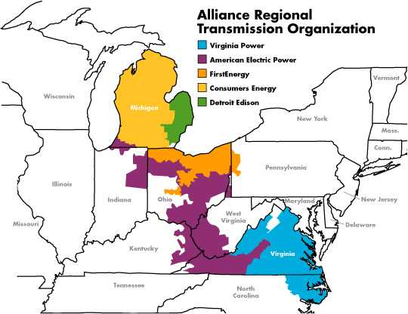

source: www.alliancerto.com

4. Operating Information

Operating Information
This section provides a description of the principal operating assumptions for the 1999 and 2000 Peaker Plants (the “Plants”).

Key Inputs

 | 1999 Plants |  |  |  | 2000 Plants
 | BROWNSVILLE | caledonia | new  albany |  | GleasoN | wheatland | wilton center
Technical Assumptions:
Number of Turbines | 4 | 6 | 6 |  | 3 | 4 | 8
Contractual PPA Capacity (MW) ⁽¹⁾ | 458 | 466 | 371 |  | 510 | 470 | 608
Plant Net Heat Rate @ 90⁰ (HHV, Btu/kWh) | 11,406 | 12,064 | 12,500 |  | 10,592 | 11,734 | 11,973
Assumed Starts Per Year | 75 | 75 | 75 |  | 75 | 75 | 75
Pricing Assumptions:
PPA Start Date | Jan. 2001 | Jan. 2001 | Jan. 2001 |  | Jan. 2001 | Jan. 2001 | Jan. 2001
Fixed Demand Charge Rate ($/kW-month) | 4.00 | 4.00 | 4.00 |  | 4.00 | 4.00 | 4.00
Energy Charge (2000 $/MWh) | 1.50 | 1.00 | 1.00 |  | 1.50 | 3.00 | 2.00
Start Charge (2000 $/Start/turbine) | 1,500 | 1,000 | 1,000 |  | 1,500 | 1,500 | 1,000
Annual Generation (000 MWh/year)⁽¹⁾ | 625 | 544 | 410 |  | 533 | 461 | 2,002
Operating Cost Assumptions:
Variable O&M Rate (2000 $/MWh) | 1.50 | 1.00 | 1.00 |  | 1.50 | 3.00 | 2.00
Fixed O&M (2000 $000) | 1,564 | 1,721 | 1,878 |  | 1,242 | 1,516 | 1,449
Major Maintenance ($/Start/Turbine) | 1,500 | 1,000 | 1,000 |  | 1,500 | 1,500 | 1,000
Major Maintenance Per Plant (2000 $000) | 450 | 450 | 450 |  | 338 | 450 | 600
Owner’s Expense (2000 $000) | 432 | 411 | 363 |  | 322 | 306 | 401
Property Tax Liability (2000 $000) | 250 | 591 | 489 |  | 92 | 203 | 334
Tax Assumptions:
Federal Income Tax Rate | 35.00% | 35.00% | 35.00% |  | 35.00% | 35.00% | 35.00%
Applicable State Income Tax Rate | 6.00% | 5.00% | 5.00% |  | 6.00% | 4.50% | 7.18%
Adjusted Gross Income Tax | N/A | N/A | N/A |  | N/A | 3.40% | N/A
Gross Receipts Tax Rate | N/A | N/A | N/A |  | N/A | 1.20% | N/A
Franchise Tax Rate | 0.25% | 0.25% | 0.25% |  | 0.25% | N/A | 0.15% yr 1, 0.10% yr 2-20
- Includes additional capacity of 20 MW at Caledonia and 15 MW at New Albany, with installation of evaporative coolers by June 2000.

A. Pricing Assumptions
The fixed price period extends from January 1, 2001 through December 31, 2003 for all 6 Plants.
- Fixed Demand Charge Rate. ENA pays a Fixed Demand Charge Rate of $4.00 per kilowatt-month.
- Energy Charge. ENA pays an Energy Charge as outlined in the Key Inputs.
- Start Charge. ENA pays the Start Charge as outlined in the Key Inputs. The assumed starts for each Plant is 75.

B. Operating Cost Assumptions
- Variable O&M. Variable O&M expenses include water costs and variable maintenance expenditures.
- Fixed O&M. Fixed O&M includes payroll expenses and other fixed O&M expenses. The amount of annual Fixed O&M is approximately $5.2 million for the 1999 Plants and $4.2 million for the 2000 Plants ($ 2000).
- Major Maintenance. Annual Major Maintenance expense is approximately $1.35 million for the 1999 Plants and $1.39 million for the 2000 Plants ($ 2000), assuming 75 starts/year.
- Owner’s Expense. Owner’s Expense includes insurance, utilities, interconnection fees, gas pipeline metering cost and miscellaneous expenses. The amount of the Owner’s Expense is estimated at $1.2 million for the 1999 Plants and $1.1 million for the 2000 Plants.
- Property Tax Liability. The amount of the Property Tax is estimated at $1.3 million for the 1999 Plants and $0.6 million for the 2000 Plants ($ 2000). Property Tax varies based on abatement programs and other local issues.

C. Accounting and Tax Assumptions
- Depreciation and Amortization. The Plants are depreciated on a 15-year MACRS depreciation schedule for the calculation of cash taxes. Book depreciation on the other hand, uses a 30-year straight-line schedule, with a residual value for the assets of 10%.
- Income Taxes. Federal Tax is calculated at a 35% rate. The applicable local State Income Tax rates are listed in the Key Inputs table.
- Wheatland Adjusted Gross Income Tax and Gross Receipts Tax. Indiana income is subject to the greater of a 3.4% Adjusted Gross Income Tax or a 1.2% Gross Income Tax. The Adjusted Gross Income Tax is based on federal net income, adjusted for specific Indiana additions and subtractions. The Gross Income Tax base is total Gross Receipt, without any deductions for expenses or related cost.
- Franchise Tax. Franchise Tax is calculated for Brownsville, Gleason, New Albany, Caledonia and Wilton. For Brownsville and Gleason, Tennessee imposes a .25% tax on the higher of (1) capital stock less treasury stock or stock held in other Tennessee corporations, retained earnings, indebtedness to, or guaranteed by, affiliated corporations and all reserves that do not represent legal liabilities, or, (2) the cost of all property owned less book (GAAP) accumulated depreciation. For New Albany and Caledonia, Mississippi imposes a .25% tax on corporation capital employed in Mississippi. The measure of capital includes stock, paid-in-capital, surplus and retained earnings less certain reserves. For Wilton, Illinois imposes a Franchise Tax, which is the product of the computed paid-in capital multiplied by a .15% (drops to .10% after first year) rate. The computed paid-in capital is comprised of consideration paid for stock, any other consideration contributed to the corporations by a shareholder.

With the installation of evaporative coolers, output will increase to 466 for Caledonia and 371 for New Albany.
Excluding the entire month of March
Excluding the entire month of October

