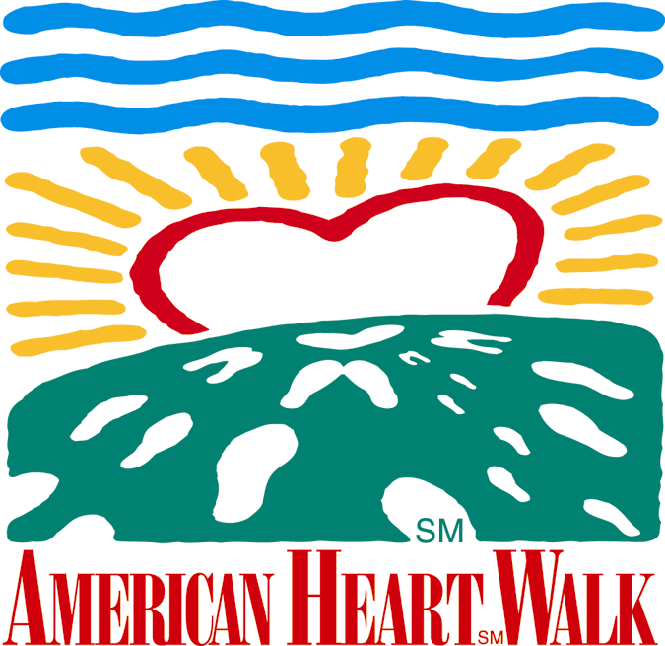
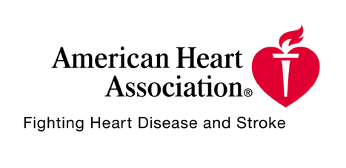
Foot Notes October 22, 2001

pa



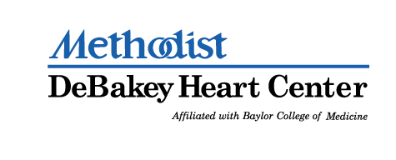

Contributing Sponsors

Apache Corporation, Aerofil Technology, Inc., Boston Rack and Wire
Burlington Resources, Inc., Citgo Petroleum Corporation, Compaq
Ergon, Inc., Ethyl Corporation, Gold Eagle, GSD&M,
Honeywell Consumer Products, Houston Peterbilt, Inc., Hydrosol, Inc.
Infineum USA L.P., Lehman Brothers, McCarthy, Mambro, Bertino
McKinsey & Company, Morgan Stanley Dean Witter, Purolator
The Tucker Partnership








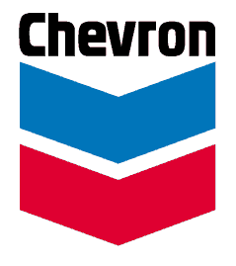






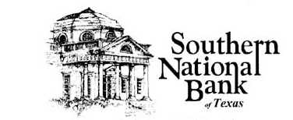

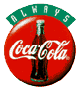
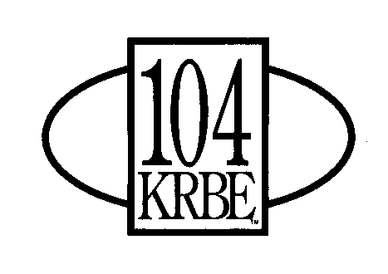




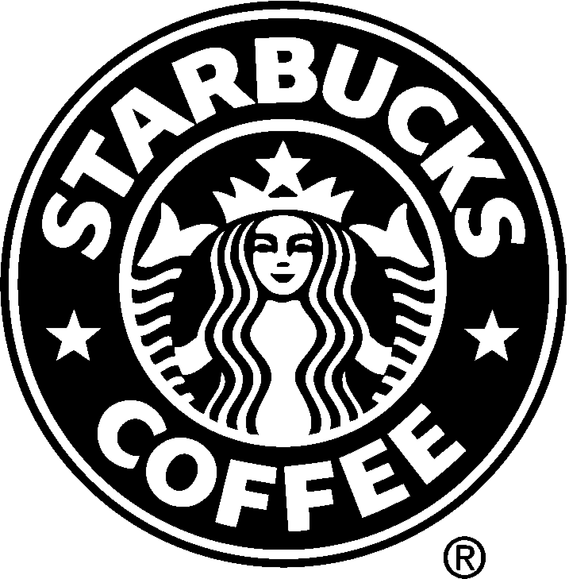
Just Some Miscellaneous Things...

Saturday, November 3rd
Pre-Walk Festivities: 9am
Walk Starts: 10am

- Health Fair & all post Walk fun will go until 2pm.

- Dogs are welcome – visit Petco’s Pet Tent. Just keep “Fido” on a leash...

- Kids Kids Kids...
Clowns, Face Painting, Petting Zoo, Pony Rides
Magic Shows, Little Heart Hospital & more...

- Remind all your Walkers to sign the Release section on the Walker Envelope.

- Register your Red Cap survivors with us. Just send us an e-mail with the name of the survivor.

