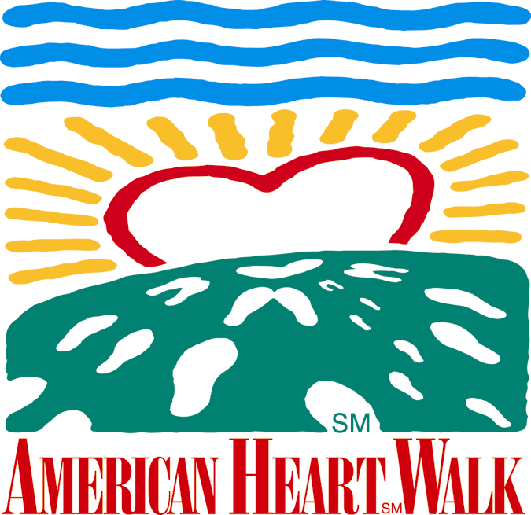
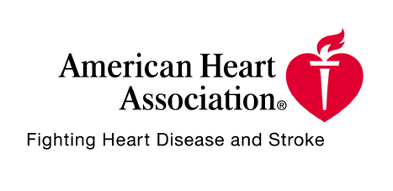
Foot Notes October 19, 2001

pa

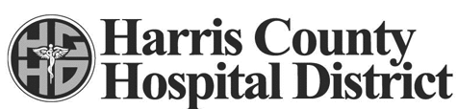

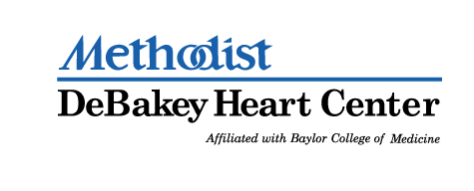

Contributing Sponsors

Apache Corporation, Aerofil Technology, Inc., Boston Rack and Wire
Burlington Resources, Inc., Citgo Petroleum Corporation, Compaq
Ergon, Inc., Ethyl Corporation, Gold Eagle, GSD&M,
Honeywell Consumer Products, Houston Peterbilt, Inc., Hydrosol, Inc.
Infineum USA L.P., Lehman Brothers, McCarthy, Mambro, Bertino
McKinsey & Company, Morgan Stanley Dean Witter, Purolator
The Tucker Partnership


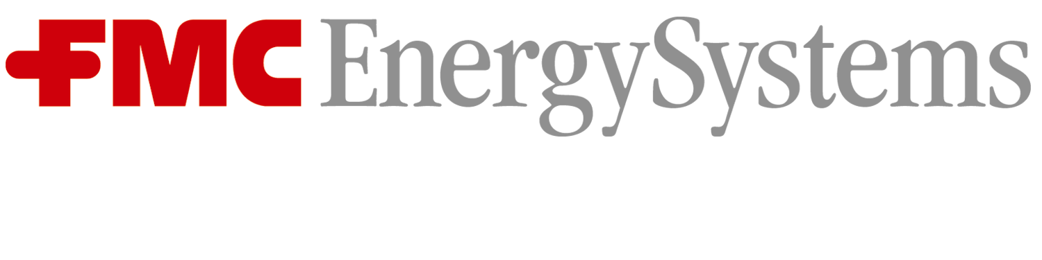

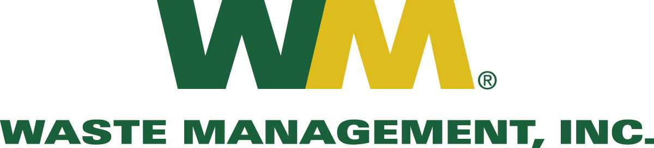


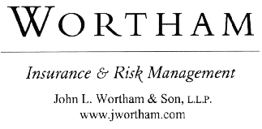
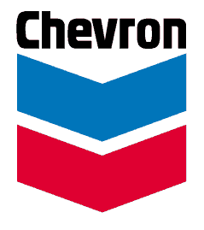


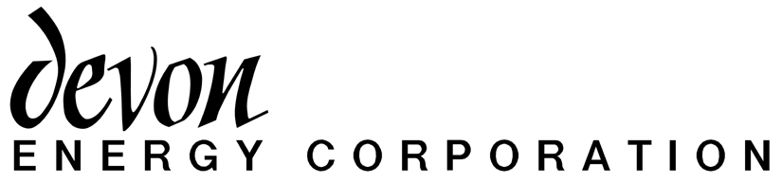

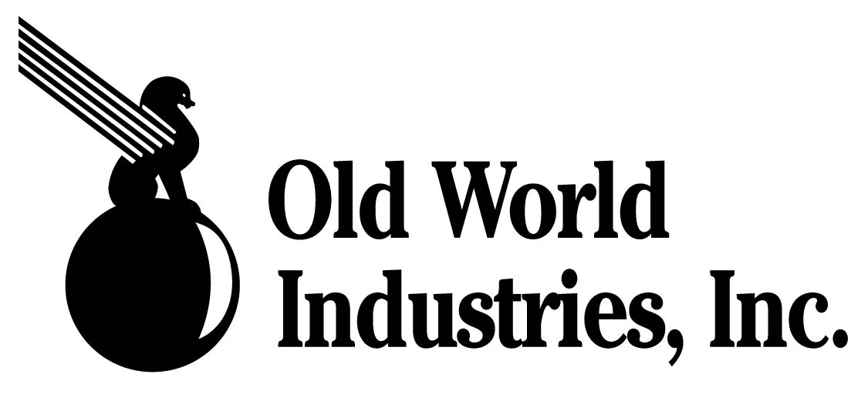
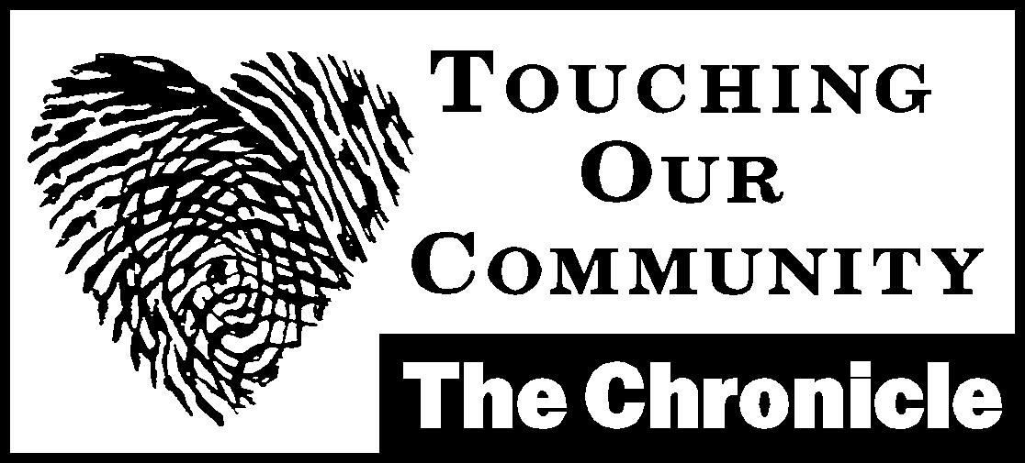
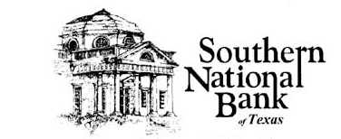

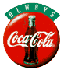
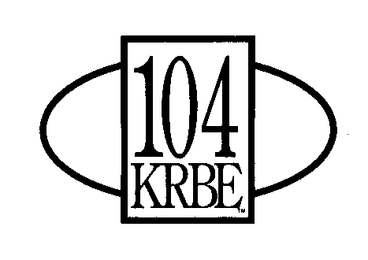

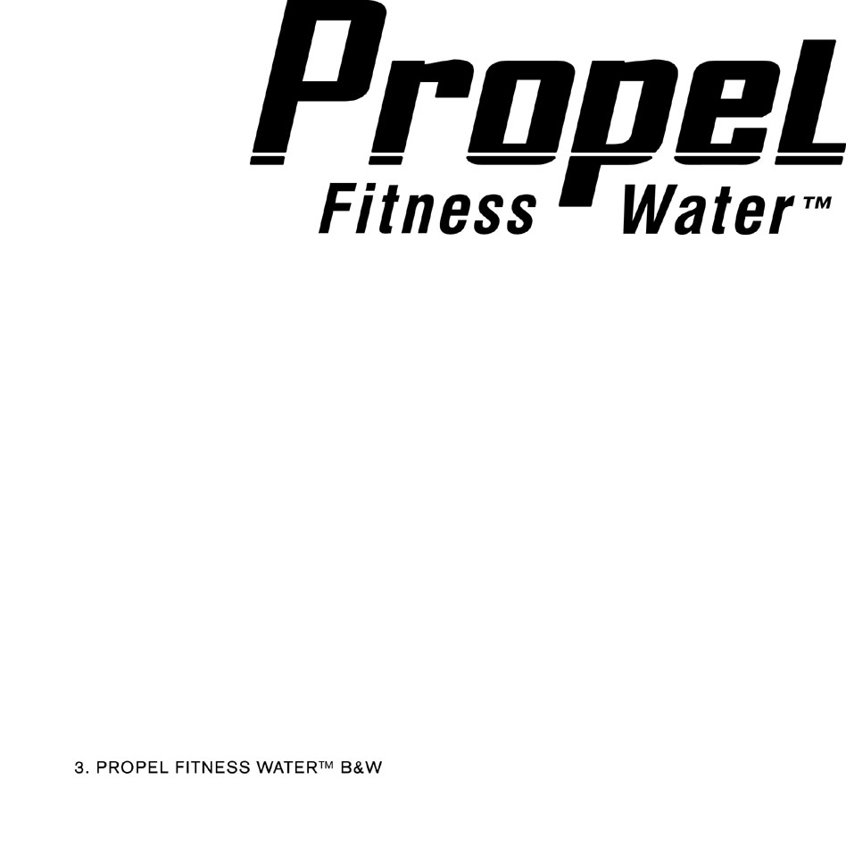
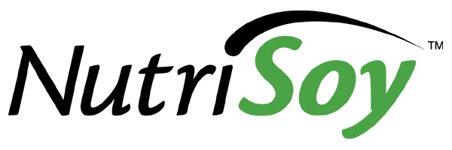

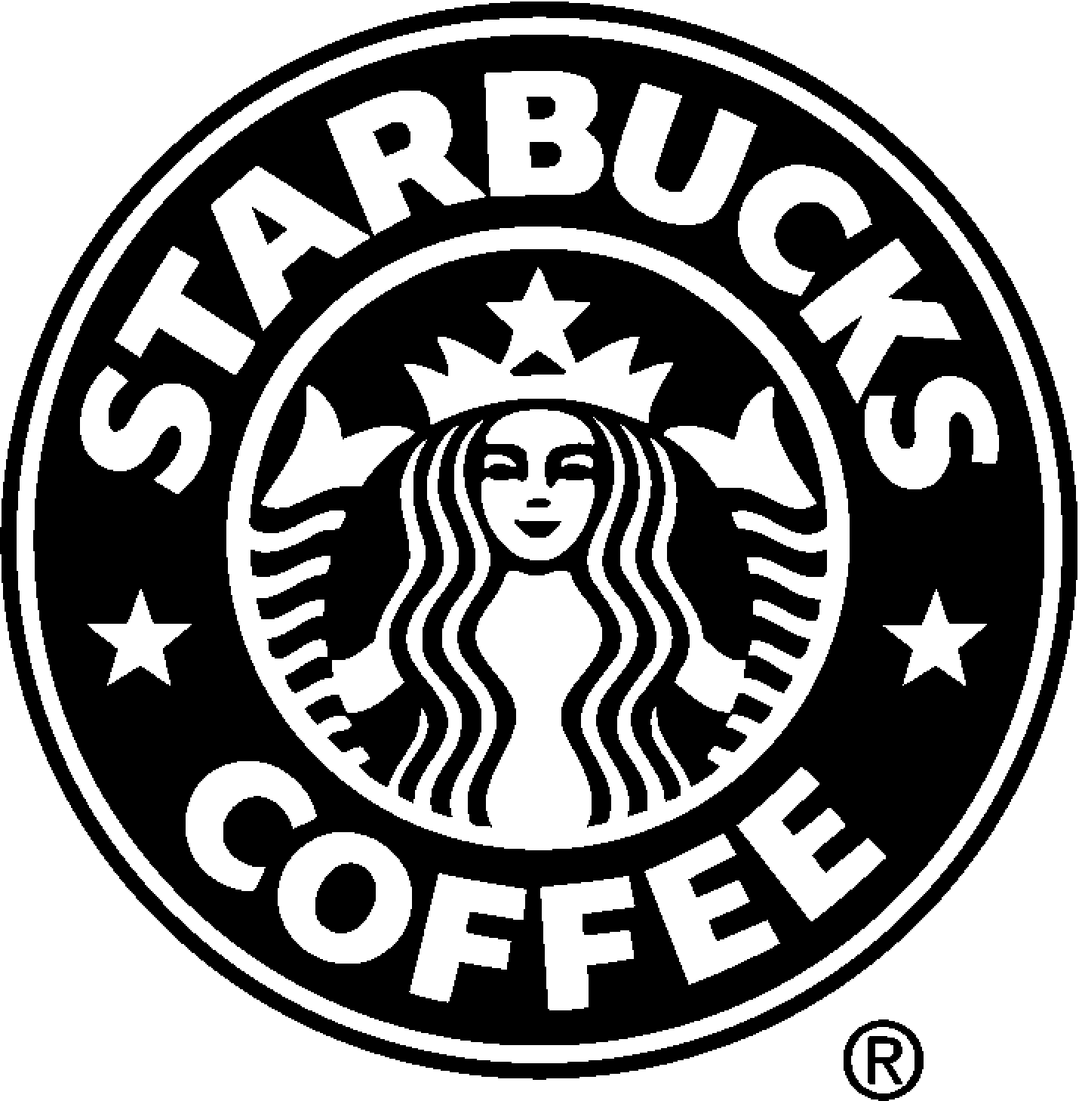
“This Is What We Play For...”
The “greats” in any field of performance, look forward to those moments where it all comes down to the wire. Those moments where the pressure is on and they get one shot at a spectacular last minute game-winning save. They will come right out and tell you that those are the moments they thrive on.

For all the players in this year’s American Heart Walk, it’s the final minute of play...

Remember:
It requires raising $100 to get the Heart Walk T-Shirt.
Last year’s individual Walker average in the Houston Metro Walk was $164.
Last year’s Team average was $1,214.

Okay, who wants the ball...

