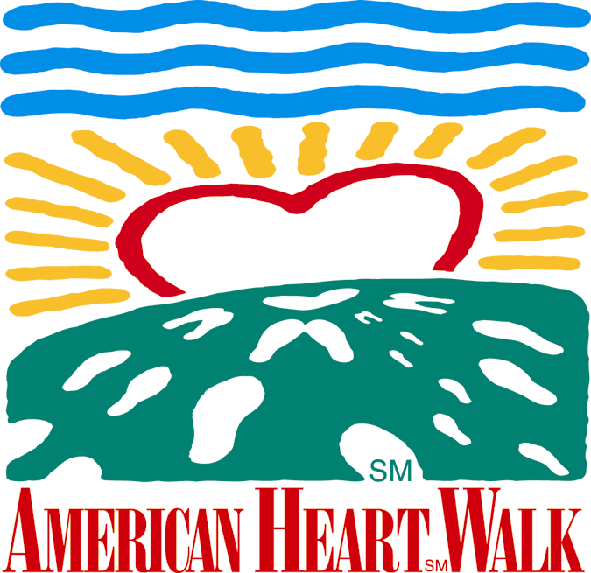

Foot Notes October 26, 2001

pa



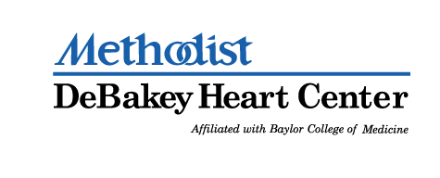

Contributing Sponsors

Apache Corporation, Aerofil Technology, Inc., Boston Rack and Wire
Burlington Resources, Inc., Citgo Petroleum Corporation, Compaq
Ergon, Inc., Ethyl Corporation, Gold Eagle, GSD&M,
Honeywell Consumer Products, Houston Peterbilt, Inc., Hydrosol, Inc.
Infineum USA L.P., Lehman Brothers, McCarthy, Mambro, Bertino
McKinsey & Company, Morgan Stanley Dean Witter, Purolator
The Tucker Partnership


















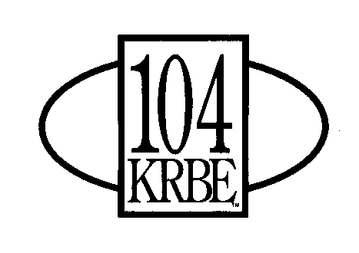





The deadline for the T-Shirt Contest is here:
If your company will be entering the T-Shirt contest, please let us know so we can be prepared.
Also, you will need to designate a person to “model” your T-Shirt at the Walk. The judging will take place around 9:30am, so let your designated model know to be around the stage no later than 9:25am waiting to be called up by Sam Malone.

Red Caps
Get the names of any more Red Cap Survivors to us by e-mail. All Red Caps will check in at the Methodist / Red Cap Tent on Walk Day.

Star Walkers
Those that raised at least $500 will check in at the Star Walker Tent on Walk Day.

Team Photos
Plan to get your team together for a photo session at Lakeside. Time to be determined next week.

Stay tuned...
Early next week you will receive the final version of the Park Layout Map along with the Walk Route Map.

