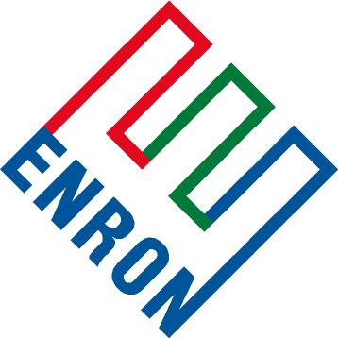
Frequently Asked Questions

Enron Global Markets – Emissions Trading

- What are emissions allowances?

- Why should companies consider trading their emissions allowance?

- How does emissions trading help control air pollutants and clean up the environment?

- Is emission trading a more cost-effective way to comply with environmental regulations?

- What emissions trading options are available to U.S. companies?

- When is the right time to sell emission allowances or hold in reserve?

- When buying allowances, does Enron ensure competitive pricing?

- How does trading emissions with Enron provide companies flexibility to manage their revenue flow and strengthen their position in a competitive marketplace?

- How many transactions has Enron completed? How many transactions industry wide?

- Do companies pay a commission or fee when buying and selling emissions allowances?

- Can companies exchange physical commodities for emission allowances?

- How can companies gain up front cash flow when selling allowances?

# # #

