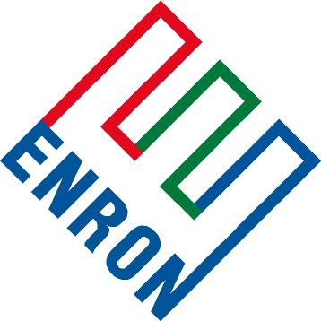
Frequently Asked Questions

Enron Global Markets – Coal

- How is deregulation shaping the future of the coal industry?

- What are key factors affecting a coal producers’ long-term goals?

- Why should coal producers consider hedging their inventories?

- What kinds of risk management tools are available to stabilize profitability?

- What can companies do to assess their protection needs?

- How does Enron distinguish itself in the marketplace?

- How many transactions has Enron completed? How many transactions industry wide?

- Is there such a thing as a standard contract?

- Explain how Enron also helps coal producers manage emission allowances.

- How does creating new markets for coal differ from traditional marketing? How is it similar?

- Can Enron help coal producers with financing and investments opportunities to stay competitive? How does this process work?

# # #

