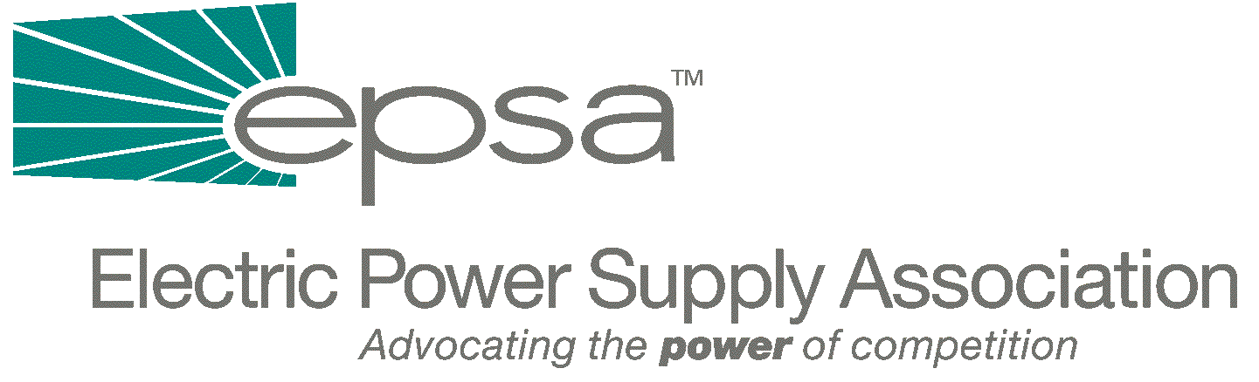
1401 New York Avenue, N.W.
11th Floor
Washington, DC 20005
202/7628-8200
202/628-8260 fax

FACTS ABOUT FERC’S RTO POLICY
November 2001

Why We Need Truly Regional RTOs

- A robust, well-functioning, competitive wholesale power market allows utilities and new market entrants to acquire the least-cost power supply to meet their customers’ needs. A competitive wholesale market is important both to states which implement retail competition and those which do not.
- The FERC has found that continuing inefficiencies and on-going discrimination in the provision of transmission service allows utilities to favor their own generation and prevents power suppliers from competitively selling wholesale power.
- The current balkanization of the transmission system creates inefficiencies that decrease market liquidity, increase price volatility, prevent least-cost power from flowing where it is needed and threaten reliability.
- According to the FERC: “RTOs are the platform upon which our expectations of the substantial generation cost savings to American customers are based.... These savings will be delayed, perhaps significantly, if RTOs are permitted to develop incompatible structures and systems, or if we approve RTOs that do not encompass wholesale market trading patterns.”
- Arbitrary rules, deadlines and timeframes vary from RTO to RTO, making it difficult for power to be transmitted from one RTO to another. The fewer junctions between RTOs, the more efficient the transmission of power will become.
- So called “seams agreements” between RTOs are not adequate to resolve inconsistent approaches to transmission management.
- Left on its own, the industry was not solving these problems. The Northeast ISOs had signed an agreement two years ago in an effort to resolve differences between the three ISOs but very little substantive progress (beyond issues lists) has been accomplished since then. The Southeast RTO parties were not meeting and were investing significant resources in systems that were not coordinated or compatible and which were likely to exacerbate rather than fix the current problems.
EXAMPLE – New York City, one of the largest centers of electricity demand in the U.S., is on the edge of three distinct RTOs. This complicates wholesale transactions and results in market inefficiency. Recent analysis estimates that these inefficiencies are costing northeast consumers $440 million annually.
EXAMPLE – In the west, wholesale power sales often reach thousands of miles. In the summer, power generated in the cooler northwest is sold to utilities in the hot and arid southwest. In winter, the power flows reverse. In spite of the fact that the western market operates as a broad regional market (under the oversight of a single reliability coordinating council), three separate RTOs have been proposed.
EXAMPLE – In the southeast, municipal utilities, cooperatives, electricity consumers, and power marketers endorsed the FERC’s RTO plans in a recent Southeast RTO filing.
What FERC Is Doing

- The Federal Energy Regulatory Commission (FERC) has not ordered the formation of four Regional Transmission Organizations (RTOs) nationwide. In two separate orders issued July 12th, the Commission concluded that it was “necessary” for the transmission owners in the Southeast to combine to form one RTO and for the three Independent Service Operators (ISOs) in the Northeast to combine to form one RTO.
- The FERC directed the parties into a 45-day mediation period to help accomplish this goal. At the conclusion of the 45-day mediation period, the Administrative Law Judges overseeing the process will send reports to the Commission, including milestones for accomplishing the goal of a single RTO for the Northeast and one for the Southeast.
- The Commission has not ordered similar mediation for the Midwest or the West, although Commissioners have spoken about the country being comprised of four natural energy markets. The Commission has said that it “favors” the development of one RTO for the Northeast, one for the Midwest, one for the Southeast and one for the West, although they are not wedded to only four RTOs.
- RTOs (in any shape or configuration) are not a step towards retail competition; they will facilitate wholesale competition. States will continue to have authority over retail electric service.
Now is the time to ensure a rational structure for RTO development

- The Commission has announced plans to initiate a Section 206 rulemaking proceeding to develop standard market structures and market designs for RTOs and to develop a new tariff to replace the Order No. 888 Open Access Transmission Tariff (OATT). FERC recently convened a week long conference to consider a host of RTO issues. Half-day panels of industry experts addressed required and optional RTO markets, standardized market design and tariffs, reliability and business practices, congestion management and transmission rights, transmission planning and expansion, and market monitoring and mitigation.

