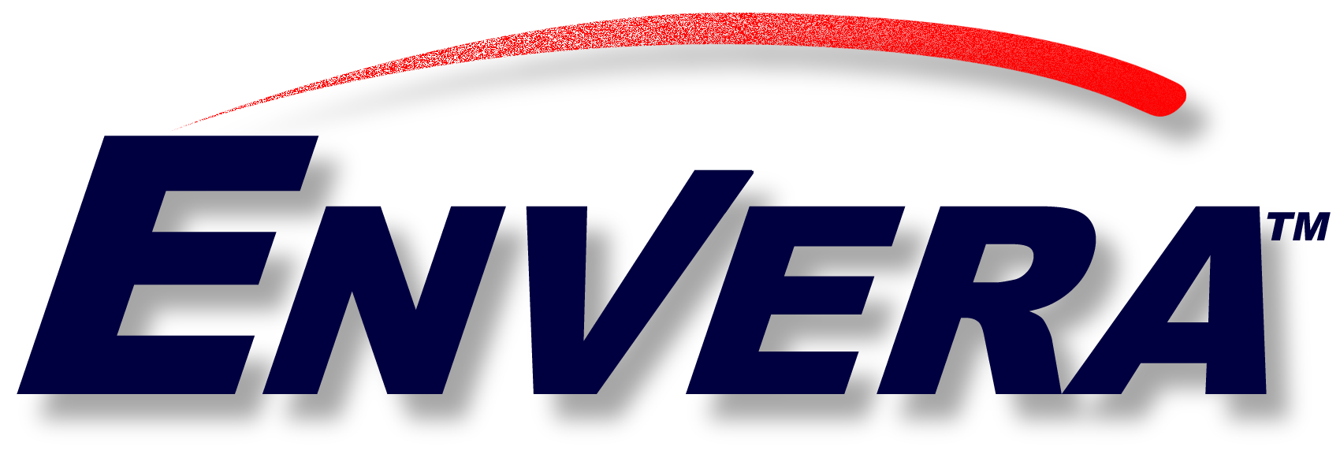

Embargoed until 12 noon EST Wednesday, January 10, 2001

Envera Contact:
Richard J. Chvala
(804) 788-5667
rchvala@envera.com

Envera becomes Enron Global Markets’ “Preferred Electronic Network ” for Petrochemical Transactions via EnronOnline

HOUSTON, TX (January 10, 2001)—Envera announced today that its newest equity participant and trading member is Enron Global Markets (EGM). Envera is the leading global electronic network for chemical and petrochemical industry B2B transactions and services.

EGM will connect its petrochemicals, natural gas liquids and plastics systems to the Envera network. Additionally, Envera will become EGM’s “Preferred Electronic Network” for Envera Members’ petrochemical transactions via EnronOnline, the world’s largest e-commerce Website for global commodity transactions.

“We welcome Enron as an Equity and Trading Member of Envera”, stated Bob Mooney, Envera’s CEO. “As our newest member, Enron extends Envera’s value proposition by opening up to Enron’s trading verticals, including new industries such as oil and gas, petrochemicals and plastics to Envera’s trading members. Furthermore, our members have enhanced access to Enron’s many services, continuing Envera’s “Business FOR Business” strengths.”

Envera members, consisting of chemical firms throughout the world, will have preferential access to many of Enron’s world-class product and service offerings. These include EnronOnline, DealBench and Enron Energy Services, a B2B platform providing a collaborative environment to share documents, conduct auctions, host webcasts, manage deal information and monitor deal progress.

ABOUT ENVERA

Envera is a trusted e-business solutions provider that improves members’ supply-chain communications and fosters business growth in the chemical and petroleum industries. Envera’s initial equity and trading partners include: Albemarle Corporation (NYSE: ALB); Borden Chemical, Inc; Equistar; Ethyl Corporation (NYSE: EY); Lubrizol (NYSE: LZ); Lyondell Chemical Co. (NYSE: LYO); Mays Chemical; Occidental Chemical Corporation (NYSE: OXY); Phenolchemie; and Solutia (NYSE: SOI). Visit Envera via its Web site at www.envera.com or call 1-888-ENVERA1.

# # #

