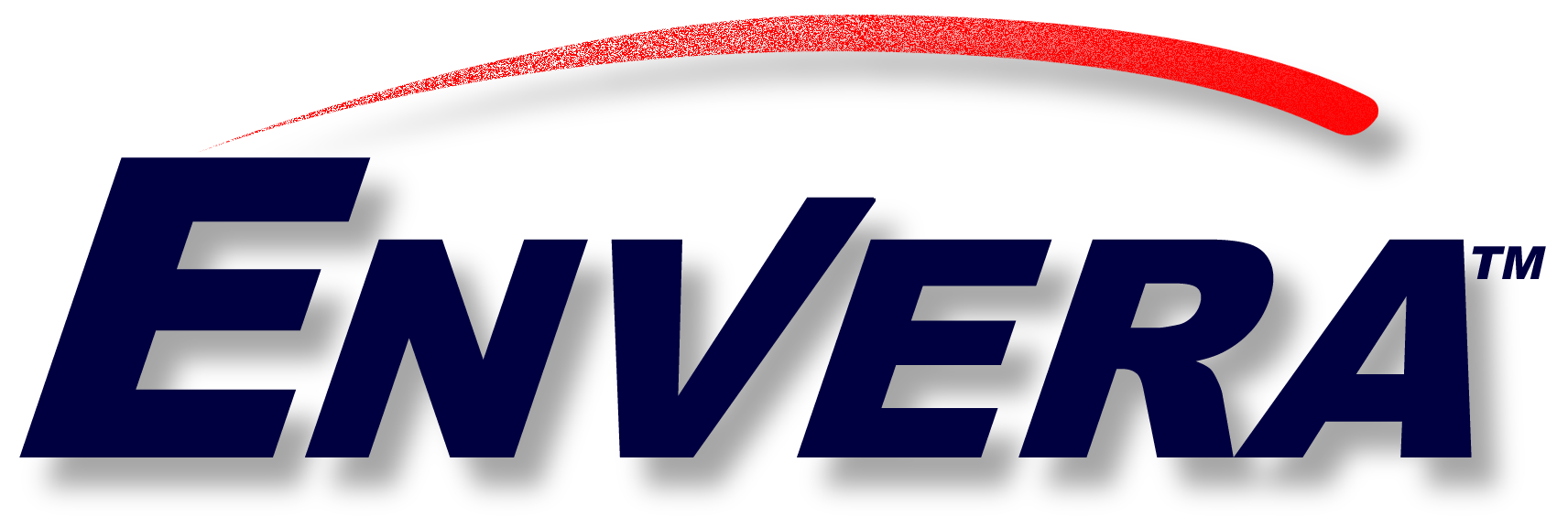

Envera Contact:
Richard J. Chvala
(804) 788-5667
rchvala@envera.com

Envera becomes Preferred Settlement Network for Enron Global Markets’ Petrochemical Transactions

HOUSTON, TX (XXXXX)—Envera announced today that Enron Global Markets LLC has become its newest trading member. Envera is a leading global electronic network for chemical and petrochemical industry B2B transactions and services.

Enron Global Markets will connect its petrochemicals, natural gas liquids and plastics systems to the Envera network. Additionally, Envera will become the Preferred Settlement Network for members’ petrochemical transactions with Enron Global Markets. Envera members also will have access to Enron’s world-class product and service offerings.

“We welcome Enron as a Trading Member of Envera”, stated Bob Mooney, Envera’s CEO. “As our newest member, Enron extends Envera’s value proposition by opening up to Enron’s trading verticals, including new industries such as oil and gas, petrochemicals and plastics to Envera’s trading members. Furthermore, our members have enhanced access to Enron’s many services, continuing Envera’s “Business FOR Business” strengths.”

ABOUT ENVERA

Envera is a trusted e-business solutions provider that improves members’ supply-chain communications and fosters business growth in the chemical and petroleum industries. Envera’s initial equity and trading partners include: Albemarle Corporation (NYSE: ALB); Borden Chemical, Inc; Equistar; Ethyl Corporation (NYSE: EY); Lubrizol (NYSE: LZ); Lyondell Chemical Co. (NYSE: LYO); Mays Chemical; Occidental Chemical Corporation (NYSE: OXY); Phenolchemie; and Solutia (NYSE: SOI). Visit Envera via its Web site at www.envera.com or call 1-888-ENVERA1.

# # #

