Entering the Credit Markets

Background

Throughout much of 1999, we have actively evaluated the credit markets and various opportunities to leverage our internal credit processes to both optimise our existing portfolio and provide third party credit protection. This exercise has provided valuable insights into the market dynamics of credit pricing and the unique nature of corporate credit risk.

The culmination of this exercise has convinced us that there is a big gap in the existing Capital Markets approach to providing credit protection and what is desirable from a corporate perspective. Specifically, default on most of our commercial contracts, those of our counterparts and corporate entities in general is more closely correlated with actual bankruptcy as opposed to corporate bond defaults, which is where the Banks are comfortable making markets.

Business Proposition

We propose to develop the market for bankruptcy derivatives, and thus the market for corporate credit protection, as a core Enron business delivered and executed completely on the Internet. This will be our initial attempt to develop a risk management business around the principles of business to business e-commerce. It is our belief that the framework and infrastructure developed for EnronOnline should allow us to quickly scale up and create a dominant market position in a very short timeframe

Initially, we expect to offer credit protection on our current customer base, including telecommunications clients. This focus has two primary benefits: 1.) the infrastructure already exists to evaluate the credit worthiness of these counterparts 2.) it will provide an additional product for all of our marketers, globally, to integrate into structured transactions.

Leveraging the infrastructure necessary to manage the initial portfolio, we expect to be able to market bankruptcy protection and quote prices across a wide spectrum of institutions on a global basis. Therefore, the ultimate risk management goal is to develop Global Credit Intermediation capabilities for non-financial entities.

Very quickly, we expect to use this initiative to add wholesale credit services to the range of outsourcing products currently being offered. This will be accomplished, in part by offering fee-based access to our credit data and models similar to the Riskmetrics™ product (formerly marketed by JP Morgan and subsequently spun off). In short, we expect this product to provide another significant mechanism to develop ‘hooks’ into counterparties, both traditional energy customers and other desirable potential customers.

Value Proposition

Using the marketing and execution power of EnronOnline, we intend to quickly build a portfolio of credits using the premium to underwrite expected losses. Similar to the insurance markets, the key is to ensure that premiums are high enough to cover expected losses. This fundamentally implies that we need to build a diverse portfolio with no significant concentrations. The key initial earnings driver is market share and effectively leveraging EnronOnline to enable us to capture huge market share quickly and cost effectively.

In addition to market share and premiums we see additional benefit and potential revenues becoming the market provider of prices for bankruptcy. As there is no current market or source of data for global bankruptcy protection, this business has the opportunity to quickly become the provider of credit pricing data to non-financial institutions. Additionally, our credit prices will reflect real time credit markets and should become a mechanism for banks and corporations to supplement traditional historically based credit evaluation with forward looking real time default indications. Similarly, our credit pricing models will provide cutting edge tools to an underserved market. The internet will allow us to offer products and services to a diverse customer base in a cost effective manner.

There is approximately a $3 trillion (initial conservative estimates) undeveloped corporate credit market. Banks recognise that the new money in credit is not by trading amongst themselves but in providing additional products to their corporate clients. Banks continue to struggle with how to attack the corporate market because their natural portfolio is based on bond default. The best place to jumpstart this business is in a corporate entity whose natural credit portfolio is bankruptcy-based and who has the foresight, experience and risk appetite to be the first. That said, our balance sheet does not easily support the long-term requirements of a generally buy and hold strategy with periodic large syndications. Based on informal discussions with large Bank participants, there would be significant interest in integrating fully developed corporate credit trading capabilities into an existing business.

Implementation Plan

We feel that in order to successfully jumpstart this business we have to go big and fast. This business is primarily an e-commerce business and must operate on ‘Internet Time’. Our goal is to quote prices on 200 names via EnronOnline 3 months after approval of the business plan and be prepared to quote on a minimum of 2000 names by the end of the first year.

During the time leading up to the official launch the team will focus on the following primary tasks:
- Pricing – We have developed preliminary models and begun to calibrate the models to existing markets. Although difficult to explicitly quantify, our initial analysis shows that bankruptcy protection will be less expensive than currently offered default protection. We expect to quote out to five years on corporate and municipal names of all credit ratings (we also intend to develop capabilities to quote credit prices on unrated names) on a global basis.
- Product Delivery – EnronOnline will be the primary delivery mechanism for the credit protection product. We will leverage the existing infrastructure to promote the products as well as facilitate execution. We also expect to establish a stand alone web site, EnronCredit.com, which will have a direct link to EnronOnline, where we can provide additional services which do not fit into the existing framework.
- Marketing – We feel that the best marketing tool will be the EnronOnline application itself complemented with interviews with various financial and internet publications. We intend to use the application itself to promote the business and leverage the sophisticated data analysis capabilities built around Enron Online to directly target potential counterparties across credit ratings on a global basis.
- Portfolio Analytics – The team has begun to develop portfolio tools and evaluate third party tools. Given the nature of the product we anticipate that much of the work done by the Research group on the insurance markets will be directly applicable. We will likely need to apply sophisticated actuarial techniques to evaluate the risk/return profile of the portfolio and individual transactions.
- Risk Transfer – The most effective vehicle for transferring risk will be to utilise the insurance and capital markets. Both markets continue to have significant appetite for structured risk and initial discussions lead us to believe that we can move tranches of similar risks in reasonably efficient manner in both markets.
The goal is to be in a position to make a public announcement within three months of approval.

In order to execute the above tasks quickly and effectively, the team will include two primary skillsets: 1.) E-Marketing 2.) Quantitative portfolio analysis.

Product Definition

The key to quick market penetration is to develop simplistic products that meet the requirements of the market. The core product will be bankruptcy protection. Products will be further delineated by tenor. Depending on our ability to negotiate terms, we expect to also offer protection with a higher credit rating (using an insurance company to enhance the Enron credit) as an alternative product.

In the language of EnronOnline, we will be offer firm prices on two product types, either BBB+ (Enron Credit) bankruptcy protection or AAA (wrapped by an insurance company) bankruptcy protection.

Product Differentiation

Commercial Bank Credit Products | Enron Credit Products
- Payout on Bond Default | - Payout on Bankruptcy
- $5MM on Eastern = 40bp | - $5MM on Eastern = 30bp
- Driven by regulatory capital | - Driven by business
- Complex documentation | - Simple documentation

Enron Online Implementation

Product Types:
BBB+ Default Swap
AAA Default Swap

Products:
Defined by Name, Tenor and Settlement

e.g., 5 year default swap on Dynegy with up front payment
2 year default swap on Entergy with monthly payments

This implies that there will be hundreds of products very early on with thousands of products very quickly. Additional filtering capabilities may be necessary to facilitate ease of use.

Stack:
Volume and Price in Bp (we may only quote offer prices at first but the intent is to be able to quote on both sides)

e.g., $1 mm of protection: bid 35 bp at 40 bp.
$2 mm of protection: bid 32 bp at 42 bp
$2 mm of protection: bid 30 bp at 45 bp

As additional functionality, we intend to provide a credit calculator that can be launched from the site to calculate implied default probabilities from the price.

Prior to launch, the following items must also be addressed:

- Draft long descriptions which clearly articulates the terms of the deal and default events
- Agree GTC
- Obtain RAC approval

Risk Management

The risk management approach is modelled after the insurance markets. We must build a deep enough and diverse enough portfolio that no single loss will drive us out of the market. We initially propose limiting our exposure in the following manner:

- Investment Grade:
- Maximum Tenor = 5 years
- Maximum Notional Amount = $10mm
- Non Investment Grade:
- Maximum Tenor = 2 years
- Maximum Notional Amount = $3mm
- VaR = $1mm
In addition to limiting our portfolio exposure, we expect to be able to transfer tranches of similar credits to the insurance and capital markets.

Infrastructure

Legal

Current market research indicates that one of the most challenging aspects of the existing credit derivative market is the complex documentation and actually defining a default event. We plan to simplify the documentation as much as possible. The termination event will be defined as bankruptcy and specific to the country of incorporation for the legal entity.

Paul Simons in Enron Europe Legal has been handling the legal work to date. Contracts for UK credit protection have been drafted and are currently under review.

Risk Management and Settlements

Test risk books have been developed and test curves are being generated. We are in the process of transferring existing exposures to the test environment to assist us in building the appropriate infrastructure. Barry Pearce’s team in London will handle trading support.

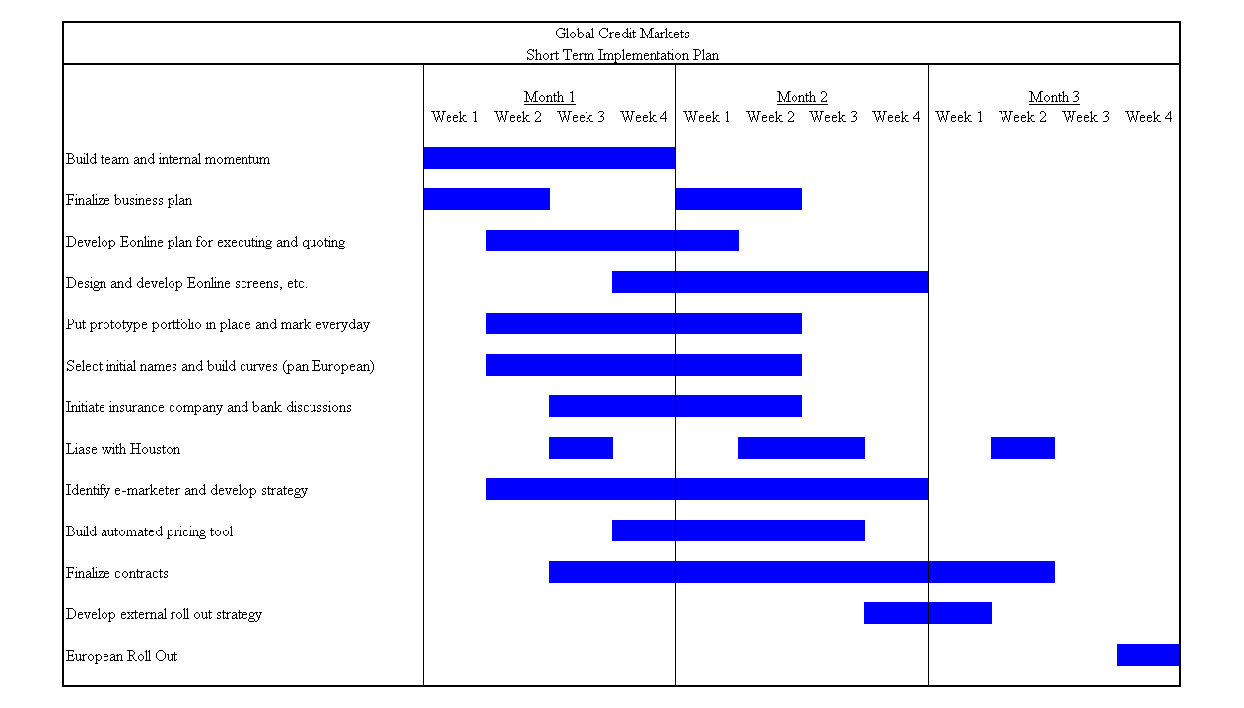
Timelines

