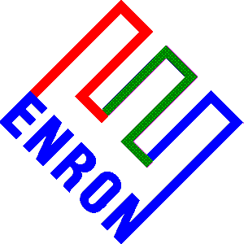 BIOGRAPHY OF SUSAN J. MARA

SUSAN J. MARA is Director of Government Affairs at Enron Corp., San Francisco, California. She is responsible for promoting pro-competitive policies in California’s energy markets. She directs Enron’s California Government Affairs staff, which covers restructuring issues at the CPUC, FERC, ISO, PX and state legislature.

These activities include monitoring California legislative initiatives on restructuring, participating in regulatory proceedings related to direct access at the CPUC, participating in ISO and PX meetings and activities, monitoring and conforming with requirements for Energy Service providers, Meter Service providers, Meter Data Management agents and scheduling coordinators, and participating in proceedings before FERC regarding the ISO and PX.

Before joining Enron in 1996, she was ISO Policy Team Leader and Director of Transmission Policy and Pricing at Pacific Gas and Electric Company, where she worked for thirteen years. She was responsible for leading much of PG&E’s activities in developing and implementing the ISO, and helped to draft the FERC filing made by the three California investor-owned utilities in April 1996, where she led a staff of five who worked on many activities including the ISO, open access transmission services, FERC contractual issues and transmission pricing policies. She began working on restructuring activities in 1993, when the CPUC first began investigating how to restructure the California electricity market.

Before joining PG&E in 1983, Ms. Mara worked in energy and environmental consulting for several companies, such as Stanford Research Institute and Williams Brothers Engineering Company, where her work centered on evaluating energy and environmental tradeoffs, looking at the environmental effects of alternative energy developments and ways to stimulate the development of geothermal power.

Ms. Mara received her Bachelor of Science degree in Geology from the State University of New York at Fredonia in 1973 and a Master of Science in Water Resources Management from the College of Engineering at the University of Wisconsin in 1975.
2704/110/X11821-1

