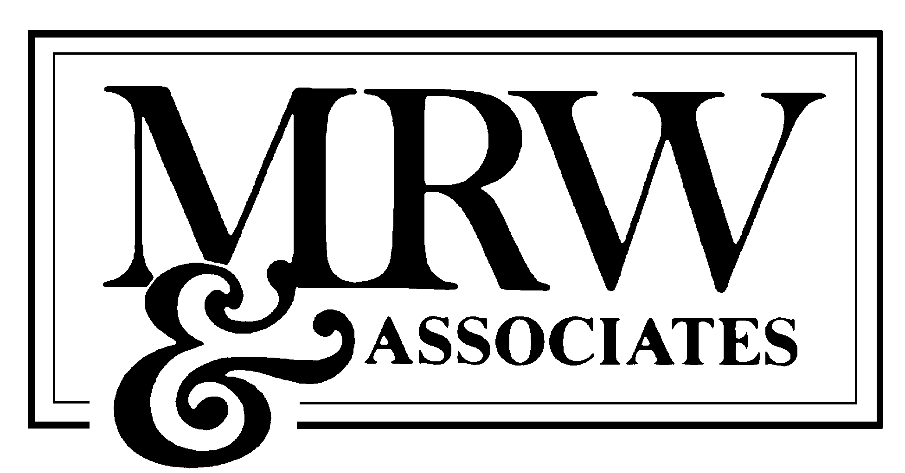

CONFIDENTIAL – LITIGATION WORK PRODUCT

via e-mail

September 28, 2025

Mona Petrochko
Enron Corp.
101 California Street, Suite 1950
San Francisco, CA 94111

Dear Mona:

As we discussed, this letter contains MRW & Associates, Inc.’s (MRW’s) Scope of Work to prepare an update of our estimate of the value of the PG&E hydro system to reflect current power market conditions and also potentially to submit testimony regarding the valuation of Pacific Gas & Electric’s (PG&E’s) hydroelectric assets, which will be allowed in accordance with Administrative Law Judge (ALJ) Hale’s October 16 ruling in the on-going proceeding regarding PG&E’s request to auction its hydroelectric assets (A. 99-09-053). Please feel free to call if you have any questions regarding the scope or the budget, both of which are discussed below.

Scope of Work

In its recently submitted application (A.99-09-052), PG&E proposed to auction off its hydroelectric assets. Parties submitted direct and rebuttal testimony and hearings were held addressing this testimony. ALJ Hale found, however, that the record was insufficient to allow the Commission to market value the assets by December 31, 2001 and, thus, requested that parties submit additional testimony limited to the issue of alternative methods of valuation. Supplemental testimony was filed on June 8 and rebuttal testimony was filed on June 23. MRW filed testimony on behalf of Enron based upon an adaptation of the approach used by Southern California Edison (SCE) to value its hydro system, while TURN filed testimony based on a more comprehensive financial analysis but, given its support to retention of these assets by PG&E with a sharing of benefits between ratepayers and shareholders, generally took a more conservative approach. PG&E attacked MRW analysis based on alleged inaccuracies and over-simplifications in the SCE methodology.

. To this end, MRW proposes to assist Enron by preparing a memo, and potentially testimony and possibly rebuttal testimony in this proceeding. MRW will develop an updated valuation using either the TURN model or potentially a revised version of the Edison approach, which will reflect updated assumptions, , including:

- Estimating the net present value of the future revenue stream based upon current projections of the future value of power and ancillary services;

- Estimating the impact of any mitigation measures contained in the DEIR;

O Estimating the potential impacts of enhanced leverage, optionality, and/or securatization of these assets.

As part of this effort, MRW will review any information provided by PG&E in this proceeding concerning the operation of the Helms Pumped Storage project and its value in the ancillary service markets over the past year.

Budget

MRW will provide budgets for the development of the initial memo and also for potential direct testimony. Given the nature of the regulatory proceeding at this time there is too much uncertainty concerning a budget for responding to data requests, preparing rebuttal testimony, assistance in the development of cross-examination and the brief, or any assistance in the overall lobbying efforts in this proceeding. Rather than provide a budget for these potential activities, MRW will bill Enron on a time and materials basis for this potential third phase. We estimate that the development of the assessment memo will be about $12,000 and that preparation of the direct testimony would require an additional $15,000 budget. This would include preparation of the testimony to be submitted on December 5, reviewing testimony of other parties, cross-examination preparation, and sponsoring the testimony, and some of the scheduled lobbying activities (see table below). This budget, however, would not cover the development of rebuttal testimony, responding to data responses, or preparation of cross-examination questions. We propose to bill you on a time and materials basis with an overall cap for the testimony, testimony preparation, and for sponsoring the testimony. Any additional work would be provided on a time and materials basis. These estimates do not include expenses, which typically is another 10%.

Task | Time | Budget
Preparation of Nov. 21 assessment | 2.0 person weeks @$150 | 12,000
Preparation of Dec. 5 Testimony | 1.5 person weeks @$150 | $9,,000
Reviewing Testimony of Other Parties | 0.2 person weeks @$150 | $1,200
Preparing Rebuttal Testimony |  | Time and materials
Preparing Responses to Data Requests |  | Time and materials
Preparing for Testimony | 0.2 person weeks @ $275 | $2,200
Sponsoring Testimony (estimate) | 0.2 person weeks @ $366 | $2,900
Preparation of Cross-Examination, Briefs, and Lobbying Efforts |  | Time and materials
Total |  | $27,300

If you have any questions, please feel free to call me.

Best regards,

Bob Weisenmiller

