---------From Executive Director: Regulation and Compliance

To: ALL MEMBERS

Ref: 01/286 : A286

Date: 16 July 2001

Subject: disciplinary action: enron metals limited

- Pursuant to regulation 11 of part 2 of the LME rules and regulations, disciplinary proceedings have been instituted against Enron Metals Limited (“EML”), formerly known as Metallgesellschaft Limited, on the grounds that it had committed a breach of regulation 9.6(b) of part 2 of the LME rules and regulations in that, between August 1999 and February 2001, EML failed to organise and control its internal affairs in a responsible manner.

- Subsequent to the institution of proceedings, EML submitted an offer of settlement to the LME in which it admitted the charge and agreed to pay a fine of £190,000.

- In accordance with regulation 11.39 of part 2 of the LME rules and regulations, and taking into account the seriousness of the breach and the fact that EML had co-operated throughout the disciplinary process, the Enforcement Committee agreed to ratify the settlement agreement between the LME and EML.

Background

- Between August 1999 and February 2001, EML persistently failed to ensure that warrants needed to settle its Exchange Contracts were delivered to the London Clearing House by 11.00am.

- Members are under a strict obligation to deliver on time warrants to settle Exchange Contracts because the effectiveness and efficiency of the LME delivery mechanism depends on the LCH being able to collect and allocate all warrants due on each prompt date. The delivery mechanism is vital to the smooth operation of, and confidence in, the LME’s markets. By persistently failing to make delivery on time and failing to take swift action to remedy underlying problems, EML jeopardised confidence in the LME delivery mechanism. This was considered a serious matter by the Enforcement Committee which concluded that EML’s systems and procedures for ensuring compliance with the LME rules and regulations had been seriously inadequate.

- Between May 2000 and February 2001, EML persistently failed to input trades into the Matching System in accordance with LME requirements. Errors were repeatedly brought to the attention of EML. Despite reassurances that training and controls would be enhanced to ensure future compliance, EML continued to make inputting errors.

- In relation to both the late deliveries of warrants and the inputting errors, EML frequently provided explanations which were either inadequate to explain the particular incident or inadequate to explain the persistence of that type of incident.

8 The LME recognises that since EML became part of the Enron group, greater resources have been devoted to improving systems and procedures. EML has also sought to reassure the LME that it is committed to compliance with the LME rules and regulations.

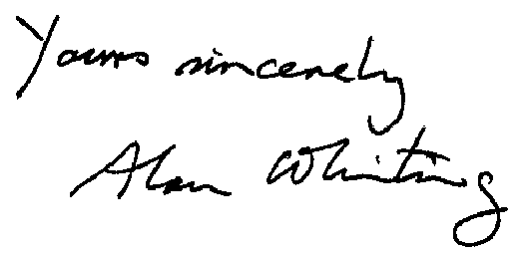

A WHITING

cc: Board directors

