Enron Credit Strategic Plan

Table of Contents

Executive Summary 4
Highlights 4
Introduction 4
1. What is Enron Credit? 4
2. What is the business plan? 4
3. What are the products planned? 4
4. Current status: what we currently trade, how we price. 5
5. What new models we need to achieve goals. 5
6. What attempts are being made internally and what external commercial sources are available. 6
SWOT Analysis 7
Strengths 7
Weakness 7
Opportunities 7
Threats 7
Pricing Approach 8
1. A diagram illustrating how various models are tied together for the overall objective of coming up with final CDS and DBS pricing. 8
2. Brief description of each model shown in the diagram. 8
Public Firm versus Private Firm 10
1. What we have as first cut for modeling primarily public firms. 10
2. Our understanding on public versus private firms’ credit risk characteristics, data availability and possible modeling approaches. 10
3. Our proposed approach/plan towards development of private firm model, including comparative analysis, model development, etc.. 10
Portfolio Level Business Feasibility Analysis 11
Accounting Breakeven Analysis 11
Portfolio Theory 11
Sections needed to be removed 12
I. Generalized Framework for Credit Portfolio Modeling 13
Figure 1. 14
I. A. Conditional Default Rates and Probability Distribution of Default Rate 15
Figure 2. 15
I. B. Conditional Distribution of Portfolio Default Rate 16
I. C. Aggregation 16
Figure 3. 16
Alternative (Short term) Measures 17
KMV’ Private Firm Model 17
Moody’s RiskCalc Model for Private Firms 17
Comparison of KMV vs Moody’s Private Firm model – see notes 17
Future Strategy 17
Development of private firm pricing models (short- and long- tenor models 17
Completion of Parent/Subsidiary Model (Parsons, 4/10/01) 17
Risk Management Model for ECT Business 17
References 19

Executive Summary
This document contains a strategic plan for the development of Enron Credit’s portfolio of pricing models, risk management models and IT infrastructure necessary to execute on this strategy. By focusing on model development and business development, Enron Credit’s near term goal is to generate gross sales of $30m and profit of $15m.

In the first section we give an introduction to Enron Credit. Section II provides a discussion of the Enron Credit pricing engine. Section III presents a discussion of public firm versus private firm models. In the fourth section we present a Feasibility Analysis for Enron Credit’s Portfolio Level Business. Section V describes alternative models. Section VI presents a discussion of our future strategy for our pricing engine.

Highlights
May use a graphical or schematic presentation for the highlight section……….

Work on this with Bryan, Markus, Scott and Ben.

Introduction

1. What is Enron Credit?
Currently,

2. What is the business plan?
Some of the introductory material in this strategic plan were extracted from the following two Enron Credit documents – (Johnson, 2000) and (Bottomley, 2001).

3. What are the products planned?
The Enron Credit trading desk currently trades two types of credit derivatives – Credit Default Swaps (CDS) and Digital Bankruptcy Swaps (DBS). These swaps essentially consist of the payment of a periodic premium (spread) by the buyer, in return for a lump-sum payment upon the trigger of a predefined credit event. The credit events are typically bond default and/or bankruptcy of a reference entity.

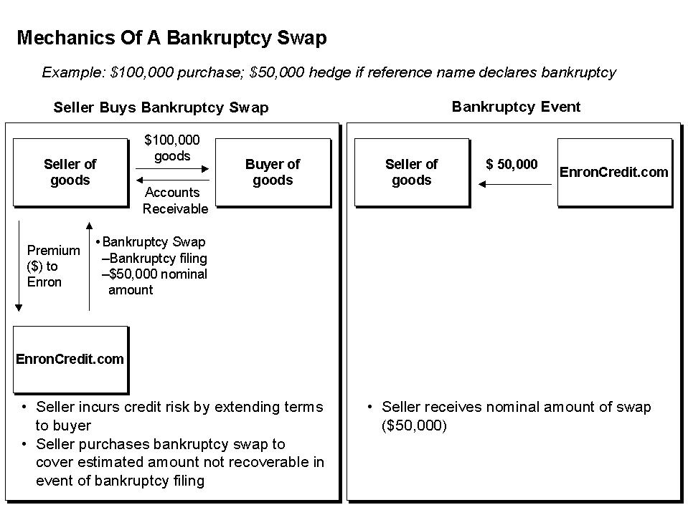

In The Case of A Bankruptcy Event
Bankruptcy is public, and therefore, a relatively simple incident to verify. When a reference entity declares bankruptcy, Enron Credit will wait the requisite amount of time (60 days in most jurisdictions) to ensure that the filing is not declared frivolous by the courts and rescinded and then will pay the swap buyer (usually, the seller of some good or service) a sum of money equal to the notional amount of the swap.

4. Current status: what we currently trade, how we price.

5. What new models we need to achieve goals.
There are several different categories of credit risk portfolio models that may be used to assist us in further development of the Enron Credit pricing engine:

- Merton’s options theoretic approach
- Econometric/Statistical approach
- Actuarial approach.
- Hybrid approach (combination of 1st and 2nd approaches).

Thus far, Enron Credit has developed (public firm) models of the hybrid form.

6. What attempts are being made internally and what external commercial sources are available.

SWOT Analysis

Strengths  - Enron has proven ability to commoditize previously opaque markets  - Enron also has a proven ability to develop and make markets in new businesses  - We have the risk appetite, balance sheet and expertise to provide two way pricing and will be willing to execute on either side of a transaction in order to make markets and to develop a more diversified book  - Enron has developed a great deal of credit assessment expertise and industry knowledge as a result of our existing businesses  - Enron has first class structuring and risk management skills  - Enron has a proven ability to create and grow new businesses as evidenced by the success of the Power business, Coal business, Paper and Pulp, Weather Derivatives, EnronOnline™, Bandwith Trading, etc.  - Enron is developing a strong name as a major e-commerce player due to the success of EnronOnline™ | Weakness  An issue to overcome is that it will be easy to originate low quality credit risk, but difficult to syndicate it; conversely, it will be easy to syndicate high quality credit risk, yet difficult to originate it  - The set up costs for adding reference credits is very high  - The ability to distribute credit risk in different stages of the business cycle is unclear  - The market makes digital credit decisions, yet Enron Credit would like to alter the way corporations manage counterparty credit. It is possible that the market is unwilling to modify its approach to thinking about and mitigating credit risk  - Enron has little commercial credit expertise, although we have brought in several industry professionals from investment banks Enron has few natural information advantages  - Enron has no market credibility in credit rating or scoring  - Currently EnronCredit.com™ is originating risk in industries with which Enron has a great deal of expertise, but we need a diverse portfolio to decrease risk in Enron’s portfolio in order to attract more syndication interest  - Enron is BBB+ rated which might pose a problem in our efforts to originate higher quality credit
Opportunities  - Adequate credit management products do not currently exist  - There is no transparency in the market and transactions are difficult to complete  - Current credit protection products are overpriced relative to the real risk  - Incumbents are reluctant to cannibalize existing businesses and margins  - The increase in B2B activity will increase the number of companies interacting with unknown counterparties and will also increase the concentration risk between known counterparties | Threats  - Alternative risk products are better known to the market  - Banks pose a significant competitive threat particularly since many are making strong e-commerce forays. Many also have better reputations in the credit derivative market and larger, more established credit derivative business infrastructure

Pricing Approach

See email from Scott Salmon on 4/25/01. It has an attachment entitled “Enron Credit Model Pursuits as of 25 Apr 01.”

1. A diagram illustrating how various models are tied together for the overall objective of coming up with final CDS and DBS pricing.
Work on the diagram with Scott & Ben when I get to London.

2. Brief description of each model shown in the diagram.
The EnronCredit pricing engine currently consists of the following pricing models for public firms:

- Asset Swap Model (Parsons, 4/20/01) An output of the EnronCredit pricing engine is an asset swap price for a corporate bond. This model uses live “good” bond feeds to price and move most liquid names. Version I is in use by the majority of the trading desk The asset swap price represents the spread above LIBOR received when the cashflows of the bond are swapped into floating cashflows indexed to a LIBOR rate, in local or foreign currency. In addition, a portfolio of an asset swap and an interest rate swap replicates the cashflows on a CDS. Thus the asset swap spread should be a close proxy for the CDS prices.

- The Fair Market Curves (FMC) model – This model uses Bloomberg's Fair Market Curves, asset swap prices and market CDS quotes to build generic Credit Default Swap (CDS) price curves for each rating, country and industry. London is attempting for the “easiest” sectors this week (Autos, Telco, Banks). Key constraints: data mining and selecting enough quality bonds to create useful FMCs to move a sector/region intersection of companies, e.g., U.S. autos, Japanese banks.

- The Regression Placement Model (RPM) - This model takes the rating of a new new name and statistically estimates a CDS price and uses this price to place the name on the nearest FMC curve. The RPM uses a form of multiple linear regression with dummified input variables to predict a 5-year CDS price, a 95% CI for the prediction, and a confidence score. By splitting the input space into ranges and then dummifying these ranges it's easy to see the relative effects of the variables and to verify that the relationships make intuitive sense.

The initial version of the RPM was designed alongside the FMC & Movement Model to facilitate bankruptcy swap pricing of 10,000 names on the EnronCredit website by 1 Jan 2001. A test was performed on the model for the accuracy across subsidiary and non-subsidiary companies. The main disadvantage of the RPM is that the # of dummy variables grows exponentially as the degree of non-linearity increases.

- The Neural Network Placement Model (NNPM) – This model also takes the rating of a new name, statistically estimates a CDS price and uses this price to place the name on the nearest FMC curve. The NNPM uses backpropagation feedforward 3-layer neural network (NN) to statistically estimate a 5-year CDS price for each name.

The NNPM algorithm consists of 2 phases – forward pass and backward pass. In the forward pass, an input vector propagates through the network layer by layer, and a set of outputs is applied as the actual response of the network. During this pass, all the weights of the network are fixed. During the backward pass the weights of the network are adjusted according with an error correction rule. The actual response of the network is subtracted from a target response to produce an error signal. This signal is then propagated backward through the network against the direction of synaptic connections. The synaptic weights are then adjusted so as to make the actual response of the network move closer to the desired response (Haykin, 1994).

The initial version of NNPM has been designed alongside the RPM, the FMC model and the MM. The RPM and the NNPM are complementary to each other and each model is targeting different price regimes. To predict CDS prices for new names, 3 different NN models are applied. These models compete for different CDS price regimes and are complementary to each other. The NNPM model has not be “trader tested.”

- Sector Models – These models are to be developed based on hypothesized unique characteristics of a sector; FMC Dynamic results. The model developer is currently analyzing the 10,000+ data set and getting trader input on most profitable efforts. The first effort is likely to be banks/financials due to number of companies/unique traits. Later there may be a possible extension to countries down the road.

- Parent-Sub Models – This model may be used to price parent and subsidiary individually and then adjusts bps gap for key factors. It will be the “go to” model for many of the GCP and origination names. Version I of this model will be used to price UK power CPs along with Moody’s RiskCalc Private Model to individually price the private firms. The current focus is to modify the models to account for the effect of being a “municipal” to cover the Nordic CPs. A longer term goal will be to link major parents to numerous subsidiaries and move whole groups of names by managing the parent.

- Private Firm Model – This model will be used to price private firms globally – for short and long tenor. The short term goals are to evaluate sample data sets, purchase calibration datasets, negotiate a contract for ongoing live data feeds.

- Alerts System Phase II – Phase II will provide alerts to traders based on live information feeds and, in certain cases, automatically “manage” a Reference Entity (RE) by pulling it from FIRM or INDIC status until trader(s) can assess.

- The Movement Model (MM) - This model tracks news, announcements and price information for all the names, alerts traders when a significant event occurs, and offers a suggested price change given such an alert. The MM consists of 2 level. (Level 1) There is an alerts system. Each time a predetermined event occurs an alert is posted on the trader's screen displaying the nature of the alert and the company it's affecting. (Level 2) An NN model will be applied to propose a CDS price movement to the trader based on the alert. The inputs to the MM will be high frequency, i.e., daily, monthly, quarterly) financial & macro economic time-series data. The intuition of the MM is to model the immediate impact of financial & economic information on the CDS price.

- Live LIBOR Bootstrapping Model (Parsons, 4/20/01(b) This document outlines the methodology employed by ECC to generate a live LIBOR (London Interbank Offered Rate) curve which represents the costs of borrowing in the interbank market, and thus is considered the riskfree discount rate. The live LIBOR curve is used as a base curve for many credit derivative pricing models, primarily the Asset Swap, Bond and FMC models. To model the credit risk in securities such as corporate bonds, as quantified by a credit spread, an estimate of this riskfree curve is required. The LIBOR is generated from cash, future & swap instruments actively traded in the money markets. A bootstrapping algorithm strips the coupons from these instruments, converts them all to a common basis & compounding frequency, & generates a zero curve. The curve is equivalent to the rate of interest on a ZCB issued by a riskless equity.

Public Firm versus Private Firm

1. What we have as first cut for modeling primarily public firms.
See above lists.

2. Our understanding on public versus private firms’ credit risk characteristics, data availability and possible modeling approaches.
FMC & AS Swap model not used for private firm model.

3. Our proposed approach/plan towards development of private firm model, including comparative analysis, model development, etc..
Gant Chart

Portfolio Level Business Feasibility Analysis
A description of our proposed approach towards building a portfolio model to analyze business feasibility and minimum required pricing, driven by overall cost including overhead expenses as well as portfolio level payout based on correlation of defaults or events: Need to brainstorm more on this with Vasant, Tanya and Vince on this.

Accounting Breakeven Analysis

BEP = FixedCost*{(SalePrice/Unit) – (VariableCost/Unit)}⁻¹

Portfolio Theory
Brainstormed with Chonawee on 4/27 (Refer to handwritten notes).

The risk of the credit derivatives in a portfolio can be broken down into two parts (Brealey, 1996):
- The unique risk that is peculiar to that particular derivative.
- The market risk that is associated with market wide variations.

The unique risk may be eliminated by holding a well diversified portfolio, but the market risk cannot be eliminated. All the risk of a fully diversified portfolio is market risk.

The derivative’s contribution to the risk of a fully diversified portfolio depends on its sensitivity to market changes. Markowitz (1952) drew attention to the practice of portfolio diversification and showed that the standard deviation of portfolio returns can be reduced by choosing securities that do not move together.

Markowitz also went on to work out the principles of portfolio construction. The goal is to increase expected return and to reduce standard deviation. Markowitz referred to such portfolios as efficient portfolios. Essentially we want to deploy a limited amount of capital to give the highest expected return for a given standard deviation. We may utilize quadratic programming to estimate the expected return and standard deviation for each security, as well as the correlation between each pair of securities, then we can use a standard quadratic program to calculate the set of efficient portfolios.

We also need to mention how we are thinking of using KMV EDF such as
- Input to regression/Neural network model
- Outright probability of default
- Use to segment the population.

With regard to RiskCalc, we need to mention Judgement Model as this is a valuable approach in some situations.

Sections needed to be removed
- Generalized Framework for Credit Portfolio Modeling
- Figure 1.
- Conditional Default Rates and Probability Distribution of Default Rate
- Figure 2.
- Conditional Distribution of Portfolio Default Rate
- Do not refer to internal documents as in section “The Fair Market Curves (FMC) model”
- Move the “Movement model” section to the end (Future work).
- From “Reference” section remove internal references.

I. Generalized Framework for Credit Portfolio Modeling
The generalized credit portfolio model consists of three main components to calculate the portfolio loss distribution [Koyluoglu, 1998]:

- Joint-default behavior – Default rates vary over time, intuitively as a result of varying economic conditions; when conditions are favorable, fewer borrowers default, and vice versa. A conditional default rate is generated for each borrower in each “state of the world” for the relevant economic conditions. The degree of “concentration” or “correlation” in the portfolio is reflected by the extent to which the borrowers’ conditional default rates vary together in different “states of the world.”
- Conditional distribution of portfolio default rate – for each “state of the world” and its corresponding set of borrowers’ conditional default rates, the conditional distribution of a homogeneous sub-portfolio default rate can be calculated as if individual borrower defaults are independent, as all of the joint-default behavior has been accounted for in generating conditional default rates.
- Convolution/Aggregation – the unconditional distribution of portfolio defaults is obtained by aggregating homogeneous sub-portfolio’s conditional distribution of default rate in each “state of the world”, and then by simply averaging across the conditional distributions of portfolio defaults for different states of the world, weighted by the probability of a given state.

This generalized framework is schematically represented in Figure I. It should allow for a structured comparison of the models.

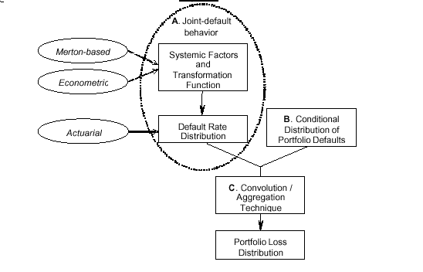Figure 1.

I. A. Conditional Default Rates and Probability Distribution of Default Rate
The above models explicitly or implicitly relate default rates to variables describing the relevant economic conditions (“systemic factors”). This relationship can be expressed as a transformation function, the “conditional default rate” function (see Figure 2).
- Since the Merton model neither assigns the transformation function, nor assumes a probability distribution for default rates explicitly, these relationships must be derived.
- The conditional default rate function is explicitly assigned in the econometric model.
- This function can be derived in closed form for actuarial models.

The systemic factors are random, and are usually assumed to be normally distributed. Since the conditional default rate is a function of these systemic factors, the default rate will also be random. The default rate distribution is an explicit assumption in the actuarial model, and an implicit assumption in the Merton-based and econometric models. The relationship between the systemic factor distribution and the default rate distribution is represented graphically in Figure 2.

The above models are related as described to normally distributed systemic factors, but the normal distribution is not a critical assumption. The default rate distributions for the Merton-based and econometric models, and the implied conditional default rate function in the actuarial model, can easily be calculated for an arbitrary systemic factor distribution. While non-normality may affect the results of model comparisons, it does not in principle render them incomparable.

Figure 2.

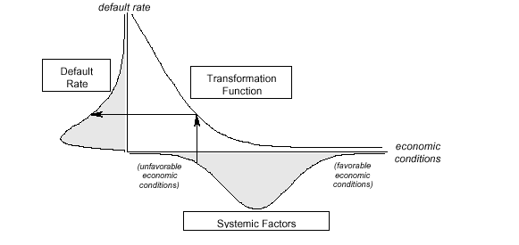

I. B. Conditional Distribution of Portfolio Default Rate
Under the condition that all loans are independent, given fixed or conditional default rates, a homogenous sub-portfolio’s distribution of defaults follows the Binomial distribution B(k;n,p), which provides the probability that k defaults will occur in a portfolio of n borrowers given that each has probability of default p.

I. C. Aggregation
The unconditional probability distribution of portfolio defaults is obtained by aggregating the conditional distributions of portfolio defaults under all possible “states of the world” for relevant economic conditions. This is simply calculated by averaging across the conditional distributions of portfolio default for different “states of the world”, weighted by the probability of a given state, as depicted in Figure 3.

Figure 3.

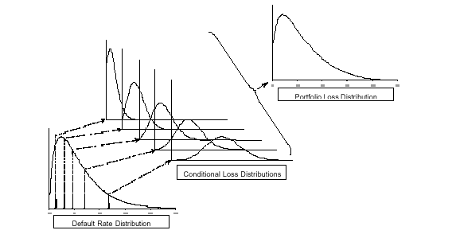

Alternative (Short term) Measures

KMV’ Private Firm Model
The idea of applying option theory to the valuation of risky loans and bonds has been in the literature at least as far back as Merton (1974). Merton (1974) noted that when a bank makes a loan its payoff is isomorphic to writing a put option on the assets of the borrowing firm. Since 1989 the KMV Corporation of San Francisco has extended Merton's ideas in several directions including the generation of a default prediction model which produces (and updates monthly) default predictions for all major companies and banks that have their equity publicly traded.

KMV has also developed a private firm model - which allows users to calculate Expected Default Frequency (EDF) credit measures by entering financial information for non-financial firms without traded equity. KMV's private firm model combines forward looking market price data with company-specific financial statement data to produce an assessment of default risk for a private firm.

Moody’s RiskCalc Model for Private Firms
RiskCalc analyzes financial statement data to produce probabilities of defaults (PDs) for corporate obligors - especially in the middle market (private firms with assets greater than $100,000; about 2 million firms in the US). RiskCalc derives from Moody's proprietary middle market private firm financial statement & default database - Credit Research Database (CRD). This database comprises 28,104 companies and 1,604 defaults. RiskCalc generates 1- and 5- year expected default frequencies.

The RiskCalc private firm model is not intended for finance, insurance & real estate industries. It is a regression model which requires 17 inputs from a company’s financial statement. Financial statement data availability is very limited for private firms (probably available for 10% of the names). This is problematic because Moody's model is solely dependent on financial statement data. This seems to indicate that RiskCalc should be a potential short term solution for ECC - not a longterm solution.

Comparison of KMV vs Moody’s Private Firm model – see notes

Future Strategy

Development of private firm pricing models (short- and long- tenor models

Completion of Parent/Subsidiary Model (Parsons, 4/10/01)

Risk Management Model for ECT Business

Ben’s comments: make your final doc give a good summary of what we've accomplished so far, and where we are going in the future. This would be of use to not just Duffie, but the entire Enron Credit team, especially origination. However this info is definitely not in any of the docs, but is under constant evolution through discussions between quants, traders and IT over here, so will require a trip to London sooner rather than later I feel.

References

Bottomley, John (1/01) “Enron Credit Business Plan,” Enron Credit Document.

Brealey, Richard and Stewart Myers (1996), “Principles of Corporate Finance,” McGraw Hill.

Haykin, S. (1999), “Neural Networks: A Comprehensive Foundation,” Macmillan.

Johnson, Gillian, (6/30/00) “Strategic Vision and Business Plan: Current Living Edition,” Enron Credit Document.

Kouluoglu, H. Ugur and Andrew Hickman (1998), “A Generalized Framework for Credit Risk Portfolio Models,” Risk.

Markowitz, Harry, “Portfolio Selection,” Journal of Finance, 7:77-91 (March, 1952).

Merton, Robert C. (1974), “On the Pricing of Corporate Debt: The Risk Structure of Interest Rates,” Journal of Finance, 29, 449-470.

