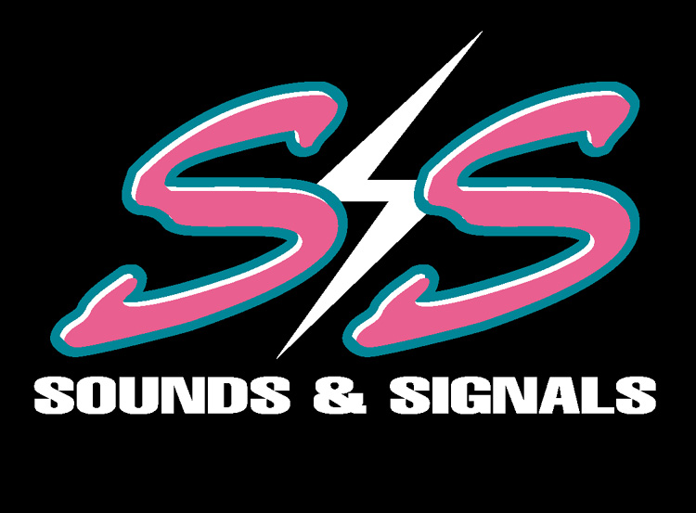

247 EAST NASA ROAD 1, WEBSTER TEXAS 77598

TEL; 281.332.1555 FAX 281.332.0705 E-MAIL SOUNDSANDSIGNALS@EXCITE.COM

Mr. Ken Lay
Chairman Of The Board
Enron Corporation
Houston Texas, 77002
(713) 853-6773

Dear Mr. Lay,

This is a follow-up letter to the original letter that I wrote to you yesterday. I am writing you this letter to update you and to make a correction of facts as I understood them. First and foremost the letter I wrote to you and the subsequent phone calls were because our company has worked hard to stay on top for 25 years. We give generously to our community and we strive to stay the best. When we give our commitment to a cause we complete that commitment.

The biggest problem is that we felt that the retraction of the right to use the logo was absolutely unfair. I had sought that permission through the proper channels and I was upset that it was retracted for no apparent reason. Therefore I reacted in haste. The truth is that I did so out of desperation as we had achieved a high profile event and suddenly it was being pulled out from under us and I felt urgency to try and stop it.

I first will say that I in no way meant to damage the image of any person or company. I simply wrote my feelings along with the facts. I have since spoken to many people and I have learned that Ms. Siegle is not Mr. Koenig’s secretary. I have also learned that the reason Mr. Koenig ordered the removal of the logo was because he puts forth quite an effort for The Sunshine Kids himself and for Enron and that he had no knowledge of our efforts.. I knew that Mr. Koenig is a board member for TSK and that he as well as your company gave tremendously to this fine organization.

That is why I was so shocked at the sudden refusal of the use of your logo. I had in fact gone through a lot of effort to achieve the right to use it in our events. I had many months ago tried to contact him to gain your company’s support. I also tried to get in touch with other people in your company to gain support. I will apologize for my words in haste. I must also correct one misleading statement in my letter yesterday, I in no way meant to imply that I was threatening your company through the media, in fact what I meant was that I was contacting the station to let them know not to attend the event because of the change in your company’s support.

The rest of that statement was that it implied that your company did not give generously to TSK’s and for that I deeply apologize. That was never meant to be the suggestion, Words in haste are a mistake and I made a tremendous one by not allowing myself time to think more clearly. I would never suggest that your company was not anything but a fine giving and caring company that does give all of itself to many great charities and causes.

The apparent cause of this entire chain of events is because of miscommunications. I know that I went through the proper channels to gain approval. I also know that I have many thousands of dollars invested in this weekend. I also have the support of many fine organizations and companies such as yours. I am also deeply involved in making sure that we reach our goal of raising as much money as possible for The Sunshine Kids.

That is why I felt so injured by the phone call that I received. That is not an excuse for typing words in haste but it is the truth. I will apologize to you directly Mr. Lay for not choosing my words more carefully. I will also state that these words never went beyond the people listed in this letter. I know that you are a fine man that gives with all his heart to your company, its employees and to the community.

I am embarrassed in whole by this situation but I am a man that will admit a mistake. I will never understand the reason for the retraction as I feel that we went through proper channels. If that be the final decision then so be it. I will also never understand the way the retraction was handled. A cell phone call two days before the event is not a proper way to handle this. Many companies are involved in this week’s event for the same reason, The Sunshine Kids. Not for profit, but in fact only to help deserving children.

I thank you for your understanding and your valuable time. I hope that you accept this explanation as it is heart felt.

Thank you,

J. Marshall Hosea
Director of Operations
Sounds & Signals Inc

CC: Mr. Jeff Skilling - President & CEO. Enron Corp
Mr. Mark Koenig - EVP Investor Relations
Mrs. Rhoda Tomasco – Founder & Director, The Sunshine Kids
Mr. Bob Allen - Channel 13 KTRK
Mr. Brian Bailey – Manager of Operations Pepsi Bottling Group, Texas
Mr. Tom Watson – President First Community Bank

