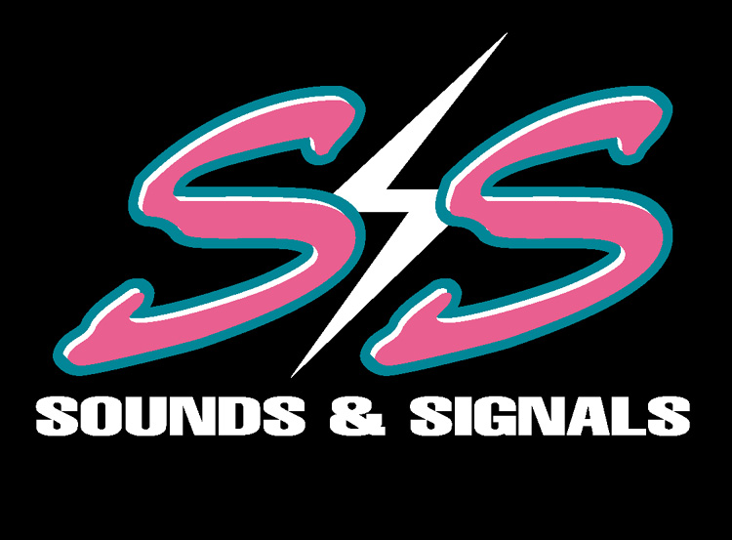

247 EAST NASA ROAD 1, WEBSTER TEXAS 77598

TEL; 281.332.1555 FAX 281.332.0705 E-MAIL SOUNDSANDSIGNALS@EXCITE.COM

Mr. Ken Lay
Chairman Of The Board
Enron Corporation
Houston Texas, 77002
(713) 853-6773

Dear Mr. Lay,

Thank you for your company’s interests in helping our company to provide social relief to our community. I know that you are a busy person who has many corporate concerns on his mind. I am in the same position and I definitely relate to that situation.

I can also understand your interest in corporate image and responsibilities. As our company has been concerned in the same aspects for 25 years in the Houston area. This is the reason that I write you at this time, as I know how hard that you have strived to build and retain your image and how much harder you have worked to build your corporate image through the years. I have worked as hard and the only reason I have survived this long in business is because of my word and my image.

After 25 years we at Sounds & Signals have tried hard to convince our customers and our general public that we are who and what we say. No matter what, we stand by our word. It is this simple view of integrity that we feel has made us successful thus far. I believe the same of your fine organization. I now must tell you the down side of this communication.

I lost my mother and my friend to cancer, as well as a niece and a nephew. I tried many times to find avenues to help them through the grief and expense, to no avail. After these tragic events my partner and I decided to respond in a gratuitous manner by dedicating as much funds as possible to help any cancer dedicated organization as we could afford. We studied hard and long and found that the Sunshine Kids spent a lot of time and effort to help our general cause.

It then became our goal to purchase a 2001 PT Cruiser and customize it, then raffle it off. We would carry the financial burden of the car and effort and give our benefactor the proceeds. We started by trying to attract ticket sales through local events, and then we discovered our error. Most people are skeptical! We then tried to gain local help through smaller companies but again to no avail. We then started to attract national companies to indulge this ideal and that started the ball to rolling.

After 136 events and $60,000 dollars to promote this effort we finally felt that we had found our path. My wife, Robin Hosea, had been working for your company for over 3 months and we had spent much effort to bring in help for your companies charitable events. No request for money, just name recognition is all that we asked. We finally found the right people at your company to help. We dedicated our employees to your art car involvement, as well as making several offers of involvement to help to your company in its charity drives.

It was only after our assistance to Ms. Charla Reese, from your 1400 Smith Street office that we finally found help. We requested no funds; we just wanted name recognition to help us in our ticket sales. We felt that we had the world by the hand, as Ms. Reese was a wonderful lady that provided a great service to the art car parade. She then tried her best to get us approved for your logo on our car. My wife Robin was also trying to help us.

After the art car festival your company decided that we would be a reasonable effort without risk and approved your logos to be added. This would be done without expense to your company. We then ordered 36 embroidered shirts to reflect this agreement as well as aprons for our cook-off teams, as well as our fliers and tablecloths. The thought was that we would both benefit from this publicity. I then received a phone call from Pepsi Bottling group and they promised to send out their 65-foot Game boy rig to the upcoming Strawberry Festival. We also received offers of help from Cavenders and Matrix Services as well as reduced prices from Compass Signs. We have spent weeks and thousands of dollars to prepare for this event. The goal is to sell as many tickets as possible to benefit the Sunshine Kids.

Then I received written permission to print the logo of Enron and a mad rush was on to get this done in time. Then yesterday I get a call from Mr. Mark Koenig’s secretary, that informed me that since your company did not benefit directly from this event, and that your company had its own agenda with the Sunshine Kids, I was told that your company had no interest and that we should remove all emblems from this vehicle, tents and paperwork that we had spent many thousands of dollars on; I came unglued.

I had received backing from Kroger, Pepsi Bottling Group, Matrix Services, KTRK 13, KLOL, KLDE, as well as Compass Signs and First Community Bank. I then became upset that any major company would give me written permission and then retract it for no explained reason. I also found that, in fact, Enron does not give money but only support service to this national organization. I called Bob Allen and Marvin Zindler of Channel 13 and advised them of this situation. They suggested that Mr. Koenig was not from your Community Relations Division and therefore had no right to change your company’s decision. They asked me to write this letter advising you of this set of circumstances. They feel that you are a man of your word and will not allow a mistake of this magnitude to happen.

I tend to agree that a person, who strives to make his company the top ranked company in the world, is also a man of his word and he will not allow his company to face this type of negative publicity. I am hoping that we are all correct, because the negativity helps no one. I will be available for any questions that you might have. My cell number is 281.924.0113.

Thank you,

J. Marshall Hosea
Director of Operations
Sounds & Signals Inc

CC: Mr. Jeff Skilling - President & CEO. Enron Corp
Mr. Mark Koenig - EVP Investor Relations
Mrs. Rhoda Tomasco – Founder & Director, The Sunshine Kids
Mr. Bob Allen - Channel 13 KTRK
Mr. Brian Bailey – Manager of Operations Pepsi Bottling Group, Texas
Mr. Tom Watson – President First Community Bank

