Enron End – User Training

Creating a Requirement

Version 1

Introduction

Contingent Staffing Solutions (CSS) have been selected by Enron to provide the people, processes and technology to supply the organization’s contingent resources (temporaries) and manage their suppliers.

This guide has been developed by Contingent Staffing Solutions for distribution to Enron Managers (and designated representatives) who have responsibility for the ordering and selection of temporaries.

If you have any questions about this guide, you can contact CSS on 713 345 6899.

Log in to the Global Resource Interchange (GRI)

Overview

This procedure details how to enter GRI, the web – enabled application provided by CSS to help your organization request and manage their contingent workforce (temporary employees and contractors).

Procedure Detail

- Launch Internet Explorer from your desktop.

- Enter the URL: gri.itiliti.com.

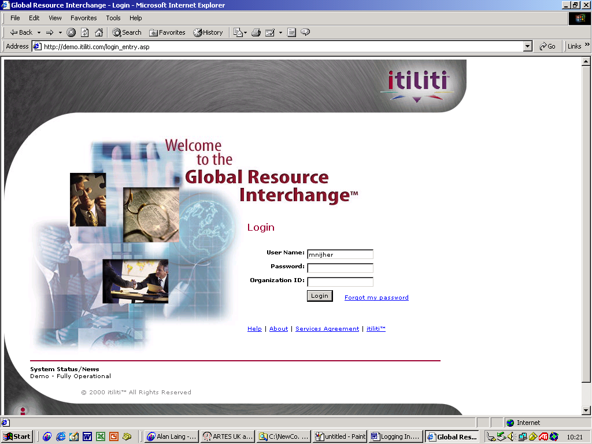
This is the GRI login page.

- Enter your User Name
- Enter your Password
- Enter your Organization ID
- Click on <Login>.

 Your User Name is your first and last name entered with no spaces between. E.g. - JohnDoe
Your initial Password is your first initial and your last name entered with no spaces between. E.g. - JDoe
The Organization ID for Enron is 2160.

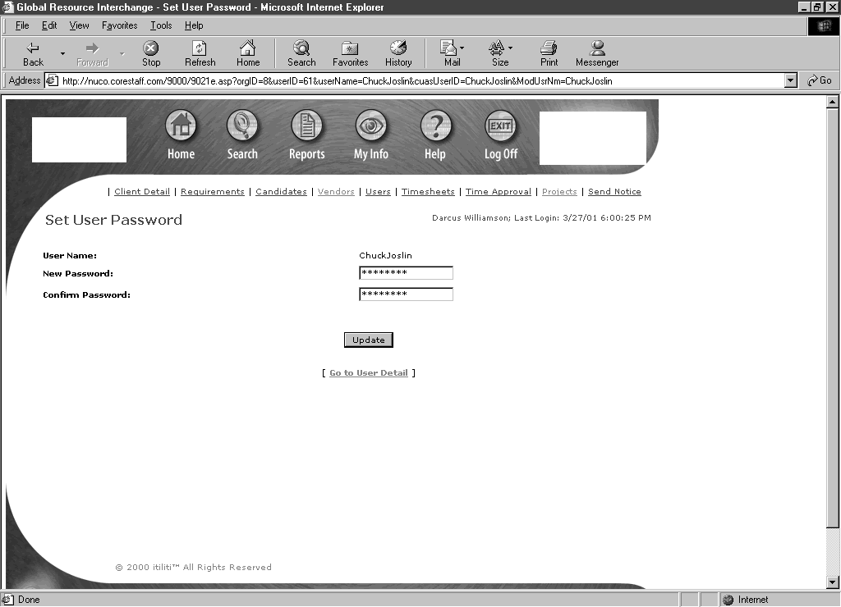
If this is the first time you have logged in, you will be asked to change your Password.

- Enter your New Password
- Confirm this Password
- Click on <Update>.

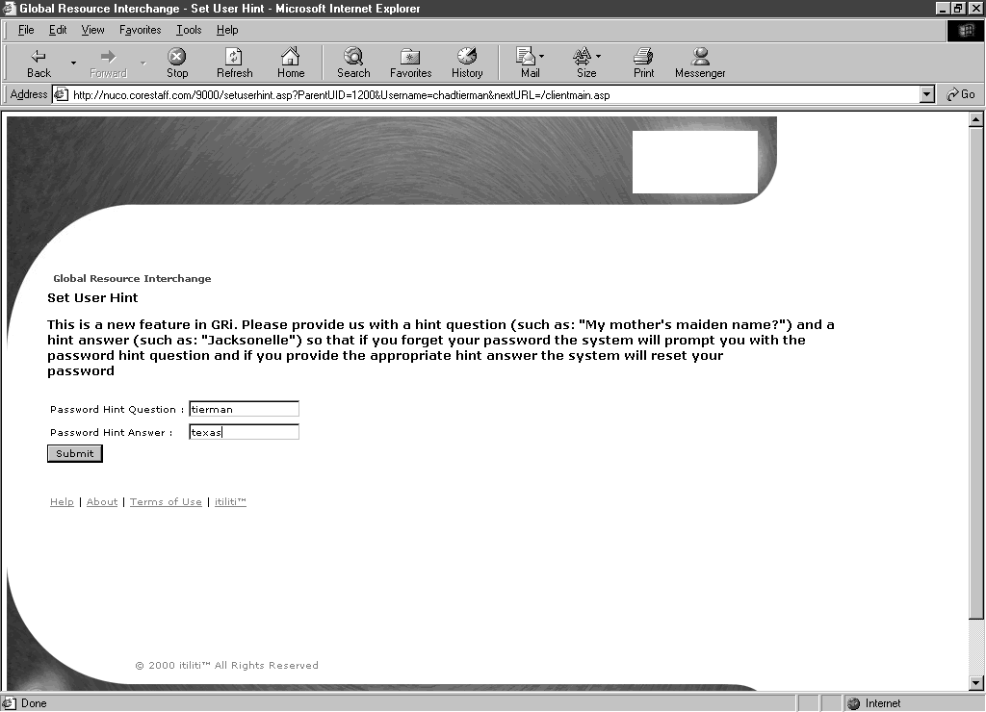
If this is the first time you have logged in you will also be asked to provide a Password Hint Question and Answer – this will be used if you forget your password.

- Enter your Password Hint Question
- Enter the Answer
- Click on <Submit>.

This completes the process for logging in to GRI (and changing your password if you are a new user).

Next Steps

Once you have logged in to the web - enabled application, you may create a Requirement.

Creating a Requirement

Overview

This procedure details how to create a Requirement (Order) for (a) temporary worker(s) and submit it to the CSS team to review and fill.

‘Call Backs’

If you would like to ‘call back’ a particular individual who has worked for you before, contact CSS so that they may contact the relevant Staffing Partner and check the availability of the individual.

‘ASAPs’

If you need a temporary as soon as possible, contact CSS to organize this for you.

Procedure Detail
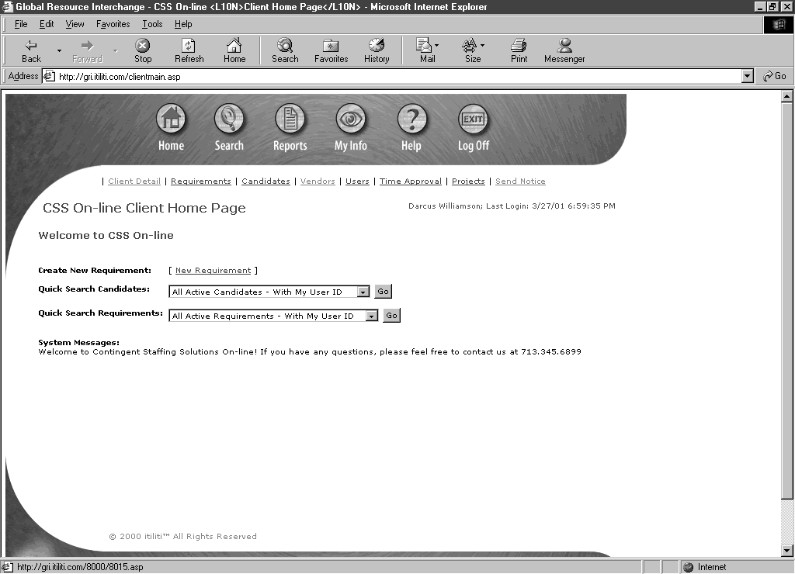
Once you have logged in to GRI, you will be taken to the Client Home Page.

- Click on New Requirement.

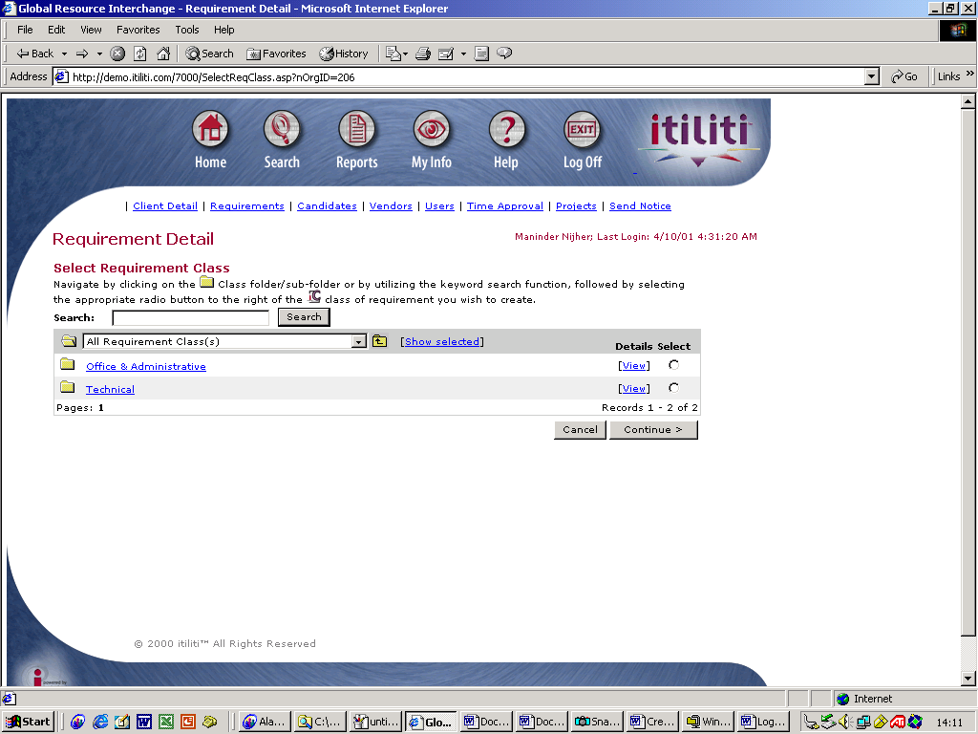
You will be taken to a Requirement Detail page to select the skill set (high level Requirement Class) - e.g. Office and Administration, Technical, Legal etc. of the resource that you require.

- Click on the underlined text of skill set that you require.

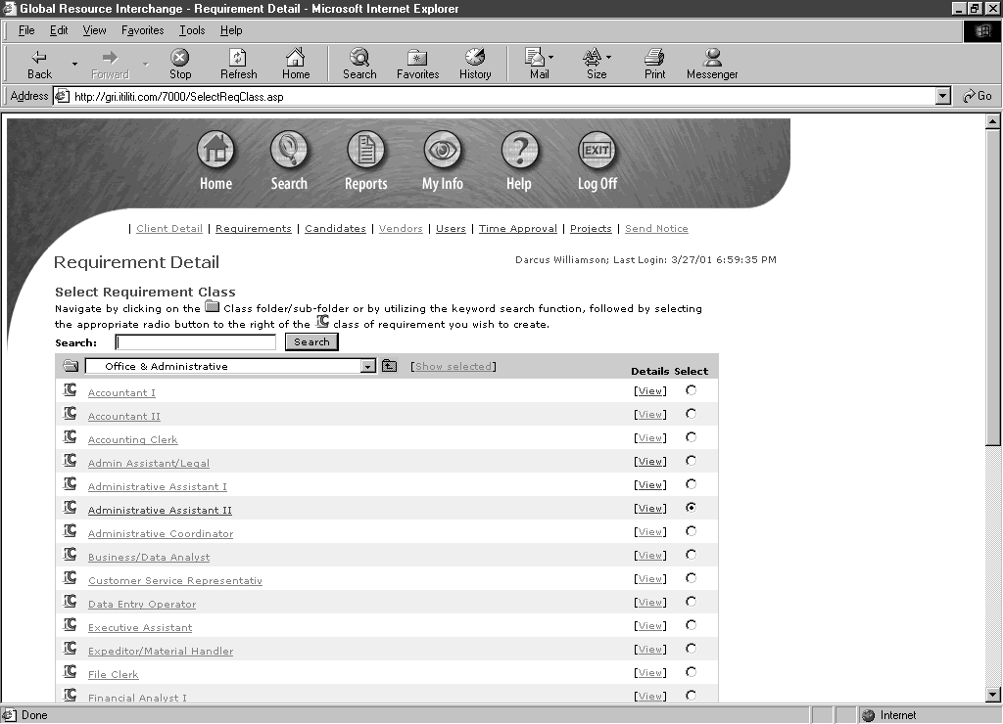

There are a number of lower level Requirement Classes associated with each skill set (high level Requirement Class).

- Select the radio button next to class of Requirement that you wish to create
- Click on <Continue>.

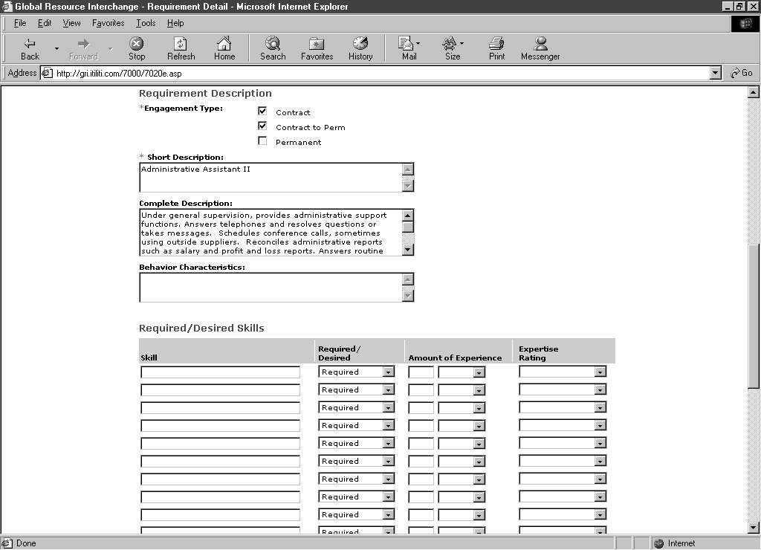
The Requirement Detail page will expand to an online requisition for the Requirement Class you have selected. This is pre-populated with a Requirement Description that has been agreed by your organization.

- Scroll down to view the Requirement Description – Complete Description to ensure that it meets your requirements
- If this description does not match what you need, scroll up and click on Change Requirement Class. This takes you back to allow you to make another selection.

You will be taken back to the selection of skill sets (high level Requirement Classes)
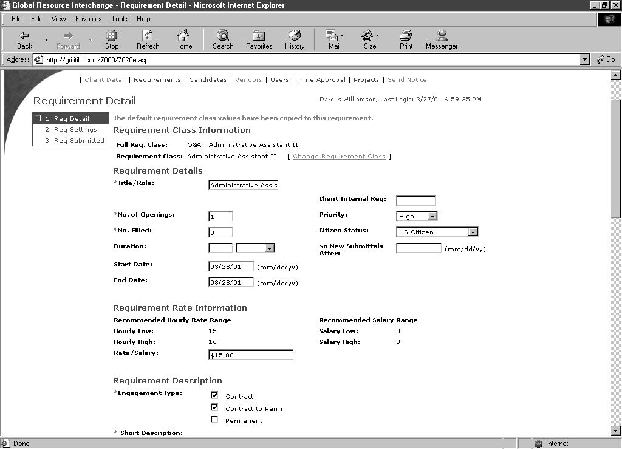
Once you are happy you have found the most suitable Requirement Class, complete the online requisition.

- Enter the No. of Openings for this Requirement. This is the number of people that you require for this requirement- the default value is 1
- Enter the Duration of the Requirement. Click on the drop down menu for Days, Weeks or Months
- Enter the Start Date of the Assignment
- Enter the End Date – this is the last day of the Assignment
- Select the Engagement Type. Only the Contract or Contract to Perm engagement types may apply.
The Start Date and the End Date must be entered for the Requirement to be processed. If you have not yet finalised the End Date, this may be extended / shortened at a later date.
The Requirement Rate Information section is not used for Orders for Office and Administration temporaries. CSS have pre-agreed rates for each Office and Administration Requirement Class with the Staffing Partners, which your organization has agreed to.
Optional - you may add more text to the Complete Description.
Optional - you may enter Behaviour Characteristics.
Optional - you may complete the Required/ Desirable Skills section. An example is Lotus Notes experience.

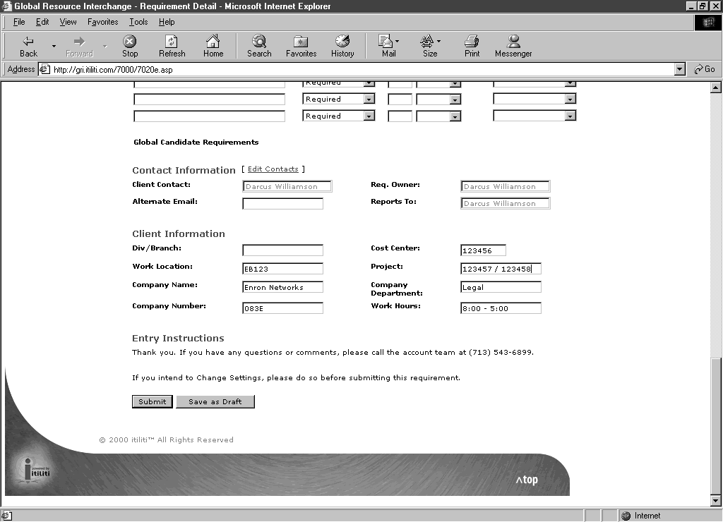
Scroll down to the Contact Information section. It is very important to complete this correctly.

- Click on Edit Contacts to alter the contact names.

Client Contact: individual that will be the primary Time Approver for the temporary worker (the ‘Associate’).
Req. Owner: individual that is creating the Requirement (you).
Reports To: individual to whom the temporary worker (the ‘Associate’) will report during the Assignment.
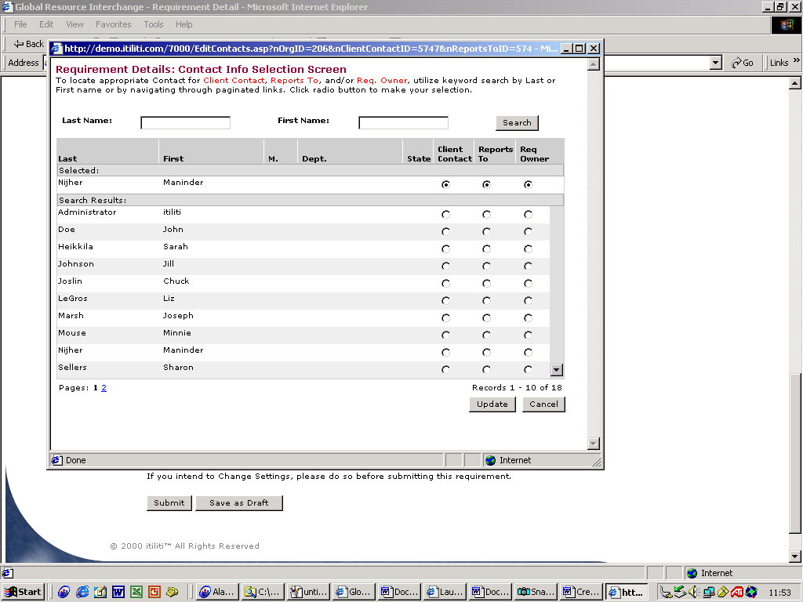
The three Contacts above may all be the same person.

When you have clicked on Edit Contacts, this pop -up window will appear. The window lists the people in your organization that have been set up as GRI users.

- Use the Client Contact, Reports To and Req. Owner radio buttons to select the individual(s) who will take these roles
- Click on <Update>.

Contact CSS if the individual that you wish to take one of the 3 roles is not listed.
You will be taken back to the online requisition to complete the final section – Client Information.

- Enter the Work Location. This is the room to which the selected Associate will work /report
- Enter your Company Name
- Enter the Company Number
- Enter the Cost Center Number. This is the number to which the cost of the Associate will be allocated
- If the Associate is going to work under more than one Cost Center, enter the additional Cost Center(s) in the Project field, separating each cost center with a ‘/’
- Enter the Company Department in which the Associate will work.
- Enter the Work Hours. This should be entered as the start and end time, e.g. 8am – 5pm.
- Click on <Submit>.

You may be taken to a Requirements Justification page. Enter the reason for your Requirement (e.g. holiday cover) and click on <Submit>.
At any point during the completion of this online requisition, you may <Save as Draft> to be able to go back and complete and submit at a later time.
Clicking the <Submit> button will complete this Requirement and sent it to CSS. You will be taken back to the Requirement Detail page and you may now Log Off the application.

Next Steps

An email with a hyperlink to this Requirement has been sent to the CSS office within your organization. They will check the details of your Requirement and distribute to the program staffing partners who will then submit their most suitable, available candidates. CSS will receive details of the candidates and will either:

- Screen and select the Associate to be engaged on your behalf. You will receive an email with a link to the details of the Candidate that has been engaged
- Screen, and allow you to undertake the selection and engagement of the most suitable candidate (see Review and Engage Candidates procedure). You will need to inform CSS if you would like to do this selection and engagement

TOP TIP - Copy Requirement functionality

This functionality helps you to save time and most suitable when you regularly place orders for particular Requirement Classes (e.g. Administration Assistants).
It allows you to reuse Requirements that you have already submitted, as long as your new Requirement has the same criteria (except the Start and End Dates), rather than creating a new requirement each time.

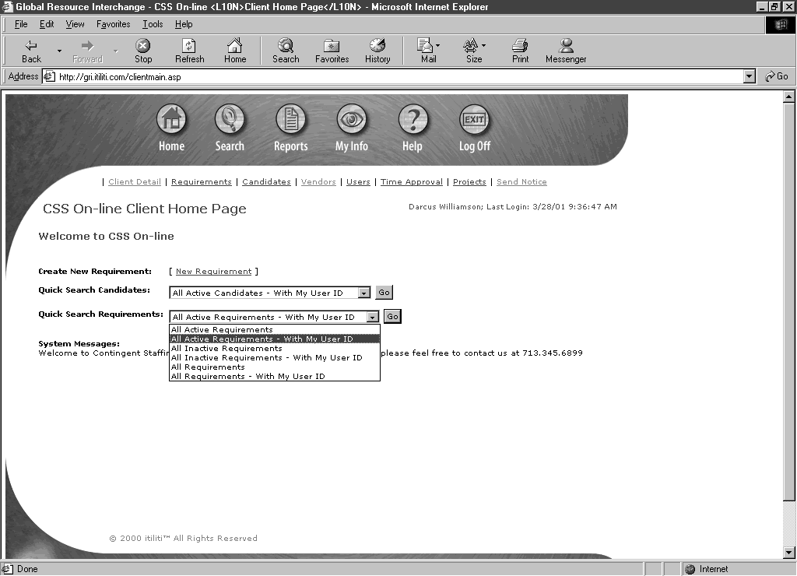
Once you have logged on to the application.

- Click on the drop down box next to Quick Search Requirements
- Select All Requirements with my User ID.

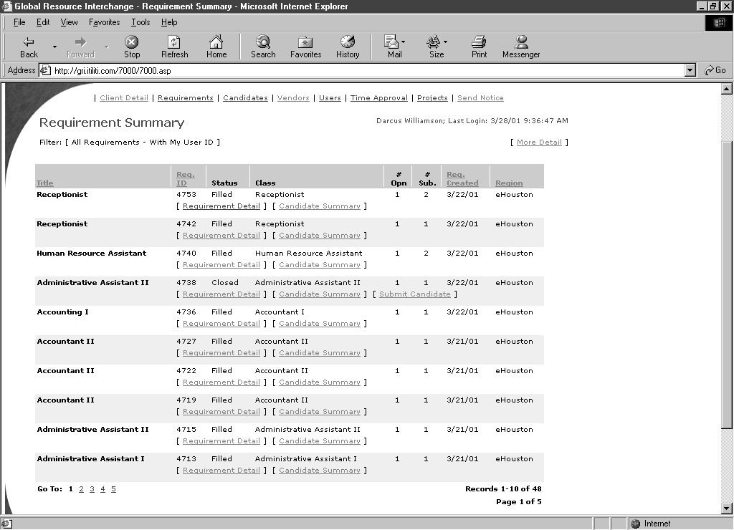

You will see a Summary of all the Requirements that you have raised.

- Look through the titles of the Requirements that you have raised
- When you have selected the title of the requirement that you would like to copy, click on its Requirement Detail.

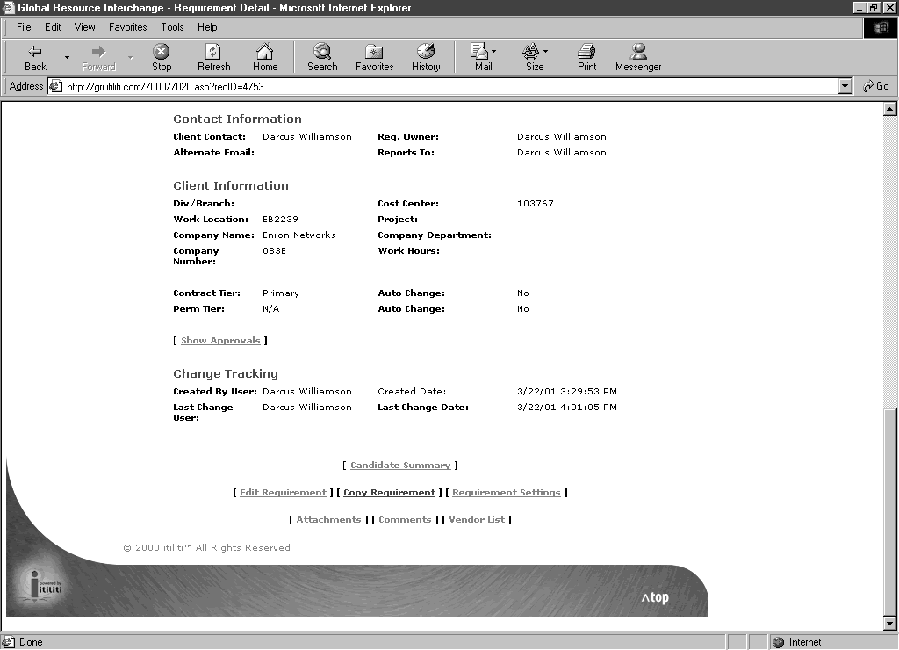
- Scroll to the bottom of the Requirement
- Click on Copy Requirement.

This will create a copy of the Requirement.

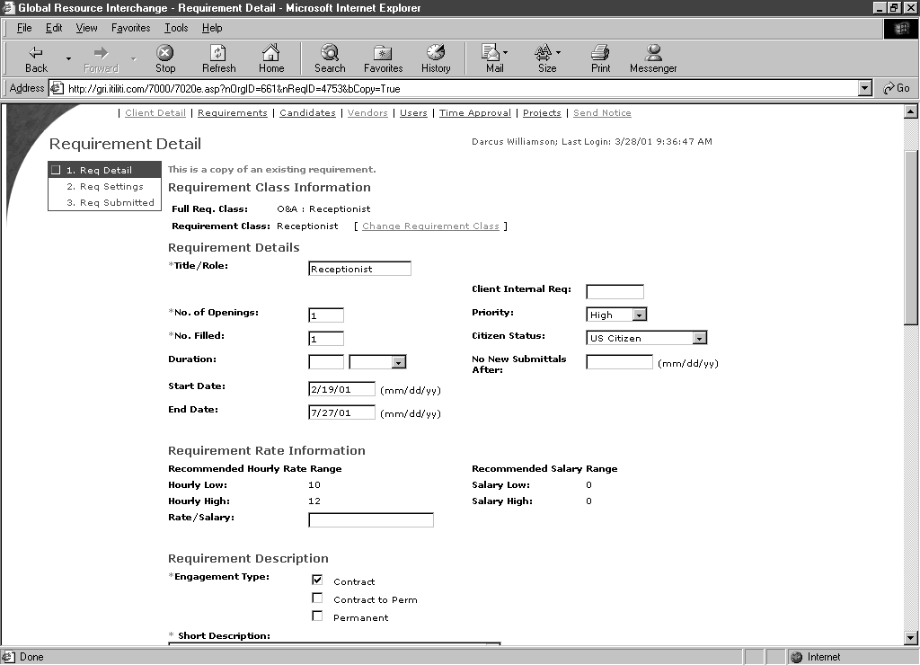
- Change the Start Date
- Change the End Date
You may also change other fields such as Client Contacts, Cost Centers etc.

- Click on <Submit> to submit this new Requirement.

You may be taken to a Requirements Justification page. Enter the reason for your Requirement (e.g. holiday cover) and click on <Submit>.
Clicking the <Submit> button will complete this Requirement and sent it to CSS. You will be taken back to the Requirement Detail page and you may now Log Off the application.

