Enron End – User Training

Approving Timesheets

Version 1

Introduction

Contingent Staffing Solutions (CSS) have been selected by Enron to provide the people, processes and technology to supply the organization’s contingent resources (temporaries) and manage their suppliers.

This guide has been developed by Contingent Staffing Solutions for distribution to Enron Managers (and designated representatives) who have responsibility for approving the time worked by temporaries:

If you have any questions about this guide, you can contact CSS on 713 345 6899.

Log in to the Global Resource Interchange (GRI)

Overview

This procedure details how to enter GRI, the web – enabled application provided by CSS to help your organization request and manage their contingent workforce (temporary employees and contractors).

Procedure Detail

- Launch Internet Explorer from your desktop.

- Enter the URL: gri.itiliti.com.


This is the GRI login page.

- Enter your User Name
- Enter your Password
- Enter your Organization ID
- Click on <Login>.

 Your User Name is your first and last name entered with no spaces between. E.g. - JohnDoe
Your initial Password is your first initial and your last name entered with no spaces between. E.g. - JDoe
The Organization ID for Enron is 2160.

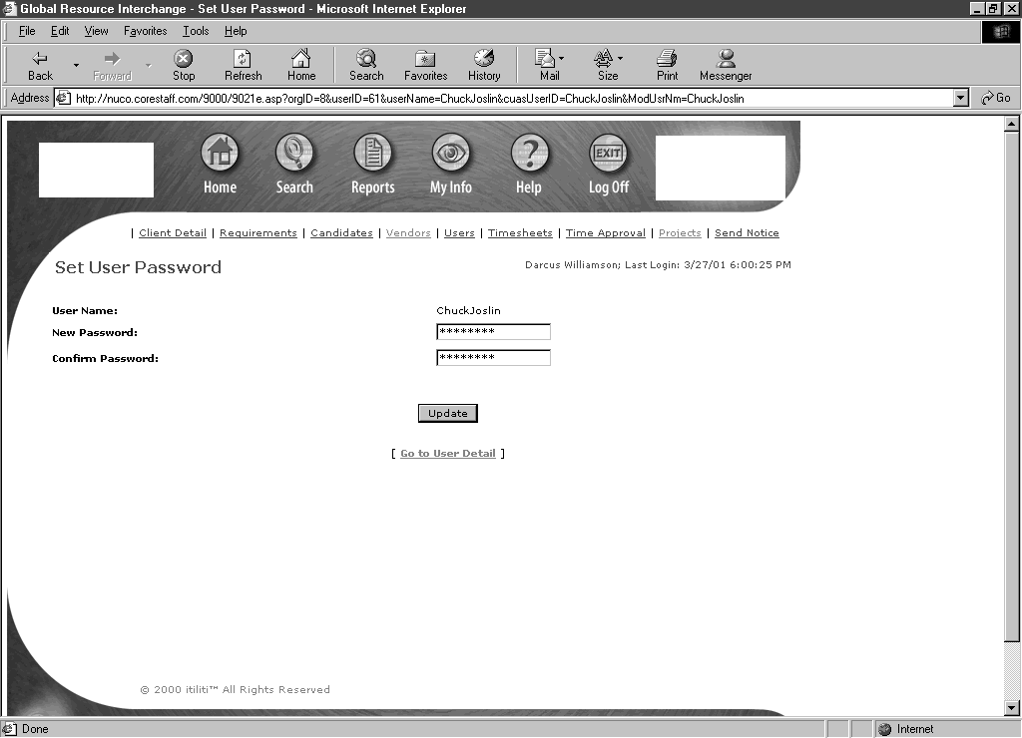
If this is the first time you have logged in, you will be asked to change your Password.

- Enter your New Password
- Confirm this Password
- Click on <Update>.

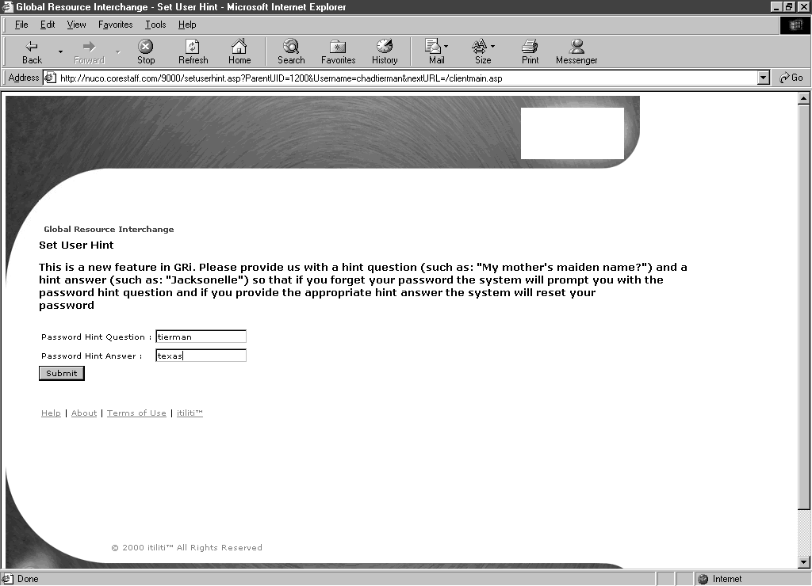
If this is the first time you have logged in you will also be asked to provide a Password Hint Question and Answer – this will be used if you forget your password.

- Enter your Password Hint Question
- Enter the Answer
- Click on <Submit>.

This completes the process for logging in to GRI (and changing your password if you are a new user).

Next Steps

Once you have logged in to the web - enabled application, you may approve timesheets online.

Approve Timesheets

Overview

This procedure details how to approve timesheets using GRI. You need to launch your Internet Explorer and log in to GRI. Timesheets must be submitted weekly and be approved by the cut off detailed at the end of this procedure.

Procedure Detail

- If you are the Time Approver for an Associate, you will receive an email when the Associate had submitted their timesheet for approval

- Click on the link in the email to be taken to the Submitted Timesheet page (you will be prompted to log in).

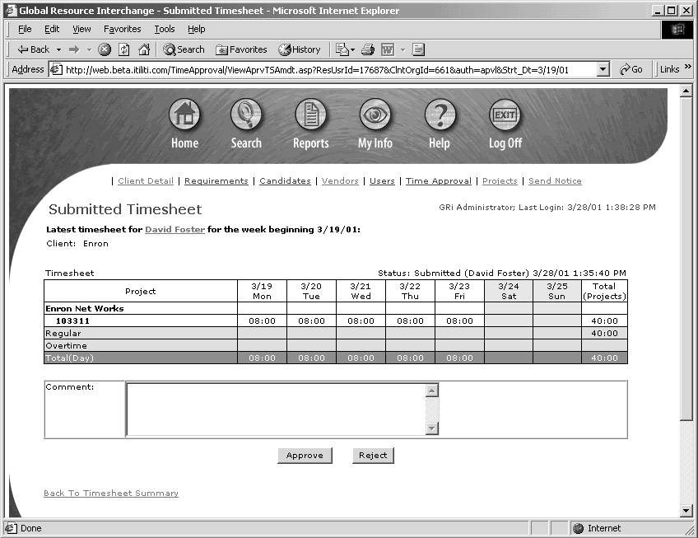
- View the details of the timesheet
- Click on <Approve> or <Reject>.

If you have chosen to reject the timesheet, you must enter Comments.

An email will be sent to the Associate (and staffing partner) advising them of your approval or rejection of the timesheet.

Approved Timesheets

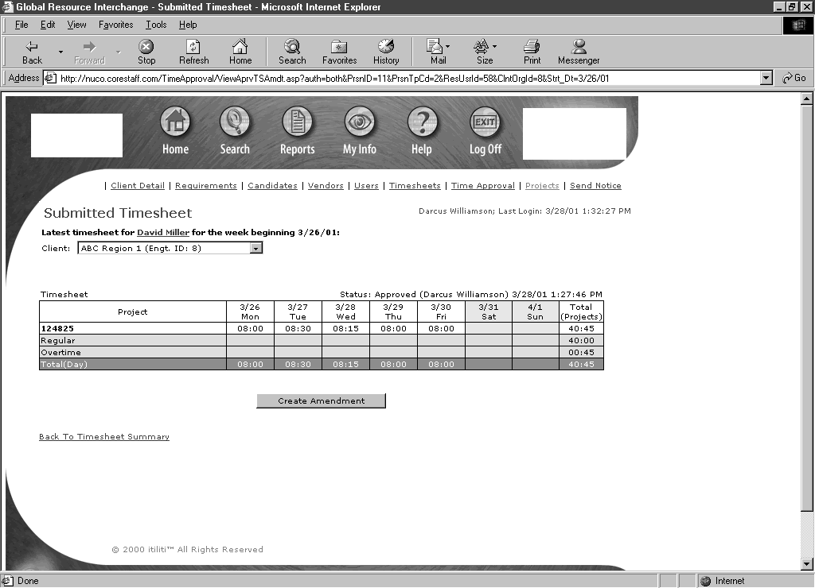
You will see Status: Approved on the approved timesheet.
If you are a Time Approver for other Associates you may click on Back to Timesheet Summary to view and approve other submitted timesheets.
Click on Log Off to exit application.

Rejected Timesheets
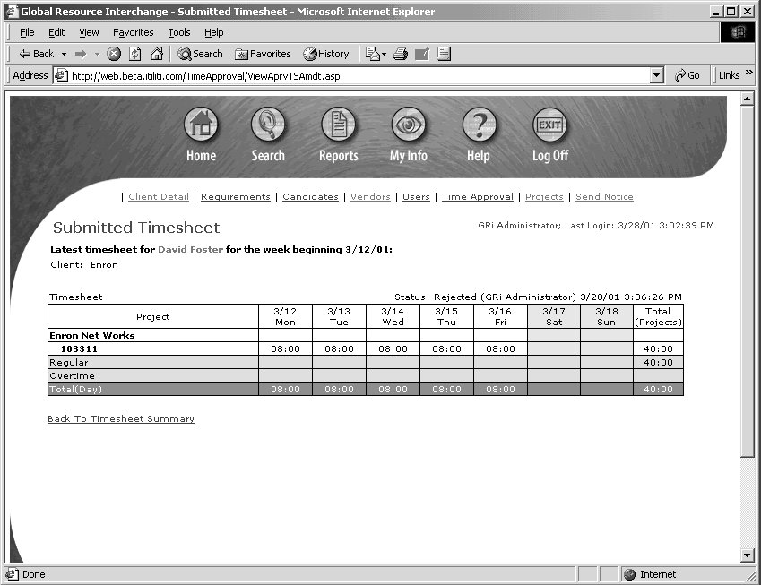
You will see Status: Rejected on the rejected timesheet.
If you are a Time Approver for other Associates you may click on Back to Timesheet Summary to view and approve other submitted timesheets.
Click on Log Off to exit the application.

Next Steps

- Approved timesheets will be used as input to billing processes and for payment of the Associate (by their Staffing Partner)

- The Associate, their Staffing Partner will receive notification if any of their timesheets have been rejected. The Associate will amend and resubmit their timesheet for you to view and approve

Timesheet Approval - Recommendations and Cut offs

- It is strongly recommended that continuing Associates submit their time every Monday by 10am

- The cut off for approval of timesheets is close of business every Monday. If the timesheet is not approved by this cut off, the Staffing Partner may not receive this revenue for the week and may not compensate the Associate

- It is strongly recommended that Time Approvers review timesheets as soon as they have been submitted so that any issues leading to rejected timesheets may be resolved and the resubmitted timesheet approved by the close of business Monday cut off.

