March 6, 2000

Dave Samuels
EnronOnLine.com
E-mail: Dave.Samuels@Enron.com

Dear Dave

Further our recent communications, I am pleased to enclose our proposal for the provision of weather graphics for open Internet carriage by EnronOnLine.com.

This contract will run for an initial period of one year from March 15, 2000 through March 14, 2001 , renewing automatically for a further year at the end of every year thereafter. It may be cancelled at any time, by either party, by giving 30 days written notice to the other party.

Information Services* Price
Selected energy graphics suite $200/month

Total price $200/month
*Please see the attached Schedule A for detailed product listings and descriptions.

The above fees will be invoiced monthly in advance, with payment due within 15 days.

Delivery of the products shall be via FTP push to EnronOnline.com’s server.

Strategic Weather Services’ WeatherMarkets.com division reserves the right to revise its pricing for these services by giving at least 30 days written notice prior to the anniversary of the start date of the contract.

If this proposal meets with your approval, please sign below and return a copy to me by fax at (610) 640-0147. I also enclose a copy of our standard Service Agreement.

At any time, additional information may be added to this agreement with the consent of both parties on an addendum listing the additions and payment terms. If you have any questions or would like to expand the services you would receive from us, please don’t hesitate to contact me at (610) 407-2954.

Yours sincerely Accepted and approved:
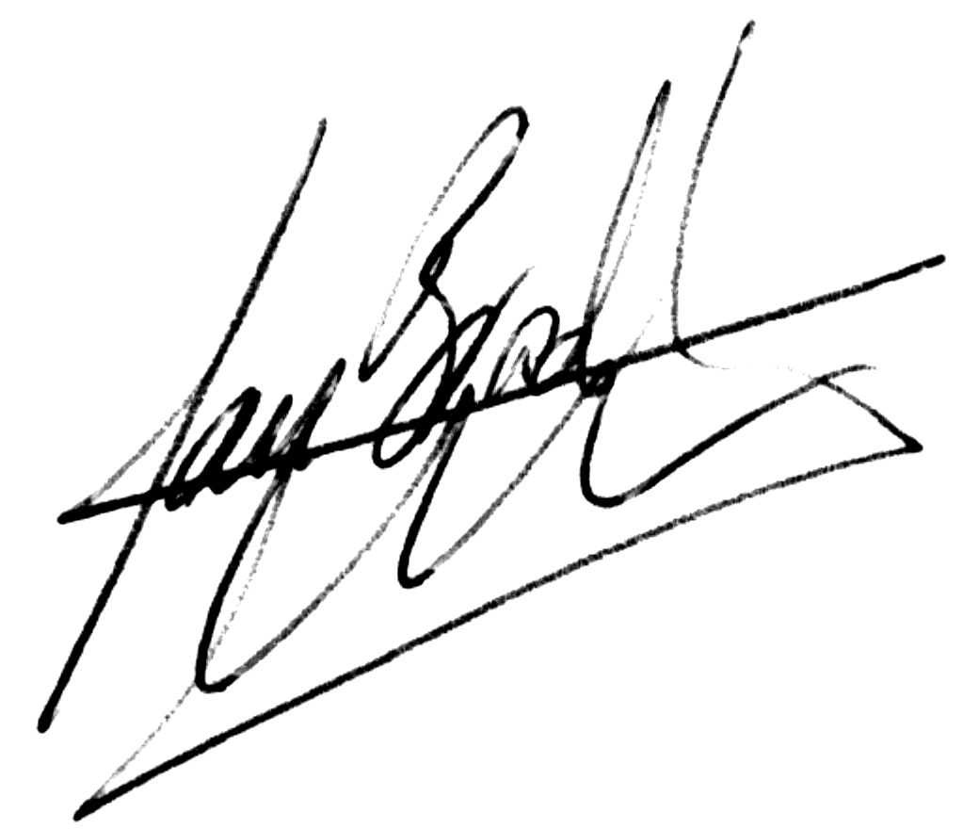
Ian Clarke Name:
Vice President Title:
WeatherMarkets.com For:
Schedule A

Product Listing for EnronOnLine.com

Internal Name Full Name Seasonal? Frequency Timing (Central)
000002a4.gif N_Amer_12_Hour_Surface_Fcst.gif N 2 x daily 0600, 1800
000003a4.gif N_Amer_Surface_Fcst_Day_2.gif N 1 x daily 0930
000016a1.gif N_Amer_3_5_Day_Temp_Precip.gif N Mon.-Fri. 1030
000106a1.gif Storm_Track_Priority_1_Atl.gif N daily as required 0500, 1100, 1700, 2300
000132a1.gif N_Amer_Current_Temps_Pipes.gif N hourly 30 mins past the hour
000341a1.gif N_Amer_Tmrow_9_9_HDD_NERC.gif N 1 x daily 0500
000345a1.gif N_Amer_Tmrow_9_9_CDD_NERC.gif N 1 x daily 0500
300002a1.gif Europe_NW_Afr_Surface_Fcst_Day2.gif N Mon.-Fri. 2000
300035a1.gif Europe_1-5_Day_Temp.gif N Mon.-Fri. 1200

STRATEGIC WEATHER SERVICES (SWS)

WeatherMarkets.com Division
1325 Morris Drive
Suite 201
Wayne, PA 19087-5521
USA

CUSTOMER SERVICE AGREEMENT

The terms below represent the general terms and conditions for the provision of weather forecasting and data services (”Service” and “Products”) to You, the Customer ("Customer"), by Strategic Weather Services ("SWS") and its WeatherMarkets.com division. Together with our Proposal document ("Proposal"), it will form the complete Client Service Agreement ("Agreement") between Customer and SWS. By signing the Proposal, Customer agrees to be bound by this Agreement as does SWS.

1. Services and Intellectual Property License
SWS shall perform weather forecasting and data services and shall provide the Customer with specified reports thereon as described in Proposal. It is understood that all weather information furnished in any format, whether verbally, hard copy or on magnetic media, et cetera, shall be delivered under a non-exclusive intellectual property license (trade secret, copyright, patent, et cetera) to Customer to use same for Customer's internal purposes, or for use by Customer's clients via Customer’s delivery system, as specified in Proposal. Customer is being granted hereby no ownership or other interest or right in or to such information and data except as specifically provided herein. Customer shall have no right to make copies of or to transfer such data and information to any third party, unless such right is specifically conferred by Proposal.

2. Payment
Customer shall pay for the services and for the intellectual property license in accordance with the payment schedules set forth in Proposal. If not otherwise prescribed herein, all payments shall be due in United States dollars at the offices of SWS within fifteen days of invoice. SWS shall be allowed to stop providing the services under Paragraph 1 above when an overdue payment exists. Moreover, overdue payments shall be subject to a late payment charge calculated at 1.5% per month during the period of delinquency. In the event such rate exceeds the maximum permissible by law, the rate shall be reduced to such maximum.

3. Intellectual Property Rights and Limited Use
The weather information and forecast data delivered to Customer in any format, and any copies thereof, in whole or in part, and all intellectual property rights (copyright, patent, trade secrets, et cetera) are and remain the valuable property of SWS. Customer shall exercise the highest degree of care to safeguard the confidentiality of same. Under no circumstances shall Customer deliver, assign, sub-license, or otherwise transfer any proprietary information to any third party or make any disclosure, or permit the disclosure, of any proprietary information delivered to Customer by SWS except to the extent expressly permitted by this Agreement. Where such activities are permitted, Customer's promotion, use and re-dissemination of the Products shall not violate or infringe any rights conferred upon third parties by SWS.

Nothing contained herein shall be construed as conferring by implication, estoppel or otherwise, any license or right under any intellectual property rights of SWS except as expressly provided in this Agreement. The obligations of Customer and its employees and agents with respect to the confidential information shall survive and continue after termination or expiration of this Agreement. Customer agrees that it will advise any of its agents, representatives or employees to whom any such information is revealed of the confidential nature of this information.

In the event of any breach of the terms of this paragraph or the Agreement with respect to the data and/or information, SWS shall be entitled to the issuance against Customer of a restraining order or injunction or other equitable relief as required to protect SWS intellectual property rights.

4. Exclusion of Express and Implied Warranties
IT IS THE BELIEF OF SWS THAT THE WEATHER FORECASTING SYSTEM UTILIZED BY SWS IS FAR AND AWAY THE MOST RELIABLE, PROVEN AND TESTED SYSTEM IN EXISTENCE TODAY. HOWEVER, THE SCIENCE OF WEATHER FORECASTING, AND PARTICULARLY LONG-RANGE WEATHER FORECASTING, REMAINS AN INEXACT ONE. THEREFORE, SWS MAKES NO WARRANTY WHATSOEVER THAT ANY PARTICULAR WEATHER FORECAST IS CORRECT. SWS WILL NOT BE RESPONSIBLE FOR ANY DAMAGES WHATSOEVER INCURRED BY CUSTOMER DUE TO ANY RELIANCE PLACED BY CUSTOMER UPON WEATHER FORECASTS FURNISHED HEREUNDER. EXCEPT AS SPECIFICALLY PROVIDED IN THIS AGREEMENT, SWS MAKES NO WARRANTIES, EITHER EXPRESS OR IMPLIED, AS TO ANY MATTER WHATSOEVER, AND ANY AND ALL WARRANTIES OF MERCHANTABILITY AND FITNESS FOR A PARTICULAR PURPOSE ARE EXPRESSLY DISCLAIMED AND EXCLUDED. IN NO EVENT SHALL SWS BE LIABLE FOR INCIDENTAL OR CONSEQUENTIAL DAMAGES OF ANY NATURE WHATSOEVER CAUSED OR ALLEGED TO BE CAUSED DIRECTLY OR INDIRECTLY BY SWS INCLUDING, WITHOUT LIMITATION, INTERRUPTION OF SERVICE, LOSS OF USE, LOSS OF PROFITS OR OTHER COMMERCIAL LOSS. IF AND TO THE EXTENT THE FOREGOING LIMITATION OF LIABILITY IS PROHIBITED UNDER ANY PARTICULAR STATE'S LAW, SWS'S LIABILITY FOR DAMAGES IN NO EVENT SHALL EXCEED THE SPECIFIC PAYMENTS MADE TO SWS FOR THE PARTICULAR SERVICES CLAIMED TO BE RESPONSIBLE FOR ANY ALLEGED LOSS.

- Subscription/License Renewal
Unless notice of termination is forwarded by either party to the other giving at least sixty (60) days notice prior to the expiration of the term set forth in the Proposal, then this Agreement shall extend for an additional period of one year, and so on from year-to-year, until and unless such notice of termination is timely forwarded. In the event, at least thirty (30) days prior to the expiration of the term hereof or any additional term, SWS forwards written notice to Customer of any change in the payment, scope of the Service, nature of the Service or any other change in the basic terms hereof, then Customer shall have the right to terminate receipt of the Services by forwarding notice to SWS at least fifteen (15) days prior to the expiration of the then term. In the absence of such notice, this Agreement shall be construed to have continued on the new terms set forth in the notice from SWS.

- Grant of License (Redistribution Proposals Only)
If the Proposal specifically allows redistribution of the Service’s Products, SWS hereby grants Customer a non-exclusive right and license to: (a) offer, sell, display and re-disseminate the Products in the proposal; (b) advertise, promote and market the Products; and (c) use the copyrights, trademarks, trade names, service marks, logos and trade dress of SWS in connection with the foregoing, so long as the Service’s Products are identified as products of SWS and/or its WeatherMarkets.com division. SWS agrees to make the Products and such trademarks, trade names, service marks, logos and trade dress available to Customer for such purposes. Customer may propose additions and deletions at its discretion from the Service listed in the Proposal by giving adequate prior written notice to SWS. If Customer adds/deletes any individual product any resulting fee increase/reduction shall be subject to the mutual agreement of SWS and Customer. Customer shall have editorial control over the form in which the Service’s Products are delivered to Customer's subscribers.
As compensation for the license herein granted, Customer shall pay SWS during the term of this Agreement the license fees set forth in Proposal for each Product acquired by Customer. If the parties agree to any adjustment in the license fees, a revised pricing schedule shall be executed and attached to this Agreement. License fees for each month shall be due by the fifteenth of the following month.

- Warranties, Representations and Indemnification (Redistribution Proposals Only)
SWS makes the following representations, warranties and covenants and acknowledges that Customer has relied thereon in entering into this Agreement:
SWS has full right, power and authority to grant Customer the license and other rights conferred by this Agreement. Where specifically permitted in Proposal, Customer's promotion, use and re-dissemination of the Products shall not violate or infringe any rights conferred upon third parties by SWS. SWS has all right, title and interest in the Products and the right to license the Products to Customer, including all software, information services and programming comprising the Products or required for the Products to be received by subscribers to the Customer’s services. The content of the Products and their provision to and re-dissemination by Customer in accordance with this Agreement do not and will not infringe or violate any patent, copyright, trademark, trade secret, trade dress right or other intellectual property of any party or any agreement to which SWS is a party or by which it is bound.

- Records and Audit Rights (Restricted Redistribution Proposals Only)
Customer shall keep complete and accurate records of all the Subscribers accessing SWS information and shall deliver to SWS written reports within ten (10) days after the close of each calendar month, showing client details including the type and amount of information each client was accessing.
SWS shall have the right, at its own expense, through a certified public accountant reasonably acceptable to Customer or otherwise, to examine Customer records required to be maintained by Customer upon reasonable advance notice and during regular business hours. Such examination shall be limited to only Customer records which relate to this Agreement and such records shall fall under the definition of Confidential Information (as defined in Section 9 hereof). Such right shall be exercisable up to once annually and upon the expiration of the Agreement and for twelve (12) months thereafter. If the auditor discloses a discrepancy in payments owed by Customer to SWS, Customer shall pay to SWS the entire amount of the discrepancy plus interest within thirty (30) days from the date upon which SWS notified Customer of the discrepancy. If the auditor discloses a discrepancy in payments owed by Customer to SWS which exceeds ten percent (10%) of the total amount owed to SWS under Section 2 of this Agreement through the date of completion of the audit, Customer shall pay the entire expense of the audit and pay to SWS the entire amount of the discrepancy plus interest within thirty (30) days from the date upon which SWS notified Customer of the discrepancy. Interest shall be computed at the rate of one and a half percent (1.5%) per month. In the event that a dispute or controversy arises between the parties regarding the records to be maintained by Customer pursuant to Section 7.1 hereof, Customer will maintain such records until the dispute or controversy is resolved.

9. Client Confidentiality: Customer and SWS each acknowledges that it may, in the course of its relationship with the other, acquire information and material about the other party (the "disclosing party"), including but not limited to the disclosing party's business, subscriber lists, customer lists, technology, know-how, methods, protocols, software or data processing techniques, which the disclosing party deems confidential and proprietary ("Confidential Information"). Each party (the "receiving party") will treat the disclosing party's Confidential Information as confidential, shall use such information only as necessary in the performance of this Agreement, and shall not reveal the same to any entity other that its employees on a need-to-know basis. Any misuse or unauthorized disclosure of the disclosing party's Confidential Information shall constitute a material breach of this Agreement and, in addition to any other rights it may have, the disclosing party may immediately terminate this Agreement by giving written notice to the receiving party. In addition to the foregoing, the disclosing party shall be entitled to obtain injunctive relief against such unauthorized use or disclosure, without the necessity of posting bond or proving lack of an adequate remedy at law.
Upon termination or expiration of this Agreement, each party shall cease all use of any Confidential Information obtained from the other and shall return such Confidential Information to the other party.
The provisions of this section shall apply to Confidential Information disclosed both prior and subsequent to the date of execution hereof.
Notwithstanding the foregoing provisions of this section, a disclosing party's Confidential Information shall not include: (a) information which is published in patents or other media or is otherwise in the public domain through no fault of the receiving party; (b) information which the receiving party can demonstrate is received by the receiving party from a source other than the disclosing party, which source was under no duty of confidentiality to the disclosing party; (c) information which the receiving party can demonstrate is independently developed by the receiving party without use, directly or indirectly, of any Confidential Information of the disclosing party; or (d) information required to be disclosed by the receiving party by a court or governmental agency.

10. Miscellaneous

10.1 Taxes
SWS may charge to Customer all existing, new or special federal, state or local taxes other than those based on SWS' income, which may be charged or assessed against SWS by virtue of this Agreement or the performance of any services hereunder.
10.2 Delays
Any failure, interruption or delay in providing forecasting information hereunder shall not constitute a breach of this Agreement if such event results from any of the following causes: technical difficulties or mechanical failure of any necessary equipment or software, strikes, labor disputes, boycotts, riots, civil insurrection, war or national emergencies, governmental restrictions, acts of God, or any other cause beyond SWS' control.
10.3 Binding Nature
This Agreement, including Proposal, and all renewal letter(s), (if any), shall be binding upon and inure to the benefit of the parties hereto, their successors and assigns and constitutes the entire Agreement between SWS and Customer. There are no other understandings, Agreements or representations, express or implied, written or oral not specified within. In the event of any conflict between the terms and conditions of this Agreement and the terms and conditions of any purchase order or the like, the terms and conditions of this Agreement shall control. Any changes or modifications to this Agreement, (except any renewal letter), shall be in writing and signed by the parties hereto.
10.4 Termination
In the event that any party breaches this Agreement, the non-breaching party shall have the right to require cure of the breach within thirty (30) days of notice of the breach. Failure to cure the breach within the thirty- (30) day period shall allow the non-breaching party to terminate this Agreement effective upon notice to the breaching party. Termination shall not remove the obligations of the breaching party under this Agreement. Specifically, if the breaching party is the Customer, the Customer shall be responsible for paying all payments due under this Agreement.
10.5 Governing Law
This Agreement shall be governed by the laws of the Commonwealth of Pennsylvania.
10.6 Notices
Any notices required or permitted under this Agreement shall be deemed given when messenger delivered or mailed via United States' registered or certified mail, international courier, or express mail, postage prepaid and addressed to the party at its address stated in this agreement (or at any other address designated hereinafter by such party in writing). Notices sent via electronic mail shall be deemed given when a return receipt and delivery confirmation have been received from Customer’s server, or when such mail is replied to.
10.7 Terms
The term of this Agreement shall commence and terminate on the dates set forth in the proposal, provided the provisions of paragraphs three and five shall survive this Agreement.

