End of the European Winter
Enron Weather Research
January 16, 2001

Review

- Surface Weather
The first part of the winter season has featured temperatures normal to above normal across most of the European continent. November and December the two warmest
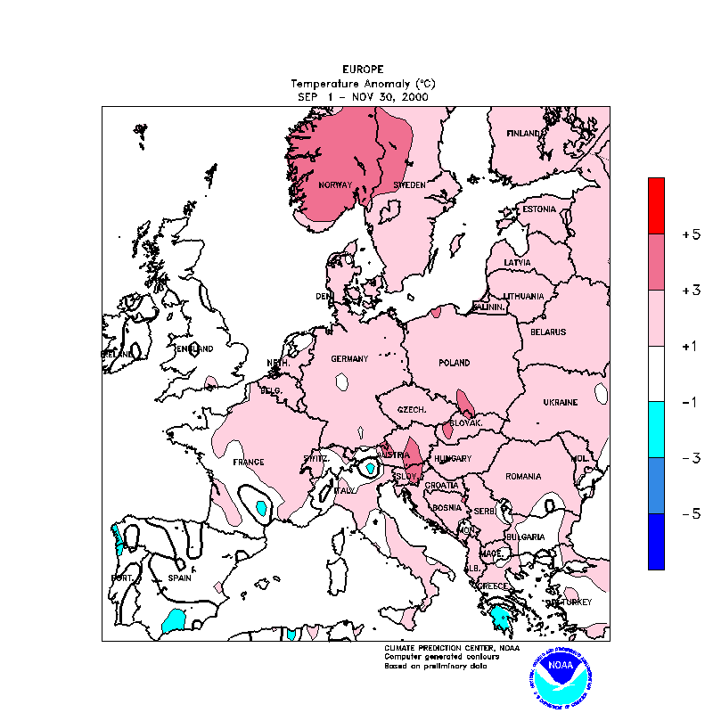
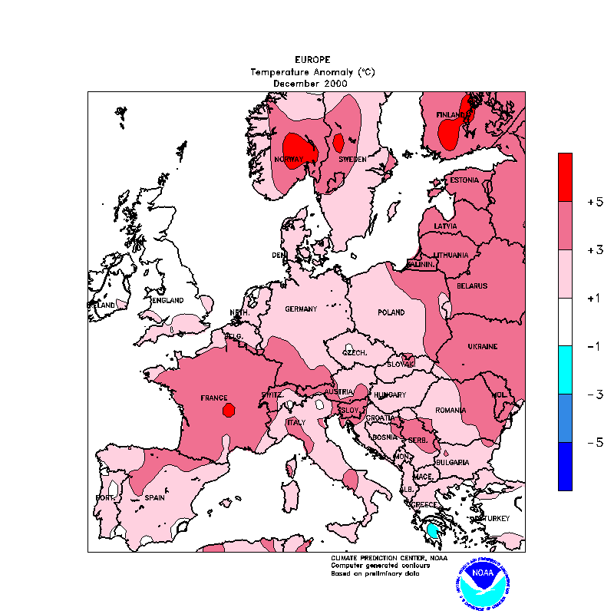

December 2000

Temperature Anomaly

months after a cooler September and October. This weather pattern is the inverse of the overall U.S. weather pattern. October featured warmer than normal temperatures across much of the eastern U.S. while the period between November and December was the coldest two month period on record in the United States. An overall shift of the hemispheric weather pattern has occurred since the beginning of January bringing milder conditions to the U.S. while cooler temperatures have pushed into parts of northern and western Europe including the United Kingdom. Asia, on the other hand, has been experiencing one of the coldest stretches of weather on record with temperatures across Siberia near 70 degrees below zero. One of the most prominent features of the early winter of 2000/2001 has been a strong southern branch or subtropical jet stream that has brought repeated stormy weather across the southern U.S. and wet weather in the Mediterranean region of Europe, particularly in December.

- Meteorological Cycles/Oscillations
North Atlantic Oscillation: The NAO has been in a dominantly negative phase since the end of October 2000. This has coincided strongly with the cold weather in the eastern U.S. as well as with the warmer that normal weather across Europe. Early January has brought a strong trend in the positive direction.
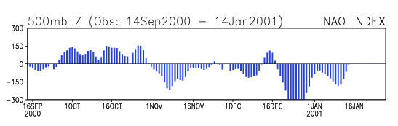

Pacific Sea Surface Temperatures (El Nino/La Nina) The winter of 2000/2001 has featured neither strong El Nino nor strong La Nina conditions. The best characterization of the winter so far would be a neutral phase or perhaps a very weak La Nina. The overall circulation across the Northern Hemisphere has been characteristic of a neutral ENSO phase.

Forecast

- Analog Approach
The winter forecast for the U.S. was based on analog years chosen based on the pre-winter state of several meteorological cycles (NAO, ENSO and PDO). The analogs chosen at the beginning of the winter season successfully forecasted the early winter pattern across the United States as well as Europe. Using this technique to project the remainder of the winter season results in a fundamental change in the overall hemispheric pattern. This change in the overall pattern should allow temperatures to moderate across the U.S. while Europe features an increased propensity for cold air movement. Temperatures across Europe are expected to average near or below normal – somewhat cooler than early-winter readings.
- Cyclic Fit
North Atlantic Oscillation: The NAO is forecast to move into a positive phase over the next seven to fifteen days. This would indicate that a cooler weather situation should establish over Europe during this time frame.
Pacific Sea Surface Temperatures (El Nino/La Nina): An overall neutral ENSO phase generally indicates a normal winter pattern is to be expected across Europe. With temperatures in the beginning of the winter averaging near or above normal it is reasonable to forecast that temperatures at the end of the winter will average near or below normal.

- Numerical Forecast Models
Numerical forecast models are providing a forecast picture through the remainder of January. Temperatures are expected to be below normal from northern to central Europe through the next seven days. In the seven to ten day time-frame cooler weather is expected to shift into southern and eastern parts of the continent.

- Putting It All Together: Conclusion
The analog approach to the winter 2000/2001 has performed well. Current cycles of the NAO as well as ENSO add support for the analog forecast solution. Examining these factors along with the numerical model forecast through the remainder of this month leads to the following forecast for the end of this winter:

Much of the continent should feature temperatures, on average, cooler than the past few months. Overall temperatures should be normal to below normal in the February and March timeframe. An active sub-tropical jetstream will continue to provide a wet pattern near the Mediterranean keeping temperatures on the below side of normal. Western Europe will also see the best chances for colder weather intrusions as the NAO trends positive. Even with this cooler trend across Europe, there are no signs that the Arctic Pool of air in Siberia will move westward toward eastern Europe. Overall no extreme deviations from normal are expected, only a slight trend toward cooler than normal.

