ERMS-PC installation and usage:

- Restart you PC by clicking on Start Shut Down… Restart. This has to be one only once for the purpose of installation purposes.
- After logging on the system, click on Start Programs Business Applications ERMS-PC. This may take few seconds to display the Logon Dialog box.
If ERMS-PC is not on the menu selection box click on

- On Log on dialog box enter ‘/ ‘for Username and leave Password and Database fields empty and click on Connect button.

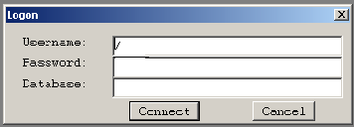

- The ERMC-PC initial screen will be displayed.

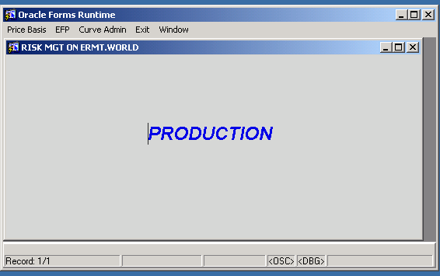

This menu is very similar to the RUNM menu. To access Report menu click on Price Basis Quotes/Deal Otc Reports. This screen is similar to the Reports screen on RUNM. All the reports but top page reports can be displayed on the screen. You may print any number of pages of a report or the entire report to your default network printer. Report names Marked by ‘*’ must be printed on legal size paper.

To change paper size:
- Click on Print Set up icon, third icon on the tool bar from left.
- On paper section, change the size from Letter to Legal.
- Click on OK button.

To Print a report:
- Click on Print Icon, second icon on the tool bar from left.
- On printer dialog box, you may choose to print all any number of pages of the report.

