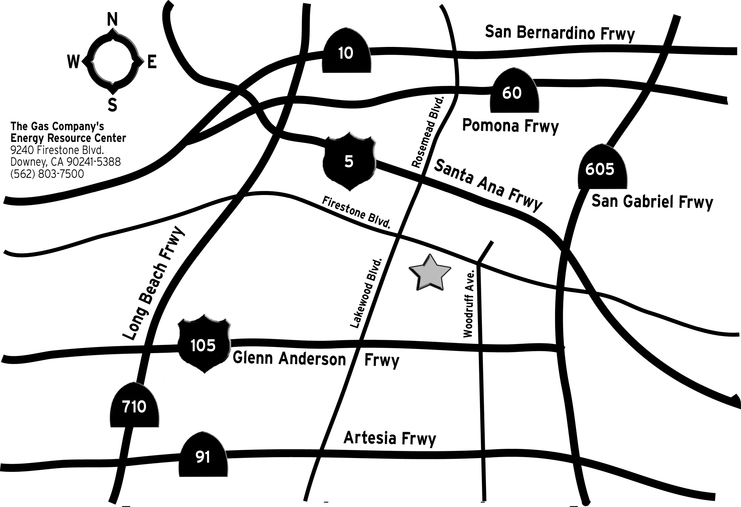

Map and Directions to the
Energy Resource Center
9240 Firestone Blvd.
Downey

From the 710 Freeway North or South (Long Beach area) - Exit Firestone Blvd. Drive 3.2 miles east on Firestone Blvd. past Lakewood Blvd. The ERC is approximately one block past Lakewood Blvd. on Firestone Blvd.
From Airport (LAX) - Take the 105 Interstate east. Exit Lakewood Blvd. Drive north on Lakewood Blvd. about 2 miles Turn right onto Firestone Blvd. The ERC is approximately one block east of Lakewood Blvd. on Firestone Blvd.
From the 605 Freeway - Exit Firestone Blvd. Drive about a mile west on Firestone Blvd., just past the ERC and Penske Toyota. Make a U-turn at the traffic signal bounded by Penske Toyota on the left and Stonewood Mall on the right. Drive east on Firestone Blvd. a short distance and you’ll see the parking entrance for the ERC on the right.
From the 5 Freeway (Los Angeles area) - Exit Lakewood Blvd. Drive south on Lakewood Blvd. for about 2 miles. Turn Left on Firestone Blvd. The ERC is approximately one block east of Lakewood Blvd. on Firestone Blvd.
From the 5 Freeway (Orange County area) - Take the 5 freeway north. Exit on Firestone Blvd. (freeway exit is on the left hand side of the 5 freeway north) Drive west on Firestone Blvd. for about 3-4 miles. Make a U-turn at the traffic signal bounded by Penske Toyota on the left and Stonewood Mall on the right. Drive east on Firestone Blvd. a short distance and you’ll see the parking entrance for the ERC on the right.

From the 405 Freeway - Take the 405 to the 605 freeway north. Drive north approximately 10 miles to Firestone Blvd. exit. Turn right and drive west (toward L.A.) approximately 1 mile. The ERC is on your left, make a U-turn at the traffic signal bounded by Penske Toyota on the left and Stonewood Mall on the right. Drive east on Firestone Blvd. a short distance and you’ll see the parking entrance for the ERC on the right.
From the Interstate 10 (Santa Monica Freeway, L.A. area) - Take the 10 east to the 5 (Santa Ana) south. Exit Lakewood/Rosemead Blvd. Turn right. Drive approximately 1 1/2 miles to Firestone Blvd., turn left. Drive east on Firestone Blvd. a short distance and you’ll see the parking entrance for the ERC on the right.
From the Interstate 10 (San Bernardino area) - Take the 10 west to the 605 south. Exit Firestone Blvd., turn right. Drive about a mile west on Firestone Blvd., just past the ERC and Penske Toyota. Make a U-turn at the traffic signal bounded by Penske Toyota on the left and Stonewood Mall on the right. Drive east on Firestone Blvd. a short distance and you’ll see the parking entrance for the ERC on the right.
From 91 Freeway (from beach areas) - Take the 91 east. Exit Lakewood Blvd. Drive north on Lakewood Blvd. about 2 miles turn right onto Firestone Blvd. The ERC is approximately one block east of Lakewood Blvd. on Firestone Blvd.
From 91 Freeway (from orange county) - Take the 91 west to the 605 north. Exit Firestone Blvd. Turn right and drive west (toward L.A.) approximately 1 mile. The ERC is on your left, make a U-turn at the traffic signal bounded by Penske Toyota on the left and Stonewood Mall on the right. Drive east on Firestone Blvd. a short distance and you’ll see the parking entrance for the ERC on the right.

