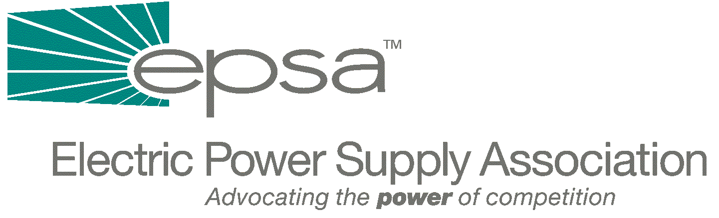

1401 New York Avenue
11th Floor
Washington, DC 20005
202/628-8200
202/628-8260 fax
Memorandum
TO: | EPSA Legislative Affairs Committee
FROM: | Scott A. Weiner, Legislative Affairs Committee Chair  Andrea L. Spring, Manager of Government Affairs
DATE: | September 28, 2025
RE: | - Administration Comments on Bingaman Electricity Legislation Analysis

Although the Bush Administration’s comments on the Bingaman draft Electricity Legislation are very positive, the Administration recommends the deletion of several key provisions, including confirming FERC authority over bundled transmission, RTO language, and much of the market power proposal. The Bush Administration appears to favor sidestepping debate over some of the more contentious jurisdictional provisions, presumably in the hopes that the Supreme Court will settle these issues and make legislative action unnecessary.
Some Major differences between the Administration and the Bingaman Bill:
Transmission jurisdiction: Deletes the language in Section 402 which provides for federal jurisdiction over the transmission component of bundled retail sales. Although EPSA obviously supports federal jurisdiction over all interstate transmission, including the transmission component of bundled retail sales, this provision is consistent with the Bush Administration’s assertion in congressional testimony that FERC already has this authority.
RTOs: The Administration would remove Bingaman’s provision allowing FERC to mandate RTOs. Again, this is consistent with Bush Administration congressional testimony that FERC already has this authority. The Administration would also add a positive definition of RTOs, including “appropriate scope and configuration” and “not undue discrimination or preference” in the definition.
Mergers: The Administration does not support Bingaman’s expansion of merger authority (which EPSA opposes as being overly broad), saying that it is unnecessary. Instead, the Administration suggests language which it says is a clarification of existing FERC merger authority.
Market-Based Rates and Market Power: The Administration believes that these sections of the Bingaman bill should be deleted because FERC already has adequate ability to address market power. EPSA also opposes these sections of the Bingaman bill, because they address the ability to wield market power instead of simply punishing those who exercise market power. Bingaman makes refunds of unjust or unreasonable rates effective from the date that a complaint is filed, or from the date that FERC initiates the proceeding, instead of the current 60 days after filing. The Administration agrees with this, but believes that this provision should only be applied prospectively; Bingaman’s bill would also apply this provision to any proceedings pending on the date of enactment, not just prospectively.
Interconnection: The Administration recommends that the interconnection provision only apply to transmitting utilities (Bingaman has a local distribution interconnection provision and a transmission interconnection provision). Although the Administration’s interconnection provision still does not explicitly mention a non-discriminatory right to interconnect, it does provide for a standardized interconnection process, while Bingaman only provided for technical standards.
Eminent Domain: The Administration says that they’ll provide legislative language on this issue soon.
Public Benefits Fund: The Administration opposes the Bingaman Public Benefits Fund, as does EPSA.
Renewal Portfolio Standard: The Administration opposes the Bingaman Renewal Portfolio Standard and the Bingaman Federal Renewable Portfolio Standard.
Renewable Energy Production Incentive: The Administration would expand eligibility for REPI to all renewable energy facilities, regardless of ownership, and would expand the definition of renewable energy facility to include energy from solar, wind, biomass (including municipal solid waste and landfill gas), geothermal or incremental hydropower. EPSA would support this expansion. The Administration does not, however, explicitly mention co-fired biomass as a renewable, which Bingaman did.
PURPA Reform: The Administration supports Bingaman’s PURPA reform, and adds a provision which EPSA supports: the repeal of ownership limits on QFs.
Refunctionalization: The Administration includes a provision similar to one in HR 2944 (from the 106th Congress), which allows FERC to decide which facilities are transmission facilities, and therefore subject to FERC jurisdiction, and which are local distribution facilities. The Administration version is superior to the one in HR 2944, because it directs that FERC “shall consider” the position taken by a state commission, while HR 2944 directed FERC to “give deference” to state commissions.
If you have any questions, please contact Andrea Spring (202-628-8200 or aspring@epsa.org).

