Media  Information | 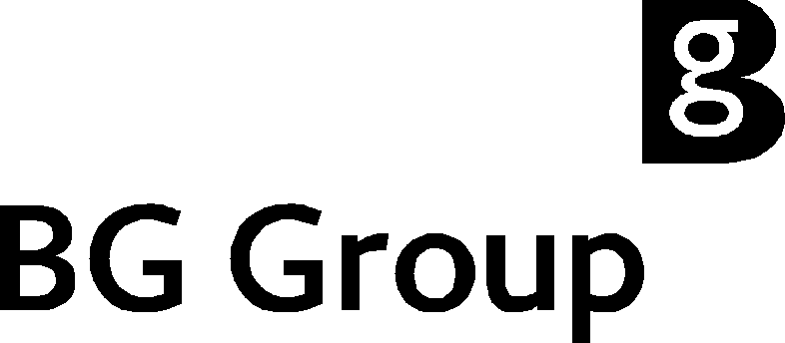

October 3, 2001

BG Group agrees to purchase Enron Indian Upstream Operations

BG Group plc has announced today agreement to purchase the entire share capital of Enron Oil & Gas India Limited (EOGIL) for US$388 million from Enron Corp. .

The assets owned by EOGIL are 30 per cent interests in the Tapti gas field and the Panna/Mukta oil and gas field, and a 62.64 per cent interest in the CB-OS/1 exploration licence. All are located on the west coast of India. These operations, which include important development and exploration opportunities, are operated by EOGIL.

The sale, which is subject to a number of consents and conditions including confirmation from joint venture partners of EOGIL’s continuation as operator after completion, is expected in the coming weeks.

Frank Chapman, Chief Executive, BG Group, said: “On completion of this transaction BG Group will have significantly enhanced its position as a leading player in the large and rapidly growing Indian energy market. Gas exploration and development opportunities will enable further growth of BG Group’s gas strategy, reinforcing expansion plans, premised on the recent Lakshmi gas purchase. Furthermore, we see the building of gas markets in Gujarat and Maharashtra States as an important stepping-stone in realising our long-term goal of importing liquefied natural gas through our Pipavav project. We are now driving hard to complete this new acquisition which will establish India as another core area of operations for the Group.”

Jeff Sherrick, President and Chief Executive Officer, Enron Global Exploration and Production (EGEP), said: "Today's announcement represents another significant step for Enron in selling assets not integrated into our wholesale or retail energy businesses.”

Equity production from these fields, in the year to March 31, 2001, totalled an average of approximately 70 million standard cubic feet of gas per day and 8,200 barrels of oil per day. As at March 31, 2001, EOGIL had estimated net proved and probable reserves of over 170 million barrels of oil equivalent. These reserves are, therefore, being acquired at a cost of less than $2.30 per barrel of oil equivalent.

As at 31 March 2001, EOGIL had proforma net assets of $419 million. In the twelve-month period to 31 March, the company’s proforma profit after tax was $60 million, on revenue of $160 million.

Further development of both the Panna/Mukta and Tapti fields is expected over the next few years, subject to Government and partner approval.

The other partners in the Tapti and Panna/Mukta offshore operations are Oil and Natural Gas Corporation Ltd. (ONGC), which holds 40 per cent and Reliance Industries Ltd. with a 30 per cent stake. The other partners in the CB-OS/1 licence are Hindustan Oil Exploration Company (17.36 per cent), Tata Petrodyne (10 per cent) and ONGC (10 per cent).

The consideration is payable in cash once the transaction has been completed.

Media enquiries

Nicole McMahon 0118 929 3110

Investor Relations enquiries

Chris Lloyd/Rebecca Biddulph/ 0118 929 3025
Megan Watson

PR/10904
Notes to Editors

Enron Oil and Gas India Ltd. The EOGIL assets comprise a 30 per cent interest in the Panna/Mukta oil and associated gas production facilities (some 60 miles north west of Mumbai), the Tapti gas production complex (some 100 miles north west of Mumbai) and a 62.64 per cent interest in Block CB-OS/1. EOGIL has about 200 employees based offshore in the two fields and at offices in Mumbai, New Delhi, Baroda and a supply base at Bhavnagar, which supports exploration, development and production activities for the fields. Currently all gas produced from the fields is bought by the Gas Authority of India (GAIL). The oil production from the Panna/Mukta complex is purchased by the Indian Oil Corporation (IOC). The deal does not include the Dabhol power station or LNG plant.

BG in India – background

BG has been active in India for over ten years. This has culminated in two natural gas distribution companies – Gujarat Gas Company Limited and Mahanagar Gas Limited.

BG has been involved in Gujarat Gas Company since 1997 and now has a 65 per cent shareholding. The company has over 125,000 domestic customers, some 1,600 commercial customers and some 425 industrial customers. It supplies major cities including Ankleshwar, Bharuch and Surat in the south of Gujarat. Just under two years ago, Gujarat Gas commissioned the 73km Hazira-Ankleshwar transmission pipeline. The company also operates compressed natural gas (CNG) filling stations for vehicles where over 700 cars and an increasing number of auto-rickshaws are fuelled by gas. Since the acquisition in 1997, the share price rose from 199 rupees to 672 rupees by the end of 2000. During the same period, the volumes sales increased by approximately 50 per cent, with the addition of 40,000 customers.

BG is also a 50:50 joint venture partner in Mahanagar Gas with the Gas Authority of India (GAIL). It was established in 1995 to develop a natural gas network in Mumbai (formerly Bombay). The company presently delivers gas to about 50,000 customers. It also sells CNG for vehicles in the city where there are about 22,000 vehicles running on CNG, most of which are taxis.

BG in India – recent announcements

In September this year, Gujarat Gas agreed with Cairn Energy and partners to buy 1.27 million cubic metres of gas per day from the Lakshmi field in the Gulf of Cambay, offshore west India. This is scheduled to begin by July 1, 2002 and run for five years. In August 2001, BG purchased the interests of Sea King Infrastructure Limited (SKIL) in the proposed Pipavav Liquefied Natural Gas (LNG) importation and re-gasification project in the state of Gujarat. BG is a 100 per cent shareholder in the project.

