ENRON – BG

PROPOSED SALE OF ENRON OIL & GAS INDIA LTD.

- BG Group plc (formerly known as British Gas) has agreed to purchase the shares of Enron Oil & Gas India Ltd. (EOGIL) from Enron Corp.

- EOGIL owns interests in and serves as operator of three upstream oil and gas projects in India: Tapti, Panna-Mukta, and CB-OS/1.

  - Tapti and Panna-Mukta have major offshore production of oil and gas, which is sold to Government-owned Indian companies for domestic consumption.
  - CB-OS/1 is an exploration project, where wells will soon be drilled, subject to receipt of final permits.
  - EOGIL’s current activities represent the second-largest upstream oil and gas operations in India, after those of Oil & Natural Gas Corporation Ltd. (ONGC), which is majority-owned by the Government of India (Government).

    - The Government has no legal right to approve the proposed transaction. However, BG wants to make sure that the Government, and in particular, the Minister of Petroleum and Natural Gas and the Director General of Hydrocarbons, is comfortable with BG’s proposed role as the new owner of EOGIL.

    - EOGIL’s co-venturers in the Tapti and Panna-Mukta projects are ONGC and Reliance Industries Ltd. (Reliance being a very large publicly held Indian company). In the joint-operating agreements among EOGIL, ONGC, and Reliance, either of the non-operators (ONGC and Reliance) has the right to remove the incumbent operator (EOGIL) upon a change of control of the operator, which would happen if Enron sold EOGIL to BG. BG requires that EOGIL remain the operator after the proposed transaction, as would any bona fide buyer of EOGIL.

    - BG has had extensive discussions with the Government, ONGC, and Reliance, and Enron has had discussions with the Government, about the proposed transaction, but BG has not yet received the level and type of comfort that it would like from the Indian parties to enable it, first, to feel welcome in India as the new owner of EOGIL, and second, to rest assured that EOGIL will remain as operator of the projects.

    - Enron and BG would like to close the proposed transaction as soon as possible, but in any event by October 31, 2001

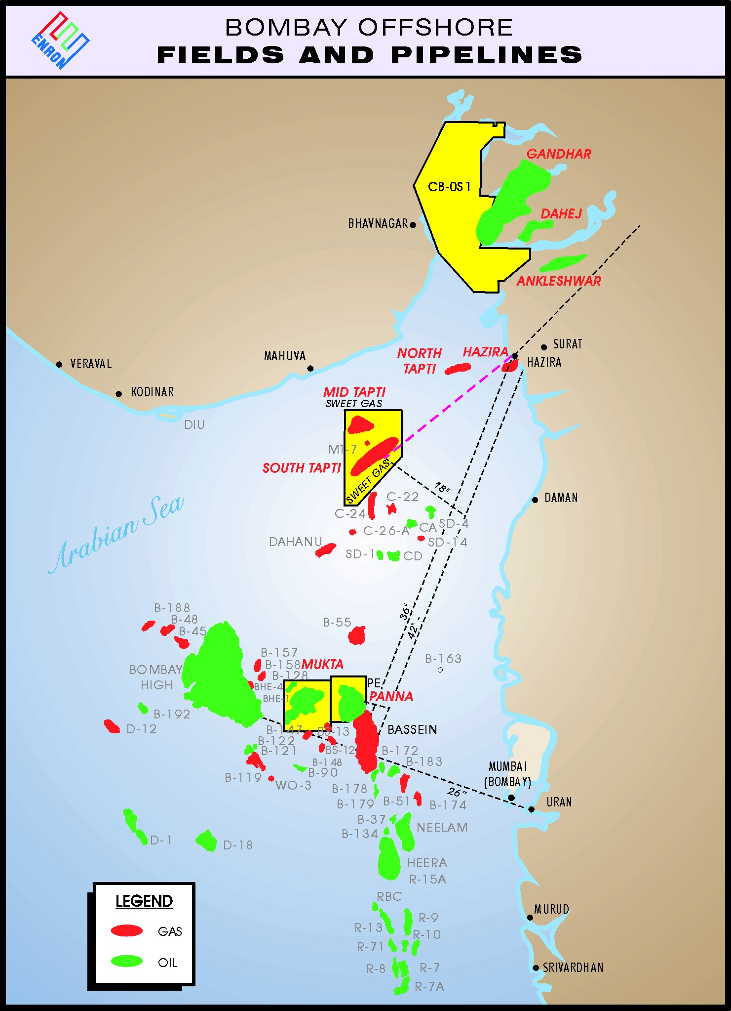

Tapti
Description – The Tapti block is located off the western coast of India in the Bombay basin region of the Arabian Sea approximately 100 miles northwest of the city of Mumbai (formerly Bombay). The block has an aerial extent of 363,500 acres or roughly the size of 73 typical US Gulf of Mexico offshore blocks. A Production Sharing Contract (PSC) was signed in December 1994 by the Government of India and the Tapti consortium, a group consisting of EOGIL, Reliance Industries Ltd. (RIL) and the Indian state-owned Oil and Natural Gas Corporation Limited (ONGC). EOGIL holds a 30% working interest in the Tapti project and is the operator while RIL and ONGC hold 30% and 40%, respectively.

Fiscal terms – The PSC was signed in December 1994 and has a term of 25 years, subject to extension by mutual agreement. Governance is by a Management Committee with four members, one from the Government of India and one each from ONGC, RIL and EOGIL. The PSC calls for 100% recovery of costs incurred, subject to certain limits, and profit splits to the Tapti consortium of 80%, decreasing in steps to 50% as certain profit-to-investment multiples are achieved. Revenues are subject to a 10% royalty on gas. Activities under the PSC are governed under the laws of India. As a foreign company engaged in the oil and gas industry, EOGIL is subject to a 48% corporate tax rate.

Development activity – Gas was originally discovered by ONGC in a series of exploration wells drilled between 1978 and 1993. Development was not pursued and the Indian Ministry of Petroleum and Natural Gas offered the Tapti block in a competitive international tender, which was won by the Tapti consortium on March 16, 1994. First gas sales occurred in the second quarter of 1997 and the initial development phase has been completed.

Through June 2001 the Tapti partners have spent approximately $337 million and have achieved natural gas production levels of 200 MMcfd, the current capacity of existing facilities.

Expansion plans – Technical work completed by EOGIL to date has shown that the reserves are significantly greater than initially estimated and will support much higher production levels. The Tapti partners are currently working on a revised plan of development which will allow for production to be more than doubled in the next three or four years.

Plans call for capital expenditures of approximately $615 million for additional wells, platforms, facilities and a pipeline that should allow output to be increased to 450 MMcfd. Upon receipt of Management Committee approval, construction activities should commence in 2002 with first sales in 2004.

Marketing – Natural gas is currently sold to Gas Authority of India Ltd. (GAIL), as nominee for the Government of India, who transports it to markets near the coastal city of Hazira as well as to markets along the HBJ Pipeline System throughout North Central India, including the Delhi area. Natural gas is currently sold according to the terms in the PSC at prices based on a rolling average of four fuel oils subject to a $2.11/MMBtu floor and a $3.11/MMBtu ceiling. The revenues EOGIL receives for natural gas sales are denominated in US dollars.

Panna/Mukta
Description – The Panna and Mukta blocks are located off the western coast of India in the Bombay basin region of the Arabian Sea approximately 60 miles west of Mumbai. The Panna and Mukta blocks have aerial extents of 106,000 acres and 190,000 acres, respectively, totaling 296,000 acres or roughly the size of 59 typical US Gulf of Mexico offshore blocks. A PSC was signed in December 1994 by the Government of India and the Panna/Mukta consortium, a group consisting of EOGIL, RIL and ONGC. EOGIL holds a 30% working interest in the Panna/Mukta project and is the operator while RIL and ONGC hold 30% and 40%, respectively.

Fiscal terms – The PSC was signed in December 1994 and has a term of 25 years, subject to extension by mutual agreement. Governance is by a Management Committee with four members, one from the Government of India and one each from ONGC, RIL and EOGIL. The PSC calls for 100% recovery of costs incurred, subject to certain limits, and profit splits to the Panna/Mukta consortium of 95%, decreasing in steps to 50% as certain profit-to-investment multiples are achieved. Revenues are subject to a 10% royalty on gas and Rupee-denominated royalty and cess on oil. Activities under the PSC are governed under the laws of India. As a foreign company engaged in the oil and gas industry, EOGIL is subject to a 48% corporate tax rate.

Development activity – The Panna field was originally discovered by ONGC in 1976. From the time of discovery until 1991 a number of appraisal wells were drilled at Panna and in the nearby Mukta block. It was recognized that effective drainage of the oil would be challenging and development was pursued in steps with first production occurring in 1986. In hopes of accelerating recoveries of vitally needed crude oil, the Indian Ministry of Petroleum and Natural Gas offered the Panna/Mukta block in a competitive international tender which was won by the Panna/Mukta consortium on March 16, 1994.

Much of the initial plan of development work is complete and has resulted in significant increases in oil and gas production. EOGIL has drilled 50 new wells, many of them horizontal and all employing advanced completion techniques. This drilling activity and the associated upgrades made to platforms and facilities have resulted in oil production rates triple those achieved before EOGIL assumed operatorship. Natural gas, which had been previously flared, began flowing to sales in February 1998.

Through June 2001 the Panna/Mukta partners have spent approximately $527 million and have increased crude oil production levels from 11.0 MBd to 29.0 MBd. Natural gas production currently averages 92 MMcfd.

Expansion plans – The Panna/Mukta partners are currently finalizing an expanded plan of development to be submitted to the Government of India. Plans call for the expenditure of approximately $142 million that should increase output to 30,000 BOPD and 120 MMcfd. Upon receipt of Management Committee approval, construction activities should commence in 2002 with first sales in 2003.

Marketing – Crude oil is currently sold to Indian Oil Corporation (IOC), as nominee for the Government of India, after production into a floating storage vessel. The crude is then lightered off by IOC and sold to local refineries in the Mumbai region. Crude oil is currently sold according to terms in the PSC at prices based on Dated Brent less $.10/Bbl.

Natural gas is currently sold to GAIL, as nominee for the Government of India, who transports it to markets near the coastal city of Hazira as well as to markets along the HBJ Pipeline System throughout North Central India including the Delhi area. Gas is currently sold according to the terms in the PSC at prices based on a rolling average of four fuel oils subject to a $2.11/MMBtu floor and a $3.11/MMBtu ceiling. The revenues EOGIL receives for both crude oil and natural gas sales are denominated in US dollars.

CB-OS/1
EOGIL holds a 62.64% interest in and operates Block CB-OS/1 on the western coast of India located north of the Tapti block in the Bay of Cambay and adjacent onshore lands. Partners are Hindustan Oil Exploration Company, ONGC and Tata Petrodyne Ltd. with interests of 17.36%, 10% and 10%, respectively. Several exploration targets have been identified with mean gross potential of 643 Bcfe and a P₁₀ of 1,157 Bcfe. An approved budget is in place with the first well of a three well commitment scheduled to spud late 2001. There are no requirements to market hydrocarbons through a Government of India nominee.

