ENRON RESEARCH-TECHNICAL ANALYSIS

STEPHEN W. BIGALOW TECHNICAL ANALYST 713-789-5207
Stephen W. Bigalow, one of the leading candlestick technicians in the nation, has been commissioned to provide daily Japanese Candlestick analysis for Crude, Heating Oil, and Natural Gas. He has 25 years of investment background. 15 years directed towards overlaying candlestick analysis on top of existing Western Technical methods. His soon to be published book “ Profitable Candlestick Investing, Revolutionizing Investor Psychology” will be made available to Enron personnel prior to publication.

CANDLESTICK ANALYSIS

NATURAL GAS

May 31, 2001 – Wednesday formed a very strong buy signal, a Bullish Engulfing pattern, with stochastics curling up. Expect a few days to the upside

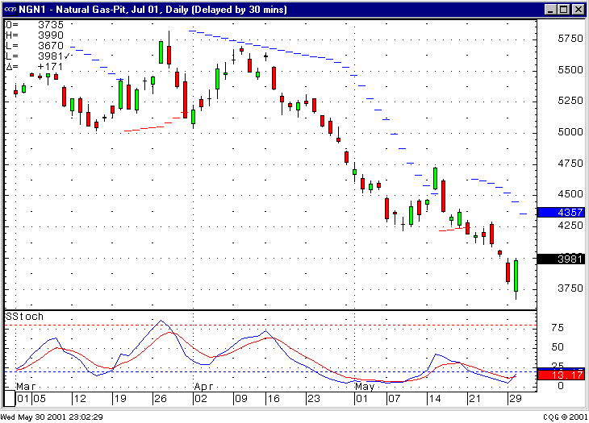

ENRON RESEARCH-TECHNICAL ANALYSIS

STEPHEN W. BIGALOW TECHNICAL ANALYST 713-789-5207

TREND ANALYSIS

NATURAL GAS

MACD and RSI are near bottom. The E.W. point 3 is a viable target. $3.48 Area The long term trading channel has been breached. Any bounce will have the trend-line acting as overhead resistance. 