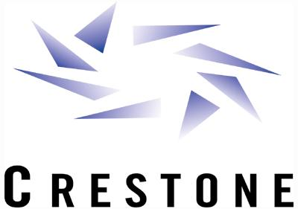 | Crestone Energy Ventures, L.L.C.  An Affiliate of Northern Border Pipeline  400 16th Street, Suite 310  Denver, CO 80202  (720)946-3600 Fax (720)946-3810 | INVOICE NO: FF200108  DATE: September 27, 2001

To: | Remit to:
Enron North America Corp | See wire instructions below  Catrina Lucero
Theresa Staab | Crestone Energy Ventures, L.L.C.
1200 17th Street, Suite 2750 | 400 16th St, Suite 310
Denver, CO 80202 | Denver, CO 80202

Contact | P.O. NUMBER | Date Shipped | Shipped via | f.o.b. point | Due Date
Catrina Lucero (720)946-3645 | N/A | N/A | N/A | N/A | 10/1/01

quantity | description | unit price | amount
 | Fixed Fee –September, 2001  $21,600/day x 30 Days  MSA Agreement NBP Energy Pipelines, L.L.C. and Enron North America Corp. effective September 21, 2000. Daily Fee shall mean $21,600/day commencing January 1, 2001 through December 31, 2001. |  | $648,000.00
PLEASE WIRE TRANSFER PAYMENT TO:
(NEW INSTRUCTIONS)
Bank Name: Citibank
Bank Address: New York
Bank Routing #: 021 000 089
Bank Account #: 30479083
Bank Account Name: Crestone Energy Ventures, LLC
SUBTOTAL |  |  | $648,000.00
SALES TAX |  |  | 0.00
SHIPPING & HANDLING |  |  | 0.00
TOTAL DUE |  |  | $648,000.00

If you have any questions concerning this invoice, call: Catrina Lucero @ (720)946-3645

THANK YOU!

