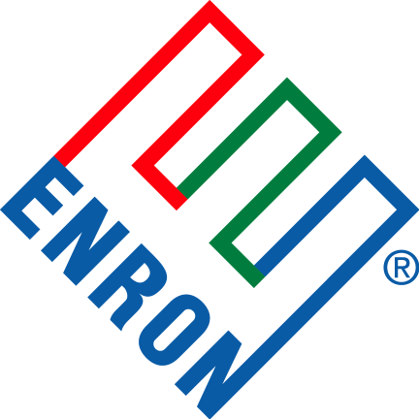

November 7, 2001

Duke Energy Field Services Inc.
5718 Westheimer, Suite 2000
Houston, Texas 77057
Attention: Mr. Stephen P. Noe
Director, Deepwater Services

Re: Mississippi Canyon (“MC”) 674 Flow line Transaction

Dear Mr. Noe,
Pursuant to our recent discussions, Enron North America Corp. (“ENA”) is pleased that Duke Energy Field Services, Inc. (“Duke”) is interested in a potential transaction to purchase the above referenced MC 674 flow line (the “Potential Transaction”). ENA and its affiliate Mariner Energy Inc. have provided Duke with certain information and documents related to the Potential Transaction and Duke is currently conducting due diligence. The purpose of this letter is to describe the structure ENA proposes for the Potential Transaction and the schedule for completion.
MEGS, L.L.C., a Delaware limited liability company owns the eight inch flow line which extends twenty nine miles from Mariner Energy’s sub sea wellhead in MC 674 (the Pluto Field) to Marathon Oil Company’s platform in South Pass 89. MEGS, L.L.C. is a wholly owned subsidiary of Enron North America. ENA proposes that the Potential Transaction take the form of an asset sale from MEGS, L.L.C. to Duke. The pertinent gathering and O&M agreements would be assigned to Duke concurrently at closing. ENA believes that an asset sale would be the least cumbersome transaction structure for all parties involved.
ENA proposes that Duke submit a non-binding letter of interest by November 16, 2001 containing the purchase price and other material terms for the Potential Transaction. If the terms contained in Duke’s non–binding letter of interest are generally acceptable or represent a basis for further discussions, Enron would then begin drafting definitive agreements for the Potential Transaction. It is anticipated that Enron would provide Duke with drafts of a Purchase/Sale Agreement and any other required agreements by November 29, 2001. Given the timetable outlined herein the Potential Transaction could be closed on or before December 14, 2001. The time between November 16 and closing would be used to conclude due diligence by Duke, resolve any issues arising from Duke’s due diligence, negotiate, and finalize definitive agreements.
This letter is not intended to be, and does not constitute, an offer subject to acceptance by Duke, nor is this letter or any of the matters contained herein binding upon ENA. Any binding agreement shall be evidenced only by a final, fully executed purchase/sale agreement containing, among other matters, mutually satisfactory provisions, representations, warranties, indemnities, covenants, appropriate credit provisions and limitation of liability. The existence of this letter, its contents, and any discussions with respect hereto are intended to be confidential and not to be disclosed to any third party by Duke without the prior written consent of ENA. ENA makes no, and expressly disclaims any, representation or warranty regarding the matters set forth herein, and neither ENA nor any of its affiliates shall have any liability resulting from Duke’s use of or reliance upon any of the matters set forth herein.
Please feel free to call me at (713) 853-3541 with any questions regarding matter.

Sincerely,

Kevin M. Miller

