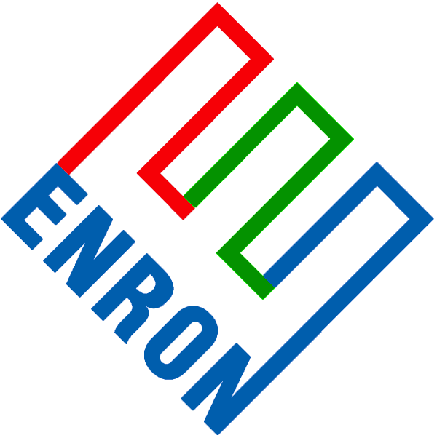

March 14, 2001

Mr. Gary Weaver
Dominion Oil & Gas Exploration, Inc.
1245 S. Brickyard Road, Suite #500
Salt Lake City, UT 84106

Mr. Weaver:

Enron North America (ENA) appreciates the opportunity to work with Dominion Oil & Gas Exploration, Inc. (Dominion) in Kern River Pipeline’s open season. Through our Denver origination and middle market group, in combination with our vast Houston trading operations, ENA has consistently offered our Rocky Mountain customers innovative energy structures and creative ways to extract value from their strategic market positions. As you are aware, ENA and Dominion have an established marketing relationship in the Rockies. We are excited about the chance to extend ENA and Dominion’s relationship into other mutually attractive market opportunities.

The Opportunity
On Monday, March 12, Williams announced an open season for two packages of capacity, both with anticipated in-service dates of July 1, 2001. Package One is for 21,000 Mcf per day ending on April 30, 2003 and Package Two is for 114,000 Mcf per day ending on April 30, 2002. All bids are due by noon MST on Thursday, March 15, 2001. ENA considers the capacity to be an attractive compliment to our trading and marketing portfolio and is seeking to obtain capacity rights both in the open season directly and also in the secondary market subsequent to the open season capacity allocation. ENA is offering to make a one-time payment to Dominion in exchange for the permanent assignment or release of any awarded Kern River expansion capacity. The payment would be calculated as 25% of any positive mark-to-market value of the awarded transportation. After the assignment or release is completed, ENA would bear all associated supply, delivery, price, credit, and all other market risks, with Dominion retaining no risk whatsoever.

Dominion’s Obligations
Should Dominion be interested in pursuing this opportunity, a few steps must be quickly taken to meet the open season bid deadline of noon on Thursday, March 15.
- Review and fill out the attached two Precedent Agreements (one for each capacity package) between Kern River Gas Transmission Company and Dominion Corporation, which reflects the receipt and delivery point and associated capacity as set forth in Exhibit A to the letter agreement.
- Fill out the attached Kern River Credit Application and provide any required supporting documentation.
- Provide a list of your affiliates as set forth in the Precedent Agreement. You also have the alternative of submitting the following sentence in lieu of a list:
"Shipper warrants and represents that no other affiliate is participating in the open season"
- Review and sign the letter agreement (which will be sent to you shortly) indicating, among other things, Dominion’s obligation to assign or release any awarded capacity as consideration for the one time mark-to-market based payment from ENA.
- Submit, by fax at (303) 534-0552 the executed letter agreement to ENA by 10:00 am MST on March 15.
- Submit, by fax at (801) 584-6950, the executed Precedent Agreement, Credit Application, and list of affiliates to Kern River Gas Transmission Company by noon MST on March 15.

ENA’s Obligations
Should Dominion submit the executed letter agreement to ENA and be awarded capacity in the Kern River open season, ENA would be obligated to:
- Accept assignment or release of Dominion’s awarded capacity
- Make a one-time payment to Dominion of 25% of the awarded capacity’s mark-to-market value as set forth in the attached letter agreement.

We appreciate your timely reaction to this offer and please do not hesitate to contact me at (303) 575-6478 or e-mail at Tyrell.Harrison@Enron.com if you have any questions or concerns.

Sincerely,

Tyrell Harrison
Enron North America
1200 17th Street, Suite #2750
Denver, CO 80202

