Directions to the NYISO building located at 290 Washington Avenue Extension, Albany

From the North (Traveling South on Route 87 – the Northway):

- From Route 87 – Take the Exit for Crossgates Mall.

- Go Right onto Crossgates Mall Road.

- Take Exit (to the Right) for Washington Avenue – WEST. Stay in the left lane of Washington Ave Ext because you will be turning left off that road.

- Look for the Italian American Community Center, also known as Le Caravelle Ristorante, on the right-hand side. Take a LEFT at the light at the crossroad that goes to the restaurant.

- After crossing the Eastbound lanes of Washington Ave Ext, Take a RIGHT onto the Service Road. The NYISO building is on the corner, and has a sign out front.

- Take the first LEFT off the Service Road and park in the front lot of the NYISO building (the front faces Washington Ave Ext). You can only enter the building from the front. The lobby receptionist will check you in.

From the South (Traveling North on Route 87 – the Thruway):

- From Route 87 – Take Exit 24.

- Go through the tollbooth and head South on the Northway, heading toward Western Avenue.

- From the Northway, Take the Exit for Crossgates Mall and follow the rest of the directions above.

From the East (Traveling West on Route 90):

- Take Exit 1S for Western Avenue. This puts you onto the Northway heading South.

- Follow the rest of the directions above.

From the East (Traveling West on Route 20):

- From Route 20, which is Western Ave, Take a Right onto Fuller Road, heading North. Washington Ave Ext is the first major highway you’ll come to.

- Take a LEFT at the light onto Washington Ave Ext, heading West. Follow the rest of the directions above.

From the West (Traveling East on Route 20):

- From Route 20 – Take a Left onto Route 155, heading North.

- Take a Right onto Washington Ave Ext, heading East.

- From Washington Ave Ext, you can either take the next Right and follow the Service Road (parallel to Wash Ave Ext) to the NYISO building;
or
Take a Right at the first traffic light, then take another Right onto the Service Road, then a quick Left to the NYISO building.
Map to NYISO at 290 Washington Avenue Extension

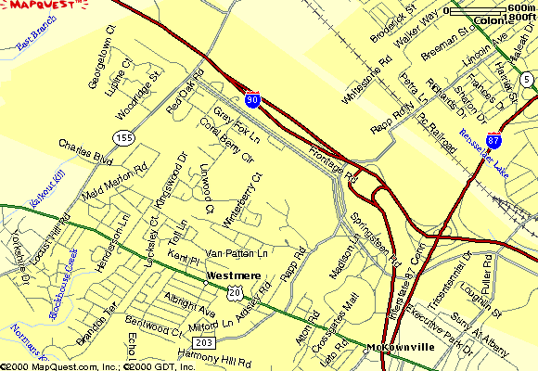
NYISO

