DIRECTIONS TO KMV

Location: 1620 Montgomery Street, Suite 140,
San Francisco, CA 94111
[Between Lombard and Chestnut Streets, near Levi’s Plaza and Fog City Diner]
Phone: (415) 296-9669

General Information

Our office is located at the corner of Lombard and Montgomery at the base of Telegraph Hill (Coit Tower), in the gray building with the covered porch, suite 140 is on Montgomery.

Parking is available at ParcTelegraph, Levi's Plaza & 55 Francisco (generally $2/hour or max of $8 for the day), as well as limited 2-hour metered parking (quarters only, $1/hour). Dress is casual.

Map

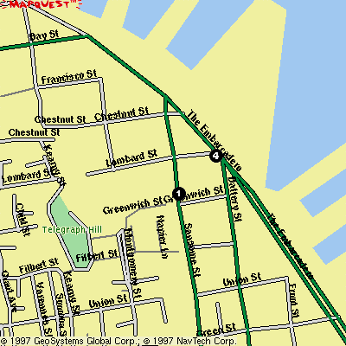
KMV Corporation

From San Francisco Airport
Driving: North on Hwy 101 to San Francisco. Exit at Fourth Street (last exit before the Bay Bridge). The Fourth Street exit feeds into Bryant Street. Travel east on Bryant Street (stay in the right lanes, because the left will force you onto the bridge). Turn left at the Embarcadero; Left on Chestnut; Left on Montgomery.

From Financial District and Downtown Hotels
By taxi: Instruct the driver to go to 1620 Montgomery Street, between Lombard and Chestnut, just past Levi’s Plaza. With this information, the driver should know to avoid getting you stuck at the top of Telegraph Hill! (see warning)

Walking: Follow Sansome (not Montgomery) from Market, heading north, to Lombard. Turn left on Lombard, follow 1 block to Montgomery. KMV is a brisk 20 to 25 minute walk from the Financial District.

*Warning: From the Financial District and downtown, do not try to take Montgomery Street to our office because from that direction, Montgomery goes over the top of Telegraph Hill and the 1500 block ends as a cliff without steps!

From East Bay:
Driving: Cross Bay Bridge and exit at Embarcadero (1st exit off Bay Bridge-left hand exit), Right on Harrison; Left on Embarcadero; Left on Chestnut; Left on Montgomery.

From Marin County:
Driving: Cross Golden Gate Bridge remain left—follow Doyle Drive to Marina Boulevard; Left on Bay Street. Continue on Bay to Kearny. Turn Right on Kearny; Left on Francisco; Right on Montgomery.

