Directions
Fax: 609-275-4135
TO: DON ADAMS

To the Omni Interlocken Resort from Denver International Airport

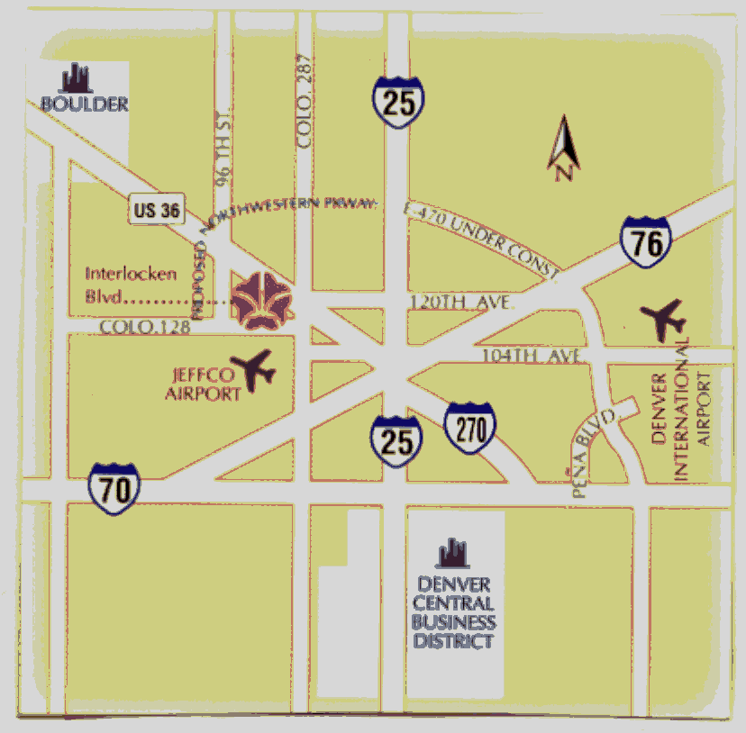

The Omni Interlocken Resort is located
9 miles East of Boulder just off the Boulder Turnpike (Hwy 36).

- From the car rental area, take Pena Boulevard South to I-70

- Take I-70 West approximately 4-5 miles to I-270 (Fort Collins/Boulder)

- I-270 terminates at the I-25 and Hwy 36 (turnpike), follow signs to Boulder (Hwy 36 Westbound).

- Take Hwy 36 West past Sheridan exit, past Church Ranch Rd. exit, past Broomfield exit. Drive approximately 1mile and exit at Interlocken Loop / Storage Tek Drive.

- Turn left onto Interlocken Loop, go to the next light (after the interchange light) and turn left. This will put you on Interlocken Blvd. Follow to the top of the hill and turn left into the Hotel driveway.

- Follow the driveway, bearing left, to the front of the Hotel.

