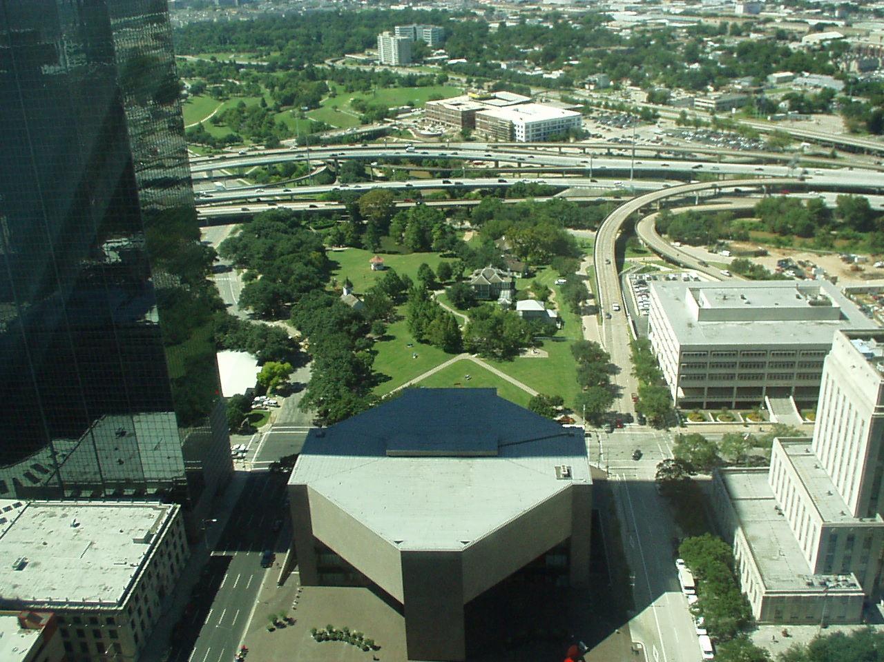

Directions

Sam Houston Park is directly off I-45 and is bordered by McKinney, Bagby and Allen Pkway.

Coming from the North on I-45 toward downtown:
Exit at McKinney (note that this is a left exit). This park will be directly on your right as you
exit the freeway.

Coming from the South on I-45 toward downtown:
Exit at Memorial Drive/Houston Avenue. One exit past the Allen Parkway exit. The exit will bring you to Memorial Drive. Turn right on Memorial. This will take you to Bagby. Turn right. You are just a few blocks from the park.

Coming from your home, whatever freeway you originally start out on, get to I-45 and follow
the above directions. This will prevent you from having to weave through downtown to get
to the park. However, if you are comfortable navigating downtown, both Hwy 59 and I-10
have downtown exits.

*** Please note that we will be closing Allen Parkway to automobile traffic about one hour
before the Walk (at 9am), so make the necessary arrangements to avoid any inconvenience.

A
l
l
e
n
B a g b y
L
a
m
a
r
I - 45
Houston Public Library
Mc
K
i
n
n
e
y

City
Hall
Park

