Digital Certificates and their Use

Table of Contents
Overview 4
Using this Guide 4
Getting Help 4
Topic 1: Digital Certificates 5
Digital Certificate Overview 5
Topic Overview 6
Process 7
Topic 2: Registering user digital certificates at the portal 9
Registering user digital certificates at the portal 9
Topic Overview 10
Process 11
Topic 3: Updating user digital certificates at the portal 18
Updating user digital certificates at the portal 18
Topic Overview 19
Process 20
Topic 4: Revoking user digital certificates at the portal 25
Revoking user digital certificates at the portal 25
Topic Overview 26
Process 27
Topic 5: Portal Usage 28
Portal Usage 28
Topic Overview 29
Process 30
Verifying ERCOT’s Identity 32
Topic 6: Certificate Protection and Recovery 33
Certificate Protection and Recovery 33
Topic Overview 34
Processes 35
Distribution 35
Storage 36
Backup 37

Overview

Using this Guide
This participant guide covers the User Registration module that contains the following 5 topics:
- Digital Certificates
- Registering user digital certificates at the portal
- Updating user digital certificates at the portal
- Revoking user digital certificates at the portal
- Portal Usage
Each topic begins with an overview of the material to be covered and is followed by the process, and summary.

Getting Help
To get help you can refer to the following tool:
- Portal on-line help
Or use the following reference:
Market Readiness Series #5- Digital Certificates

Topic 1: Digital Certificates

Digital Certificate Overview
This topic introduces the participants to digital certificates.

Topic Overview
A digital certificate is a security measure installed on the user’s PC to identify each user to ERCOT. ERCOT uses digital certificates to ensure the portal site is secure. VeriSign manages all digital certificates for ERCOT and one User Security Administrator (USA) is designated to manage the digital certificates within their company. Digital certificates are involved in registering, revoking, and renewing users.

Process
What are Digital Certificates?
- Digital certificates identify each user to ERCOT. Without a digital certificate, the ERCOT portal cannot be accessed.
- Digital certificates provide a ‘digital signature’ that tells the recipient, in this case ERCOT, that the information actually came from the sender and has not been forged or tampered with.
- Digital certificates provide access to sites that are identified by https://. The ‘s’ in the address identifies the site as a secured site.
- Digital certificates are installed on the user’s PC and are utilized by the web browser. A user must use the PC on which the digital certificate is installed to access the ERCOT portal.
- Digital certificates ensure that you are accessing the actual ERCOT site to prevent “spoofing.” This means someone could create a false site where companies could enter sensitive information.

Why does ERCOT use Digital Certificates?

- ERCOT uses digital certificates to associate an identity with a portal user.
- ERCOT uses digital certificates to secure private information from the public. The ERCOT portal is accessible by only market participants, ERCOT, and PUCT users with digital certificates.
- In addition, digital certificates are used to secure private information from other market participants.
- Digital certificates provide a transparent logon to the portal. No user ID or password is required to enter a transparent site.

Protecting Access to Market Systems
- A certificate is intended for use by only one user, and is not to be shared among users.
- Personal computers should be secured appropriately (screensaver passwords, etc.) to prevent improper use.
- The market participant assumes liability if these guidelines are not followed.

Who is VeriSign?
- VeriSign manages digital certificates for all market participants.
- VeriSign functionality provides secure Web access, certificate validation, and automated certificate renewal among other functions.
- VeriSign will correspond with market participants via email concerning digital certificates.

Who is responsible for managing digital certificates at the market participant?
Each market participant must appoint a User Security Administrator (USA). This person will be responsible for managing the entire digital certificate process for his/her company. The USA should set up a general e-mail account, for example, USA@marketparticipant.com, which is specific to the USA role, not the individual. If the USA changes, all new digital certificates will not have to be issued. The USA is responsible for the following specific tasks:
- Coordinating requests for digital certificates.
- Maintaining the roles of portal users.
- Keeping track of certificates and when they expire.
- Renewing user certificates yearly through the portal for ERCOT to process the renewal requests.
- Retrieving new and renewed certificates.
- Submitting a service request to revoke certificates when people leave the company.

How does the Digital Certificate relate to User Registration?
- When registering a user, the USA submits a request for a user digital certificate.
- When revoking a user, a user digital certificate is canceled.
- When renewing a user, the digital certificate is renewed. Digital certificates expire one year from the date of issue.

(Source: Market Readiness Series #5 Digital Certificates)

Topic 2: Registering user digital certificates at the portal

Registering user digital certificates at the portal
This topic will introduce market participants to registering user digital certificates at the portal.

Topic Overview
The User Security Administrator (USA), who is responsible for managing the entire digital certificate process for his/her company, registers through the market participant registration application. The company USA registers users through the Enroll User screen at the portal and assigns roles. The USA then downloads and forwards the digital certificates to the users.

Process

User Security Administrator (USA) Registration
Each market participant must appoint a User Security Administrator (USA). This person will be responsible for managing the entire digital certificate process for his/her company. The USA is responsible for coordinating requests for digital certificates and maintaining the roles of portal users. USA registration is part of the initial market participant registration application.

The USA is authorized by his/her company to determine the appropriate portal access each user within the company requires. This access will differentiate the information viewed at the portal.

- When the USA has been registered, the digital certificate will be received via a floppy disk through registered mail from ERCOT.
- The USA must install the digital certificate on his/her PC.
- The market participant should physically secure this workstation, preferably locating it in a locked room, making it accessible only to the USA.

User Registration

- To register a user, the USA submits a request at the portal on the Complete Enrollment Form screen. To complete the information for the Digital ID enrollment form, all information should be entered by the USA and then submitted to ERCOT via the portal.
Note: At the portal, Digital Certificates are referred to as Digital IDs.

- Within the request, the USA assigns a role or multiple roles to the user defining the level of access to portal screens. Determine with your company the appropriate roles.
The following are user roles and the portal user interfaces that can be accessed with these roles:
  - P1_QSE role
    - View Ancillary Services MCP
    - View Balancing Services MCP
    - View Replacement Services MCP
    - Ancillary Service Requests
    - View Market Schedule
    - Ancillary Service Bids
    - Bal. Energy Bids By Hour
    - Bal. Energy Bids By Interval
    - Balanced Schedule By Interval
    - Replacement Service Bids
    - Resource Plan
    - Copy Schedule and Bids
    - Select Ancillary Service Bids
    - Select Balancing Energy Bids
    - Select Replacement Service Bids
  - P1_GEN_Outage role
    - Generation Outages
  - P1_TRANS_Outage role
    - View Transmission Outages
  - P1_TCR role
    - TCR Auction
    - TCR Tracking
  - Create Switch role
    - Customer Switching
    - Continuous Service Agreements
    - Service Requests
    - Find Transactions
    - Find ESI IDs
  - View Switch role
    - Service Request
    - Find Transactions- this will allow users to view switch requests that have been submitted at the portal by their company.
    - Find ESI ID
  - Asset role
    - Asset Registration and Update
    - Service Request
  - USA role (only one person at each company can have this role)
    - User Access
    - Service Requests
    - Update Company Information
    - Find Market Participant
    - View Portal Usage
  - Settlements role
    - Settlements Disputes
    - Service Request
    - View Financial Transfers
  - Dispute role
    - Other disputes (service request screens)
Note: A user will have access to all reports and data extracts that pertain to his/her company.

Downloading and forwarding the Digital ID

Once ERCOT approves the user, VeriSign sends an email message containing a PIN number for the digital certficate to the USA. The process is complete once the USA downloads the certificate and forwards it to the user.
- At the portal, the USA accesses the Pickup ID screen and enters the PIN number contained in the email to the USA. The certificate is then installed on the USA’s browser.
Note: The user digital certificate must be picked up from the computer that enrolled the user.

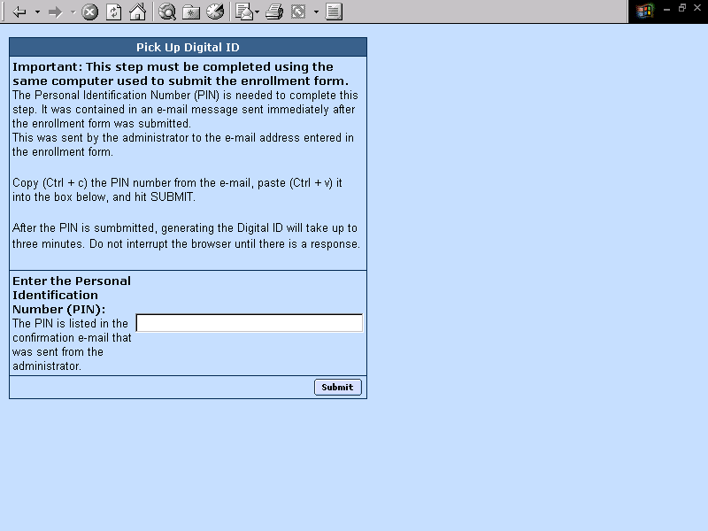

- Export the digital certificate by using the Certificate Manager. In Internet Explorer, go to the Tools menu on the taskbar select Internet Options. The Certificate Manager is on the Content tab.
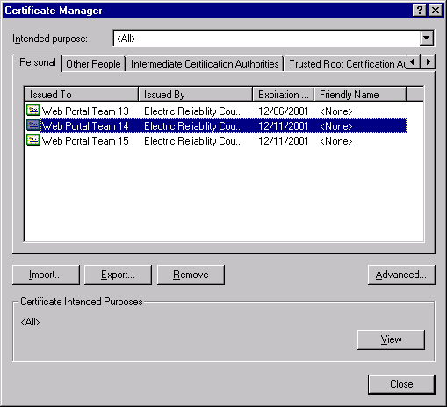
- Select the digital certificate to export and click the Export button.
- Type the password that will be used when the user imports the file.
- Select the path and filename to export the digital certificate. It is the responsibility of the USA to back up the user digital certificates in a safe place such as a floppy disk.

User Installation of the Digital Certificate
Once the user has been registered, the digital certificate will be received as an attachment in an e-mail message from the USA.
Note: To maintain a high level of security, it is suggested that the USA transmit the user password over the phone. The password should adhere to normal password guidelines such as at least 6 characters, mixed case and at least one non-alphanumeric character.
To install the digital certificate:
- Open the attachment.
- Enter the user password given by the USA to gain access to the file.
- Select the Save File to Disk radio button.
- Select the path where the digital certificate will be saved. It is important to choose a path you will remember and back up the digital certificate in a safe place such as a floppy disk.
- Click Save.
After the certificate is accessed for the first time:
  - Access the portal by opening the browser on the PC in which the digital certificate was installed.

Topic 3: Updating user digital certificates at the portal

Updating user digital certificates at the portal
This topic will introduce market participants to the process of updating user digital certificates at the portal.

Topic Overview
There are three instances in which a user’s information or digital certificate would be updated:
- A change in a user’s role or email
- Renewing a digital certificate
- A change in the USA of a market participant

Process

Update a user’s email or role

- Identify a change to a user’s email or role.
- Access the Update User screen.

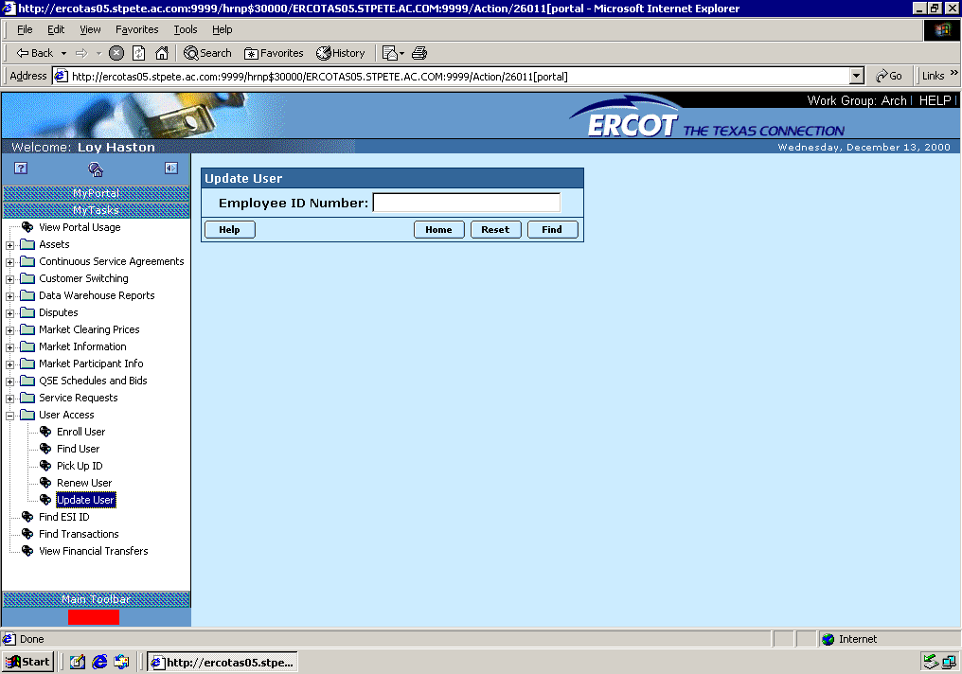
- Enter the employee ID number at the Update User portal screen to search for the user. The Update User Details screen appears.
Note: The employee ID number is a number given by the market participant to each employee in the company.

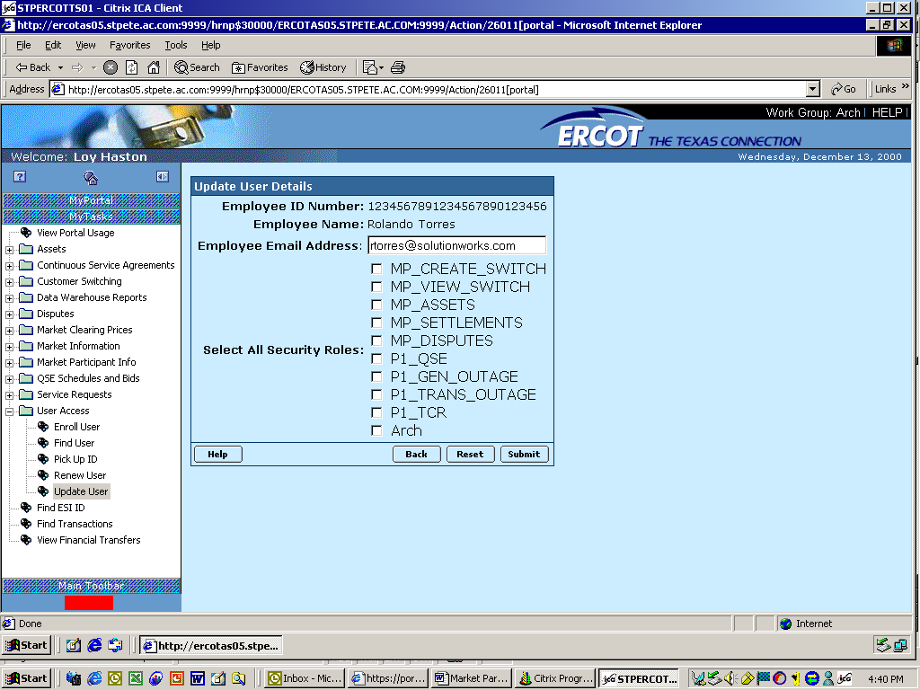
- Change the user email and/or role(s).
Note: If the user’s email or role changes, a new digital certificate does NOT have to be issued. However, if a user’s name or employee number changes, a new digital certificate must be issued.

Renew Digital Certificates
- VeriSign sends a renewal notification email to the USA 60 days prior to the expiration of a certificate.
- The USA reviews the VeriSign email and creates both a service request and a request for the renewal at the portal.

- To complete the Renew User screen at the portal, follow these steps:
- Access the Renew User screen at the portal.

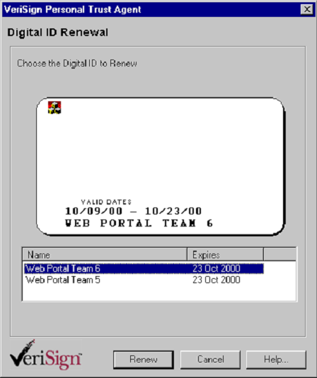
- All digital certificates that will expire within 60 days appear. Select the correct digital certificate to renew.
- Submit the request.
Note: If the USA wishes not to renew the certificate, nothing needs to be done. The certificate will automatically expire on the expiration date.
- This renewal request is submitted directly to VeriSign. Therefore, to notify ERCOT of the renewals a service request must also be submitted at the portal.
- To complete the Create Service Request screen at the portal, follow these steps:
- Complete all of the information on the Create Service Request screen. The fields labeled in bold are required.
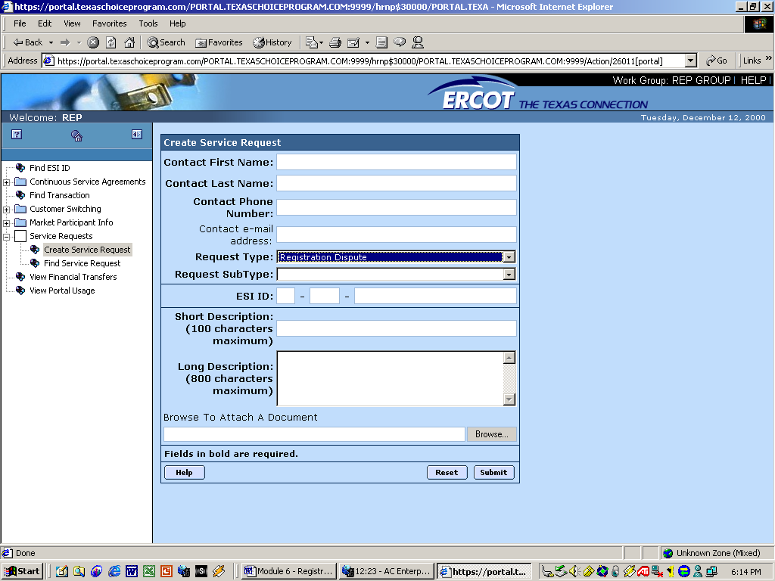

- In the Request Type field, choose Update Market Participant User Information from the drop down menu. When this option is chosen, the Request Sub Type field appears. Choose the DC User subtype from the drop down menu.
- The Short and Long Description fields should clearly identify that this is a renewal request and should include the names of those users to be renewed.
The Short Description field has a 100 character max. The Long Description field has an 800 character max.
- Click the Submit button at the bottom of the screen once the fields are complete. If the send is successful, a confirmation screen appears to confirm the submission.
Note: For more information regarding service requests, see Module 3: Service Requests.
- When the new digital certificate is issued, the USA downloads and forwards the digital certificate to the user.

Change Market Participant USA

When a new USA is identified for a market participant, a service request is created by the current USA at the portal.
- Access and complete the Create Service Request screen at the portal.
- The type to select is Update Market Participant User Information. Select Change USA as the Sub-type.
- In the Short and Long Description fields, identify key information such as the name of the new USA, the new role, if any, of the old USA, whether or not the new USA already has a digital certificate, etc.
- Click the Submit button at the bottom of the screen once the fields are complete. If the send is successful, a confirmation screen appears to confirm the submission.

- If the current USA is still a user, that person’s role will be updated by ERCOT.
- If the current USA will no longer be a user, ERCOT will revoke the current USA’s digital certificate immediately.
- If the new USA currently has user security access, ERCOT will simply update the role attached to the new USA’s digital certificate.
- If the new USA is not a current user, ERCOT will register the new USA just as the initial USA was registered and a digital certificate will be issued.
- In addition to completing the service request at the portal, the market participant is required to fill out the Notice of Change of Information Form to register the new USA. All changes to initial registration information must be addressed in this manner. Access http://www.ercot.com/ to download this form.

Topic 4: Revoking user digital certificates at the portal

Revoking user digital certificates at the portal
This topic will introduce the participants to revoking user digital certificates at the portal.

Topic Overview
Digital certificates are set to expire within one year of being issued. If a USA chooses not to renew the digital certificate prior to expiration, the digital certificate will automatically be revoked or expired. However, there may be times when a digital certificate needs to be revoked prior to the expiration date. Examples of this include a user leaving the company or a user changing their name. In the first example, the digital certificate is simply revoked but in the second example, the digital certificate needs to be revoked and a new certificate needs to be issued.

Process

Revoking a User
To revoke a user, the USA must access the Create Service Request screen.
- Access the Create Service Request screen.
- The request type to select is Update Market Participant User Information. Select Revoke User as the Sub-type.
- In the Short Description field, include a description of the reason for the revoke request. A user leaving the company is the most likely reason.
- Click the Submit button at the bottom of the screen once the fields are complete. If the send is successful, a confirmation screen appears to confirm the submission.

Topic 5: Portal Usage

Portal Usage
This topic will introduce you to viewing portal usage through the portal.

Topic Overview
The USA within the market participant company can view portal usage and the details that surround user access at the portal.

It is also the responsibility of the USA to manage the digital certificates of their users by keeping track of certificates that need to be revoked, renewed, etc.

Process

Viewing Portal Usage

- To locate a user’s last logon date for a specific period of time, access the View Portal Usage screen.

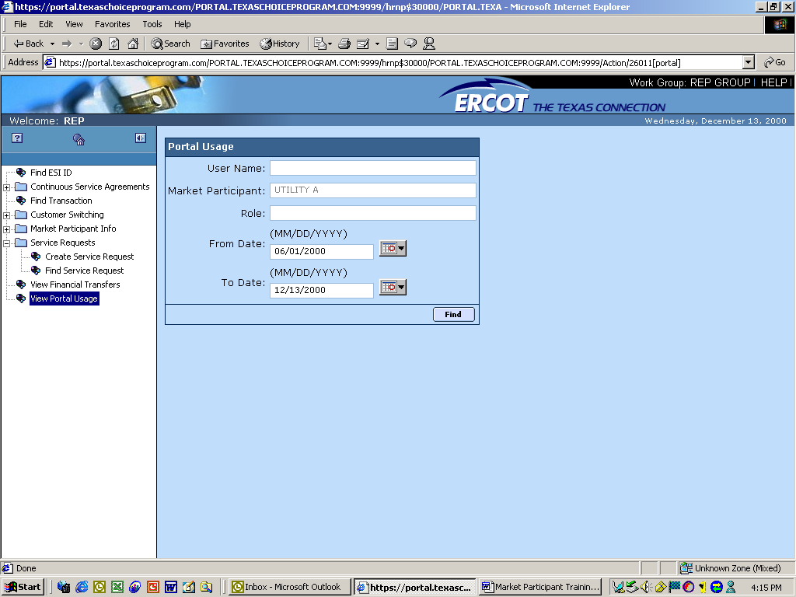
- Enter the user name. The Market Participant field will automatically populate with your company’s name.
- Select the role or roles depending on query criteria.
- Choose the date range.
- Select Find to search for the user.
The Portal Usage Lookup Results screen appears. This screen is a read-only screen that permits the USA to view all search results based on the criteria entered above.

- View the user information to verify.
  - Select the Excel button to import a report into a spreadsheet. OR
  - Select the Report button and the Report Form screen appears where you can view or print the report.

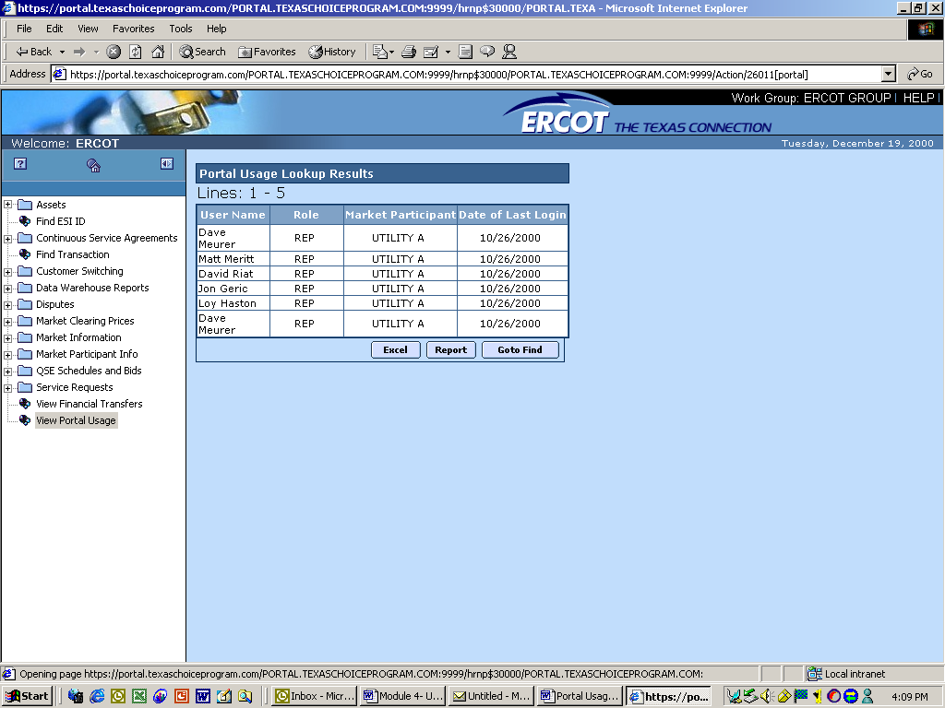

Verifying ERCOT’s Identity

ERCOT has designed its systems to use private label certificates. Using private label certificates gives an extra level of security and ensures that when using the portal you can be comfortable knowing that the information being exchanged has not been tampered with. When using Internet Explorer, a padlock icon will show up in the bottom right hand corner when a secure connection is established.


When the padlock is displayed, you have a secure connection to ERCOT systems. Using the digital certificate that ERCOT issued ensures that you could only be authenticated by an ERCOT server.

Topic 6: Certificate Protection and Recovery

Certificate Protection and Recovery
This topic will introduce you to simple security measures that can be taken when using digital certificates.

Topic Overview
This section defines the best practices for processes that a market participant should follow to ensure the protection and recovery of their private keys and associated digital certificates. These processes are private key and associated digital certificate distribution, storage and backup.

Processes

Distribution
This section describes the private key and digital certificate distribution process for the USA and the end users.

USA
The USA is the single entry distribution point for all digital certificates issued by ERCOT for a market participant. The USA should receive his/her digital certificate (and bound private key) via a floppy disk through registered mail. Once registered (has a valid digital certificate) with ERCOT, the USA requests and retrieves digital certificates for the market participant end user from his/her workstation through a secure web access protocol (https). The market participant should physically secure this workstation, preferably locating it in a locked room, making it accessible only to the USA (and an approved proxy to handle situations where the USA is not available to perform his/her tasks). Additionally, this workstation should not be available to the internal network and should have limited Internet access (only connected when needed to access the
ERCOT digital certificate management pages). This workstation should have firewall protection (either a software or hardware solution).

End User
The USA distributes digital certificates he/she receives from ERCOT to the end user. This distribution process involves exporting the end user’s digital certificate (along with the associated private key) from the USA workstation’s browser and delivering the certificate file to the end user (preferably via a floppy disk). When exporting the certificate file (with its associated private key), the USA should password protect the private key. The password should adhere to normal password generation guidelines (such as, at least 6 characters, mixed case and at least one non-alphanumeric character).

The final distribution step involves installing the certificate. This installation step depends on the usage type (i.e., web portal, programmatic or file transfer).

Web Portal
For web portal usage, the end user imports the digital certificate into his/her workstation’s browser. When importing the certificate, the end user should password protect the private key for runtime usage (this should be a different password than the one the USA created to protect it for import). Again, the password should adhere to normal password generation guidelines (such as, at least 6 characters, mixed case and at least one non-alphanumeric character).

Programmatic
For programmatic usage, the end user imports the digital certificate into the file identified by the https client program as the key input file. If the client program supports it, the private key should be password protected.

File Transfer
For file transfer usage, the end user imports the digital certificate into the PGP client program key ring files (pubring.pkr and secring.pkr). When importing the certificate, the end user should password (called passphrase by the PGP client program) protect the private key for runtime usage.

If feasible, the end user workstation should be physically secure. If this is not a feasible option, the workstation should incorporate a strong password log on scheme. Additionally, the end user workstation should be within a firewall-protected network.

Once the end user installs the digital certificate, the USA should retrieve the floppy disk containing the file and securely store it.

Storage
This section describes the private key and digital certificate storage process for the USA and the end users.

USA
The USA will have initial access to all digital certificates (and the associated private keys) for the market participant. Upon distributing a digital certificate to an end user, the USA should remove the file from his/her workstation and place it on a removable media that is subsequently stored in a safe location (preferably a safe).

As stated in the distribution process section, the USA workstation should be secure (only accessible by the USA and his/her proxy). Additionally, the USA should execute a virus scan program on his/her machine on a regular basis.

End User
The digital certificate storage process for the end user depends on the usage type (i.e., web portal, programmatic or file transfer).

Web Portal
For web portal usage, the end user imports the digital certificate into his/her workstation’s browser. The end user should not store any copies of the file (it should only reside in the browser’s database). Along with the password protection of the private key implemented during the distribution process, the browser also protects access to the user’s digital certificate through the operating system’s user account management. The user must log on through their normal username/password to access their digital certificates in the browser. The end user should ensure that his log on password adheres to normal password generation guidelines.

Programmatic
For programmatic usage, the end user imports the digital certificate into the file identified by the https client program as the key input file. The end user should locate this file in a protected directory (only accessible by his/her log on account). The end user should not store any copies of the file.

File Transfer
For file transfer usage, the end user imports the digital certificate into the PGP client program key ring files. The end user should locate these files in a protected directory (only accessible by his/her log on account). The end user should not store any copies of the file.

As stated in the distribution process section, if feasible the end user workstation should be secure or at least incorporate a strong password user log on scheme. Additionally, the end user should execute a virus scan program on his/her machine on a regular basis.

Backup
The USA should define and support the private key and digital certificate backup process. As the USA is the single point of entry for all digital certificates issued by ERCOT, he/she should ensure that a backup copy of each file is safely stored. No other users should have access to the backup files and no other copies of the files should exist.

