From Control Panel Select Network and Dial-up Connections
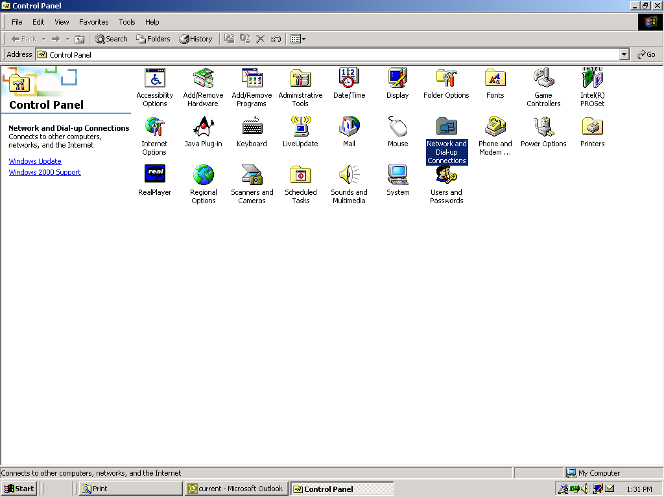

Select Make New Connection
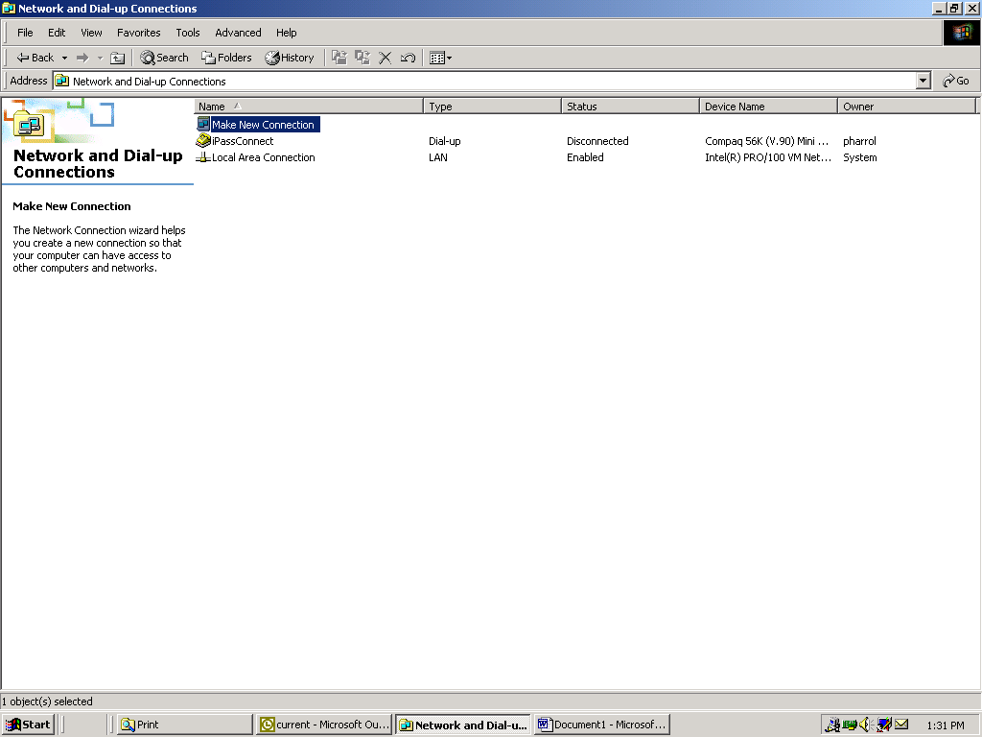
Select Next
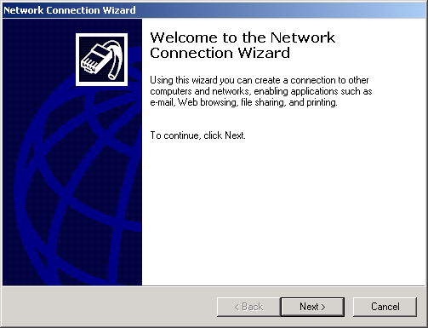

Select Dial-up Private Network and Next

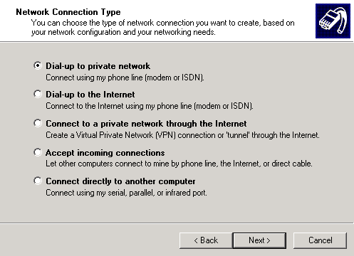

Depending on your machine select the appropriate modem (screen print NOT shown) for Production support laptop select 56k Modem only and then Next

Enter phone number 713-440-4221 and Next

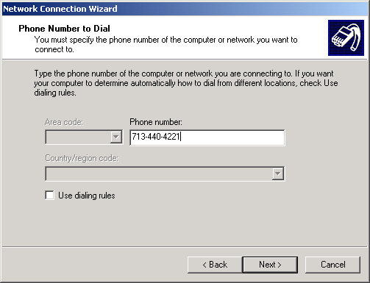
Select For all users and Next
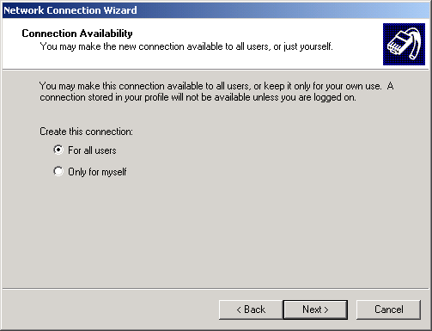

Name the connection and Finish
