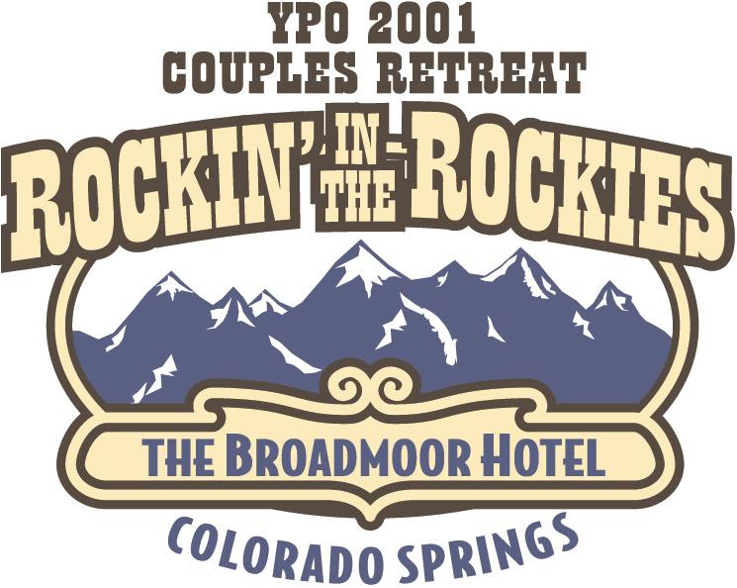

Dear Members,

Event Chairs

Kevin & Wendy Whalen

Committee Chairs
Greg & Ronda Brenneman

Larry & Pam Del Papa

John & Maureen Graf

Blake & Shawn Hogan

Mike Holthouse

Mark & Jennifer Kuebler

Mike & Patti Morgan

David & Marcia Solomon

Roy & Kim Steinhagen

REFRESH…. RELAX…. RENEW…. RECOMMIT….

RETREAT!!!!!!!!

Your Retreat Committee has put together a fabulous mix of education and recreation in beautiful Colorado Springs at the spectacular Broadmoor Hotel.

Space is limited. In order to secure your spot on this year’s couples’ retreat please send in your completed registration form and your deposit by May 15, 2001.

We are all looking forward to ROCKIN’ IN THE ROCKIES with you!

Your Retreat Committee

