Residential Broadband Access

The most popular flavor of digital subscriber line (DSL) is Asymmetrical DSL. ADSL is primarily a residential offering and most service providers are deploying this technology because it allows customers to use one line for both data and voice. As the name implies, ADSL transmits data at asymmetrical rates in the downstream and upstream paths. Downstream speeds range from 1.5 Mbps to 8 Mbps and upstream speeds range from 64 Kbps to 640 Kbps depending on the customer's distance from the telco's central office.

ADSL Lite is a variant of ADSL that is based on the G.Lite industry standard for DSL modems. It is also targeted at the residential market. It is called "Lite" because it offers maximum transmission speeds of 1.5 Mbps downstream and 512 Kbps upstream. The major benefit of ADSL Lite (G.Lite) is that subscribers can install the modem themselves since it does not require a splitter in the home to separate voice from data traffic. This fact should eliminate the need for an installation truck roll about 85% of the time, which means that ADSL Lite will effectively remove the biggest gating factor in the deployment process. The industry tends to use the general term DSL interchangeably with ADSL and G.Lite when referring to the residential market.

DSL Subscribers - A Third Quarter (September) Progress Report

The dominant service providers in the DSL market include incumbent local exchange carriers (ILECs): BellSouth, SBC (including Ameritech), US West (Qwest) and Verizon (formerly GTE and Bell Atlantic) and competitive local exchange carriers (CLECs): Covad Communications, NorthPoint Communications, and Rhythms NetConnect. These service providers account for 85% to 90% of the domestic DSL market.

DSL Cumulative Subscribers (in Thousands)
Service Provider | 3Q99 | 4Q99 | 1Q00 | 2Q00 | 3Q00 | CY00 Target
ILECs
BellSouth | 20 | 30 | 49 | 74 | 134 | 200
SBC | 59 e | 115 | 201 | 399 | 516 | 1,000 ⁽¹⁾ e
US West | 80 | 110 | 135 | 175 | 213 | 250
Verizon | 50 e | 87 | 150 | 221 | 351 | 500 e
Subtotal | 209 e | 342 | 535 | 869 | 1,214 | 1,950
As % of Total | 81% | 79% | 78% | 79% | 78% | 81%
CLECs
Covad | 31 | 57 | 93 | 138 | 205 | 270
NorthPoint | 11.8 | 23.5 | 41.3 | 62 | 87.3 | 125
Rhythms | 6.7 | 12.5 | 20 | 31.1 | 47 | 67
Subtotal | 49.5 | 93 | 154.3 | 231.1 | 339.3 | 462
As % of Total | 19% | 21% | 22% | 21% | 22% | 19%
Total | 258.5 | 435 | 690.3 | 1,100.1 | 1,553.3 | 2,412
Note: e = estimate
(1) SBC indicates its 1 million subscriber target will likely occur during the first quarter of 2001
Source: Company documents and Raymond James' November 13, 2000 analyst report.
The previous installed volumes include self-installs. The ILECs estimate that self-installs have a success rate of 75% to 85%. During the third quarter 2000 DSL self-installs were reported by SBC to be 50%, by Verizon to be 90%, and by BellSouth to be 90% of DSL net adds.

DSL providers still struggle with several systematic problems including line provisioning and installation issues, incomplete back-office systems, and limited installation forces which continue to affecting the roll-out of DSL.

DSL Subscriber Forecast for US Residential Market

The table below contains DSL forecast below developed by Gartner, Lehman Brothers, and International Data Corporation (IDC). Given the actual cumulative installations by the dominate service providers, it appears that DSL deployment is ahead of schedule for 2000. Year end 2000 estimates by Gartner and Lehman Brothers were achieved at the end of the third quarter.

The widespread introduction of "splitterless" technology allowing most end users to self-install, configure and provision was the major technology leap allowing the uptake in DSL in 2000. This technology is also much more economical for the telecom companies, as they save the $100 - $150 per truck roll. The ultimate objective is to integrate DSL into the PC as SBC has pioneered with Compaq.

Service (in 000s) | 1999 | 2000 | 2001 | 2002 | 2003 | 2004
DSL (1) | 440 | 1,492 | 3,009 | 5,325 | 7,523 | 9,814
DSL (2) | 581 | 1,517 | 2,856 | 4,138 | 5,496 | 6,910
DSL (3) | 520 | 1,870 | 4,110 | 7,780 | 12,570 | 16,341
Source: (1 Gartner Dataquest (June 2000)
(2) Lehman Brothers (June 1999)
- IDC (September 2000) does not include DSL wholesale lines which were forecast at 75k,
300k, 900k, 1,945k, 3,110k, and 4,200k for 1999 through 2004.

Households Passed and Take Rates

Estimates by Morgan Stanley Dean Witter of the US DSL access market are detailed in the table below. Customer access to ADSL service is limited by distance. With current technology, the customer must be located within 18,000 feet of a telco's central office.

 | 1999 | 2000 | 2001 | 2002 | 2003 | 2004
Households Passed (000s) | 25.8 | 37.6 | 51.5 | 63.6 | 67.5 | 69.6
As % of US Household | 25% | 36% | 48.9% | 65% | 75% | 80%
% Take Rate | 1.7% | 5% | 11.2% | 16% | 21.3% | 26.7%
Source: MSDW The Broadband Report, May 2000

Capital Expenditures

As the roll-out of DSL unfolds, investments in the space have gone from being a golden child to being a pariah. Across the board, equity valuations of both service providers and equipment manufacturers have dropped 60% to 90% from their highs thus crimping the influx of investment dollars into the DSL arena. Two ILECs have shown financial interest in two of the data CLECs; Covad (SBC) and NorthPoint (Verizon). However, Verizon has cancelled its planned merger with NorthPoint due to NorthPoint's dramatic drop in stock value.

ADSL technology has a variable capital structure, which will enable providers to capture reduced equipment costs per subscriber as the roll-out progresses. ADSL is delivered by connecting a subscriber to a DSLAM port in a central office and installing a modem at the customer's home, thereby creating a dedicated broadband connection. The DSLAM supplies the line code that enables high speed transport over copper, terminates multiple access lines, organizes data into packets, aggregates traffic, and then passes that traffic to a digital circuit for transmission to a network operation center (NOC), regional data center, ISP, or corporate network. DSLAMS range in price from $13,000 to $50,000 or more and can serve up to 576 access lines. The chart below provides a breakdown of the capital structure required for ADSL deployment. As more customers are served by each DSLAM, the capex per subscriber decreases.

ADSL Capex per Subscriber, Years One to Three

Note: DLC stands for digital loop carrier. Areas served by a DLC do not qualify for DSL without installation of DLC-compatible equipment.

DSL Current Basic Residential Price Offerings

Over the past few months, most of the major ILECs have brought their DSL prices to the sub-$50 level per month, including ISP service. This price would equate to a payback period of about 1 year depending on the service provider fees and whether the customer self-installs.

Basic Consumer ADSL Always-on Offer, Including Internet Service
 | SBC | Verizon | Qwest (US West) | BellSouth
Monthly fee | $39.95 | $39.95 | $47.90 | $49.95
CPE charge | $99 (with a $99 rebate offer) | Free | Free | Free
Installation | $150 ($0 self-install) | $120 ($0 self-install) | $99 ($0 self-install) | $200 ($0 self-install)
Internet Service | Included (SBC Internet) | Included (Verizon Internet) | Included (USWest.net) | Included (BellSouth Internet)
Speed (down/up) | 384-1500/128 kbps | 256-640/90 kbps | 256-640/272 kbps | 192/192 kbps
Extra email accounts | 2 | 4 | NAV | NAV
Contract length | 12 | 12 | 0 | NAV
Additional promotion | -- | -- | -- | $40/mo with other services
DSL-ISP/Mo (no self-install or rebate) | $60.70 | $39.95 | $47.90 | $49.95
DSL-ISP/Mo (w/self-install & rebate) | $39.95 | $39.95 | $47.90 | $49.94

Notes:
- SBC is for Basic DSL Southwestern Bell offer in Texas
- Verizon is for Verizon Online DSL Personal
- Qwest is for MegaBit Deluxe product offering. $99 installation offer only during promotional period. Modem only free if customers selects internal Intel 2100 DSL Modem. External Cisco 675 modem costs $150. Note that Qwest has more basic offering, MegaBit Select, for a basic charge of $19.95/mo (plus Internet service). MegaBit Select requires the user to re-logon every two hours.
- BellSouth is for FastAccess basic offering.. If customer also subscribes to BellSouth Solutions monthly cost is $40 with one free month of DSL service.

Also included in this summary (in the appendix) is a summary of broadband access technology alternatives available to end-users and a chart illustrating the network architecture required to deliver DSL to the home.
Appendix

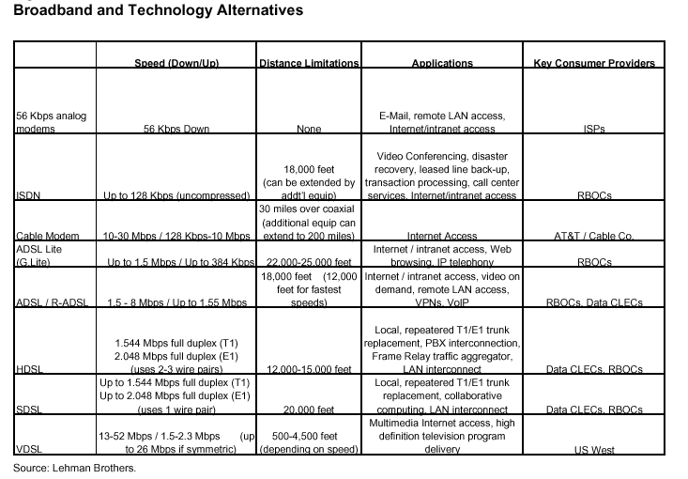
The table below defines the various methods of broadband access to the household.

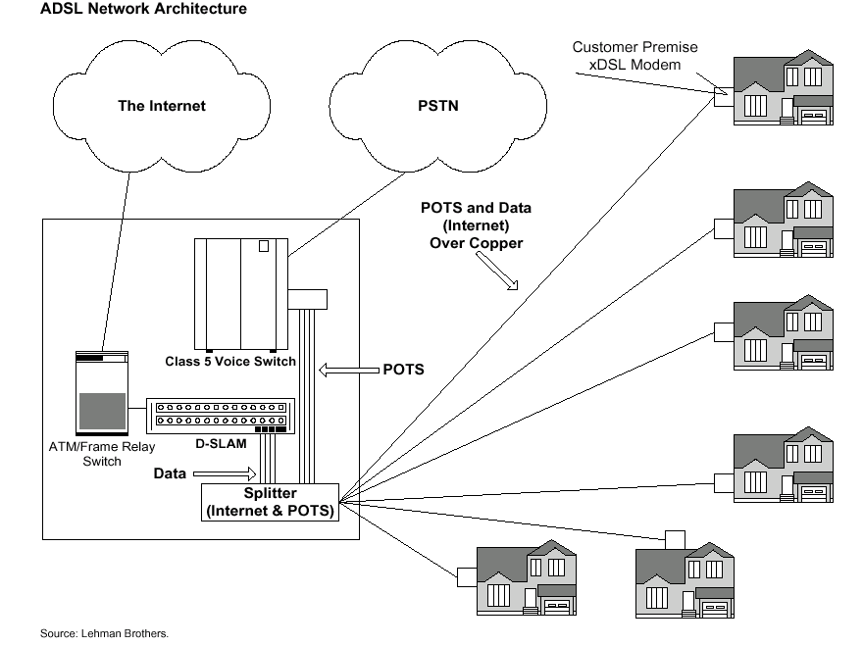
The chart below illustrates the network architecture required to deliver DSL to the home.

