DRIVING DIRECTIONS TO SOUTH SHORE HARBOUR RESORT & CONFERENCE CENTER
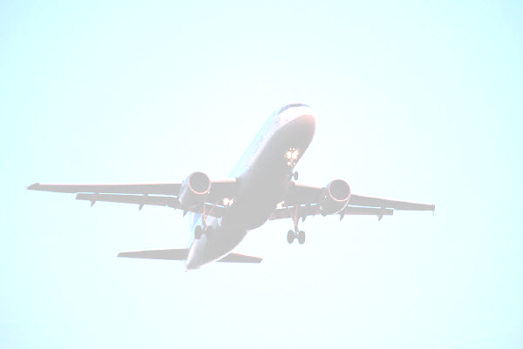
FREE HOBBY SHUTTLE SERVICE!
Complimentary Hobby Shuttle Service is available from 6:30 a.m. until 10:00 p.m.
Please remember if you are needing complimentary Hobby Airport Shuttle Pick-Up or Delivery. 24-hour advance reservations are required. CALL 281-334-3873.
From William P Hobby Airport:
Exit Hobby Airport onto Airport Boulevard-take Airport Boulevard eastbound until you approach the intersection of I-45/Airport Blvd. Turn right onto the feeder of I-45 South. Head south bound towards Galveston. Take Exit 23 off of 1-45 South, which notes League City, Kemah and FM 518. Go East (left) under the underpass approximately four (4) miles. FM 518 will turn to the right, but continue straight on FM2094 and Marina Bay Drive past the schools, drive approximately one (1) mile to the intersection with the Randall’s Shopping Center on the right, and the entrance to SOUTH SHORE HARBOUR RESORT on the left.

From Bush Intercontinental Airport:
Go South on Highway 59. Take Beltway 8 (toll fee), go East and continue to the I-45 Galveston Exit. Turn right onto the feeder of I-45 South. Head south bound towards Galveston. Take Exit 23 off of I-45 South, which notes League City, Kemah and FM518. Go East (left) under the underpass approximately four (4) miles. FM 518 will turn to the right, but continue straight on FM2094 and Marina Bay Drive past the schools. Drive approximately one (1) mile to the intersection with the Randall’s Shopping Center on the right, and the entrance to SOUTH SHORE HARBOUR RESORT on the left.

THE HOTEL IS ELEVEN (11) STORIES TALL, AND IS THE RED BRICK BUILDING BETWEEN THE TWO WHITE OFFICE BUILDINGS, THERE IS FREE PARKING UNDERNEATH HOTEL AS WEAS WELL AS OUTSIDE PARKING.

Directional Map

