Beginning 10/2/01, when logging on to the ETS Daily Market Summary located on the ETS Intranet site at http://www.ets.enron.com/ under the dropdown link "Applications" / "Daily Market Summary" you will be prompted for a username and password. The username and password you must enter in is your CORP ID and PASSWORD. Therefore, to access the Daily Market Summary you must request rights (if you don’t already have them) via .

The following is a brief tutorial on the Daily Market Summary application for all ETS pipelines (NBPL, NNG, FGT and TW)

The three main functions of the Daily Market Summary are navigating, editing, and administering.

Navigation Page
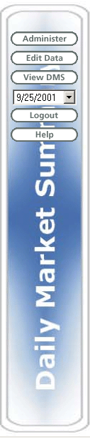
This is the navigation menu that resides on the left frame at all times. Your navigation menu changes according to the user group you belong to in the Daily Market Summary. If you belong to both the admin group and edit group your navigation menu will look exactly the same as the one shown here. If your access only allows you to view only, it will look differently. Three groups were created for the Daily Market Summary:

- Data_ETS_DMS_Admin
- Data_ETS_DMS_Edit
- Data_ETS_DMS_View

If you belong to the “Data_ETS_DMS_Edit” group then you should only see the “Edit Data” button and the “View DMS” button. If you belong only to the “Data_ETS_DMS_View” you should only see the “View DMS” button.

When you successfully logon to the Daily Market Summary the report for the previous day will automatically load. If you want to see the Daily Market Summary report for another day, then click on the drop down box, select your preferred date, and click on the “View DMS” button. Your business object report will load up to the right of the navigation menu.

Navigation Page View / Print
After logging on with your corp ID and password, the system will retrieve the report and you can then view and / or print the Daily Market Summary. The new report is in a PDF format
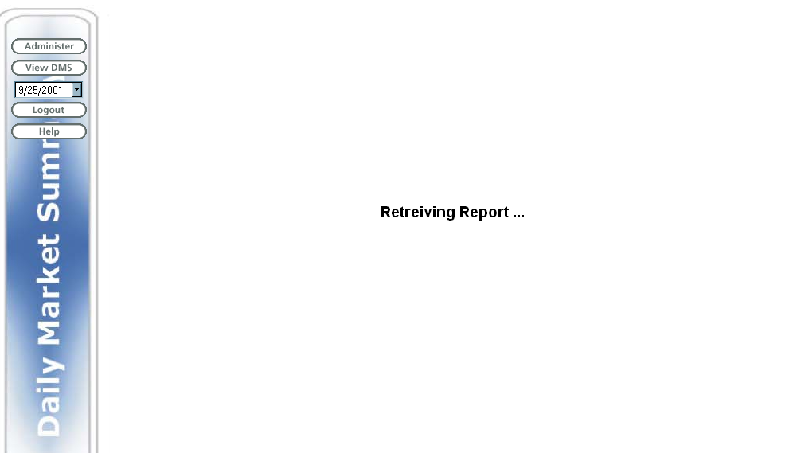

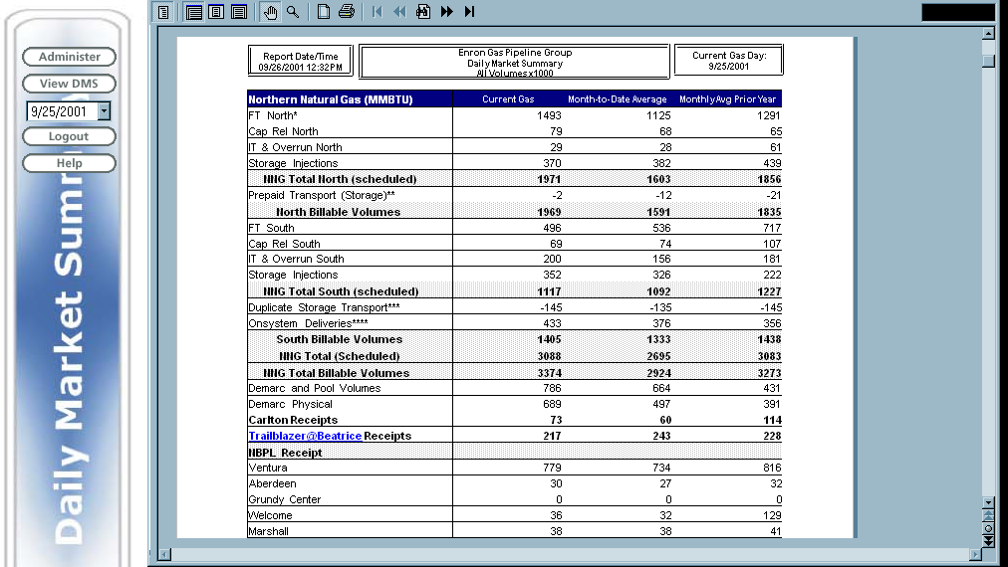

Edit Page

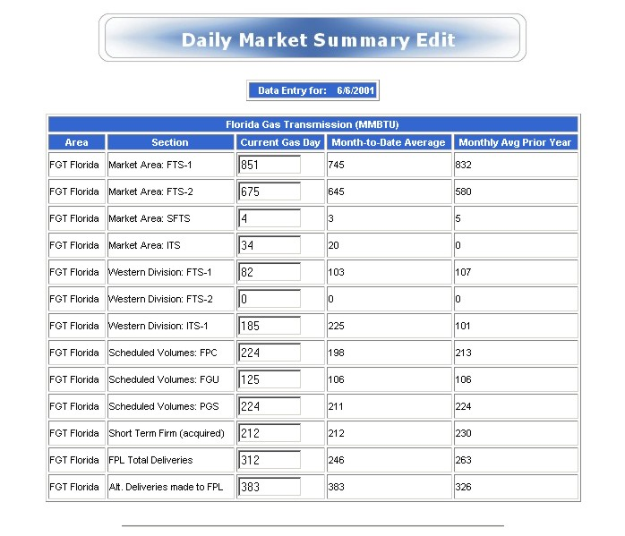

If you belong to the “Data_ETS_DMS_Edit” group you can reach the edit page above by clicking on the “Edit Data” button on the navigation menu on the left hand side of your screen in the browser. In the edit page, you will only be able to see pipeline data to which you have rights to edit. For example, if you only have rights to edit NNG and FGT data then you will only see two tables labeled “Florida Gas Transmission (MMBTU)” and “Northern Natural Gas (MMBTU)” on the edit page. To update data simply put in the values you want to change in the textboxes (the values you see in the text boxes will be the current values in the database). Scroll down to the bottom of the page and click the “Update Data” button. The page that is returned should reflect the changes that you made to the database.

Administrator Only
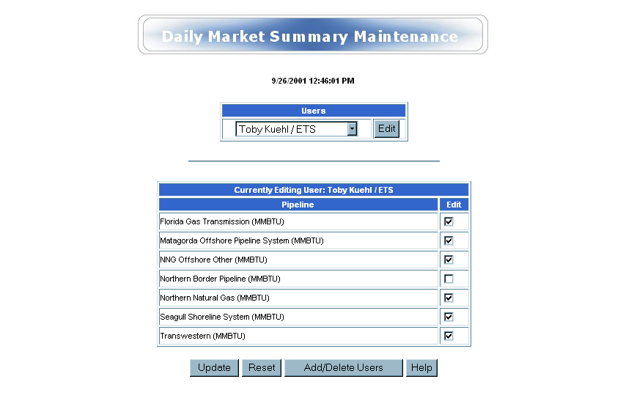
If you belong to the “Data_ETS_DMS_Admin” group then you can reach the admin page above by clicking on the “Administer” button on the navigation menu on the left hand side of your screen in the browser. To update a user you must click on the user you would like to administrate, and then click on the “Edit” button. When the page refreshes the first cell in the second table should now read “Current Editing User: (user you selected here)”. Therefore, when you click on the “Update” button the user that is updated is the user whose name is in the first cell of the second table. If you want a user to be able to edit data for a certain pipeline just make sure that the checkbox for that pipeline is checked when you update the user. After you update the user, the page you get in return should now reflect the changes you made to the database.

In the new Business Objects report, you will have the same access rights you had in the old DMS report.

Example: If you had view only access rights, you will continue to have the same type access in the new Business Object report.

You should find that the new Daily Market Summary is very easy to navigate and update your daily information for each pipeline. It you should have any questions please give ma a call at 31527.

Toby Kuehl

ETS Gas Logistics

