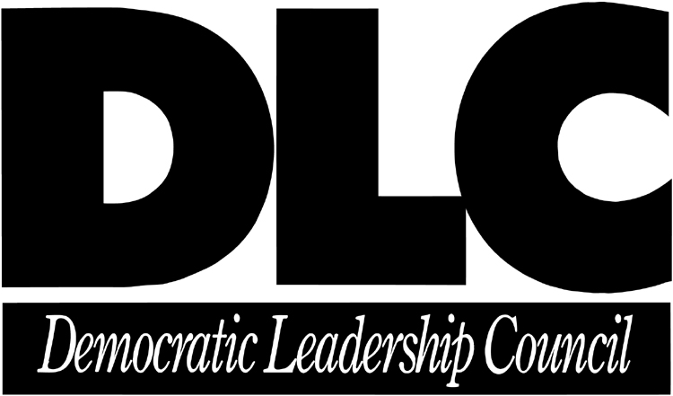

DLC WILL CALL REMINDER

Pick up tickets for Thursday evening’s event on
Wednesday, November 28,
11 a.m. – 3:30 p.m.

There will be no registration for the event at the door. You must pick up your tickets for the 2001 DLC HOLIDAY PARTY at Will Call.

Where: DLC OFFICES
600 Pennsylvania Ave., SE
Suite 400
Washington, DC

If you have any questions or to RSVP, please contact the
Development Department at (202) 546-0007.

By Invitation Only: If you are not already a member of the DLC and are interested in
joining and attending this special event, please ask for the Development Department.

