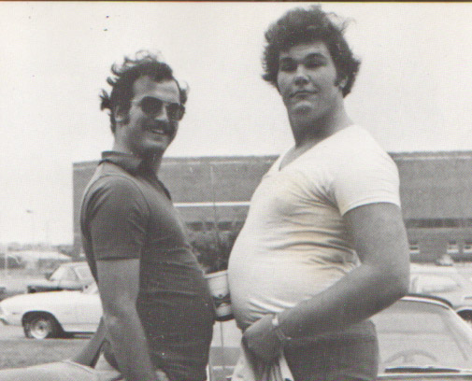

Drunken Beta

I'm a drunken Beta and I love my Haig and Haig
I love my Johnny Walker and I love my lady's leg
I love my beer and whiskey
I love my Rock and Rye
for I'm one of the drunken crew of Beta Theta Pi
Now if you see a pretty girl,
you treat her just like this...
you put your arm around her hips
and on her lips a kiss
and if she starts to murmur
and if she starts to sigh,
just tell her it's a sacred seal of Beta Theta Pi.

Now Adam was the first man to wear the Beta pin
and Socrates the wisest of all the earthly men.
Samson was the strongest although he had an itch
but if Julius Caesar comes along we'll pledge the son of a...
Betas raise your voices.
Come one and all to SWELL a song.
For every loyal heart rejoices
A sounding chorus to prolong, a sounding chorus to prolong.
In grateful praise our voices blending
To her whose radiant badge we wear...WE WEAR
And in whose mystic rites we share
IN grateful praise unending
TO BETA THETA PI, Theta Pi
Our voices ringing high, ringing high.
A song, a song, full, loud and long.
To Beta Theta Pi, Beta Theta Pi, Beta Theta Pi

Who's Pater Knox?
First in war, first in peace, first in the hearts of his fellow greeks.
Bomp bomp ba bomp bomp, bomp bomp HEY!

