October 2000
Data Room and Site Visit Procedures and Indices
Enron North America Corp.
Table of Contents
1. Data Room / DealBench™ Procedures
2. Site Visit Procedures
Appendix - Data Room Indices
I. Gleason Power I, L.L.C.
II. West Fork Land Development Company, L.L.C. (Wheatland)
III. Brownsville Power I, L.L.C.
IV. Des Plaines Green Land Development, L.L.C. (Wilton Center)
V. Las Vegas Cogeneration Limited Partnership
VI. Las Vegas Cogeneration II, L.L.C.
VII. Pastoria Energy Facility, L.L.C.
1.
Data Room / DealBench™ Procedures
DealBench™

DealBench™ is a secure online transaction platform. Enron North America has set up a virtual data room containing an electronic version of all project documents for Round II bidders. Each bidder will receive access to all documents for which a Round II bid will be submitted. The majority of the project documents are in .pdf format and can be viewed using Adobe Acrobat Reader, which may be downloaded free of charge from http://www.adobe.com/acrobat. Any technical questions regarding Acrobat or DealBench™ may be directed to DealBench™'s Technical Desk at 1-877-367-7170. Technical Support is available seven days a week, 7:00 am to 7:00 pm CDT. Questions relating specifically to the assets on the Round II bidding process should be directed to Don Miller at 713-853-0492 or don.miller@enron.com.

Registering

The process for accessing due diligence documents will be as follows:

- The Deal Team Leader from your company should submit (or have submitted) a list of names and e-mail addresses of all Deal Team Members, including company officials, counsel, outside consultants, etc. to Jinsung Myung via e-mail (jinsung.myung@enron.com) or fax (713-646-8863). Each of these Deal Team Members will become an authorized person (an "Authorized Person") and be able to view due diligence documents. Each Authorized Person will have access to all due diligence documents in the electronic data room through October 30, 2000. Any Authorized Person possessing or viewing any Due Diligence information is bound by the Confidentiality Agreement signed in September 2000 between your company and Enron North America Corp.

- Each individual you identify as an Authorized Person will receive an invitation e-mail for each applicable asset. Each e-mail contains a 16-digit Deal Key number, as highlighted on the next page.

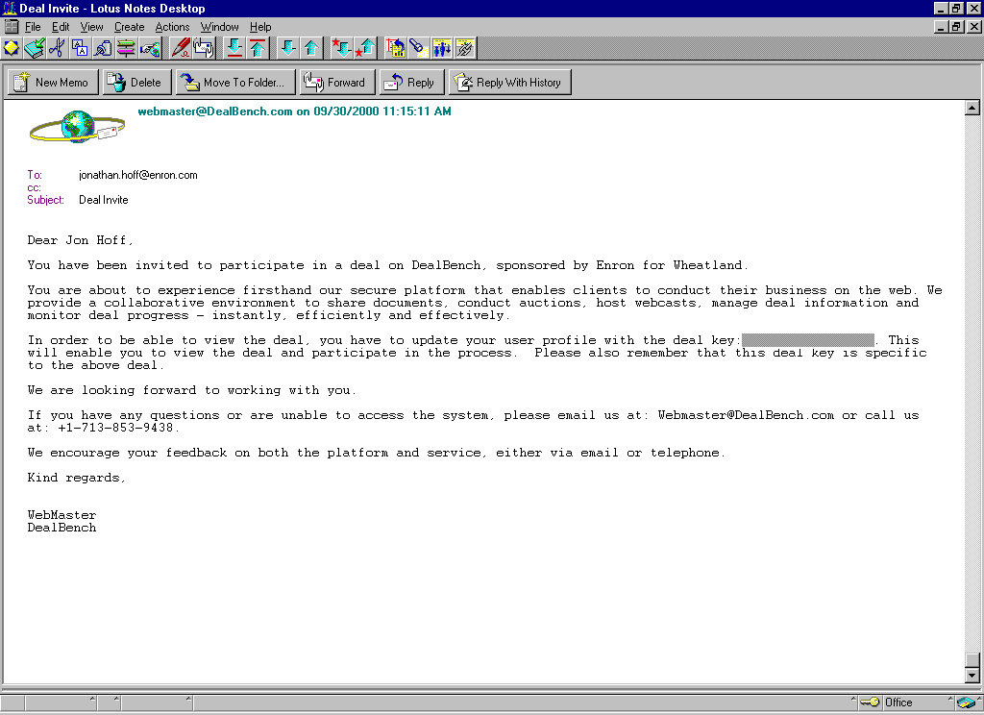

3. Using either Microsoft Internet Explorer (version 3.0 or higher) or Netscape Navigator (version 3.0 or higher), go to http://www.DealBench.com/ to register.

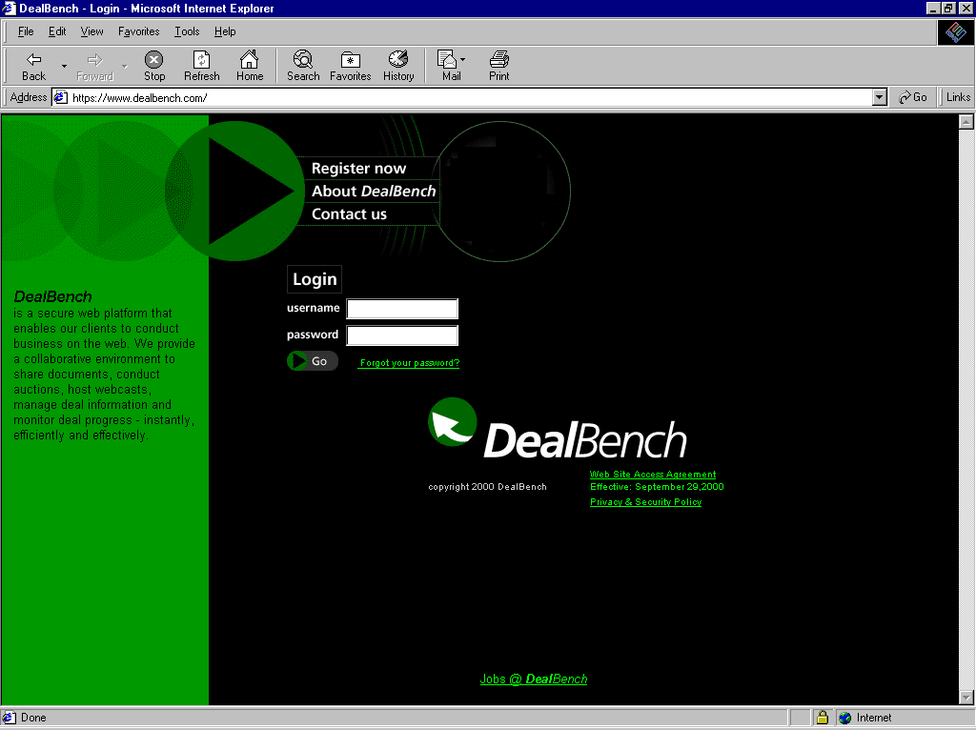

4. Click on “Register Now” to register and create your username and password. User
names and passwords must be at least eight characters long. Passwords must
contain both letters and numerical characters. Be sure to choose a username and
password that are familiar to you, as you will have to input this information each
time you log onto DealBench™.

5. Enter one Deal Key number (received in your invitation e-mail) in the Deal Key field
at the bottom of the registration page. You will have an opportunity to enter the
other Deal Keys once you have completely registered.
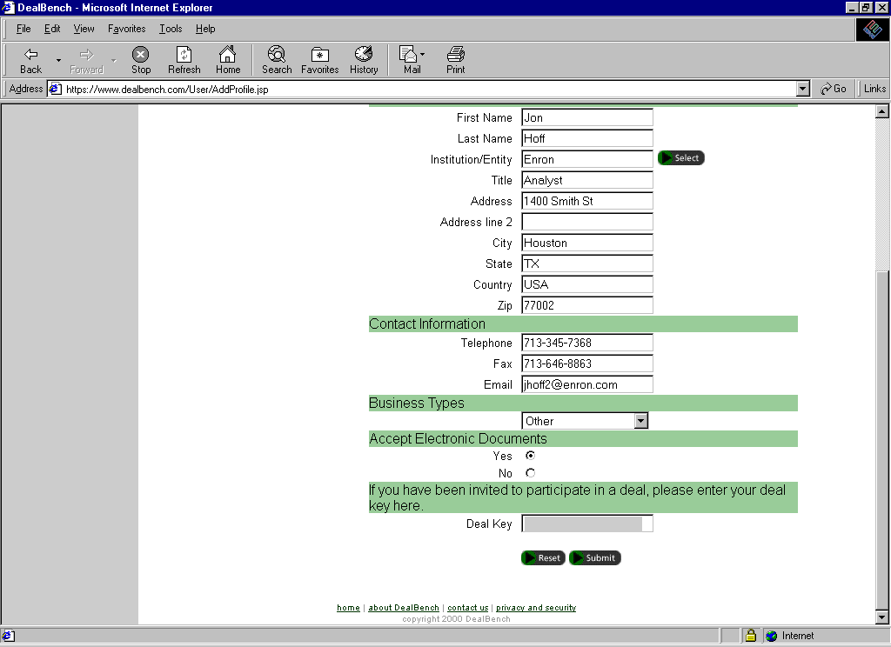

6. Log back onto DealBench™ using the username and password you created during
the registration process.

7. Bidders who receivemultiple Deal Keys will have to enter the other Deal Keys into
the system. To do this:

- On the DealBench™ home page, click on the "Update Profile" button.
- Enter the Deal Key number (one at a time) at the bottom of the Registration page. Press "Submit" once and on the next page press "Yes" to confirm that the information is correct.
- Repeat the process for each additional Deal Key you have received. For example, if you are evaluating three projects, you must receive and enter two different Deal Key numbers (you have already entered the first one during the initial registration process).
- Once you have entered all your Deal Keys and have gained access to the relevant projects, every time you subsequently log onto DealBench™, you will have access to these same projects.

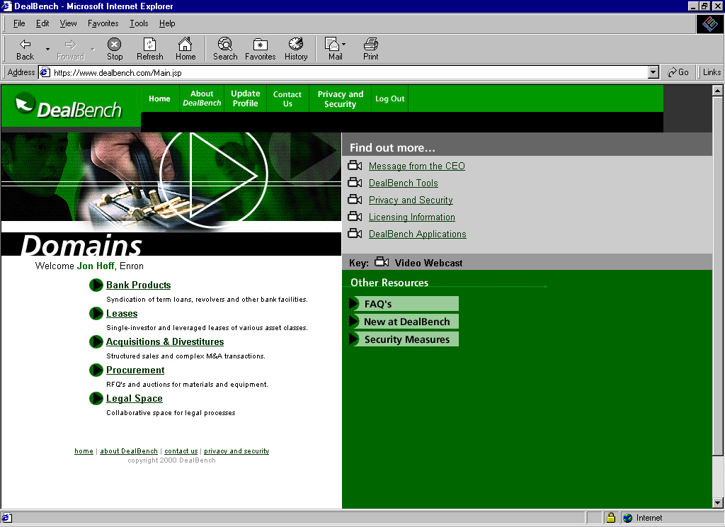

8. On the home page click on the “Acquisitions & Divestitures” link, which will take you
to the list of projects to which you have access.

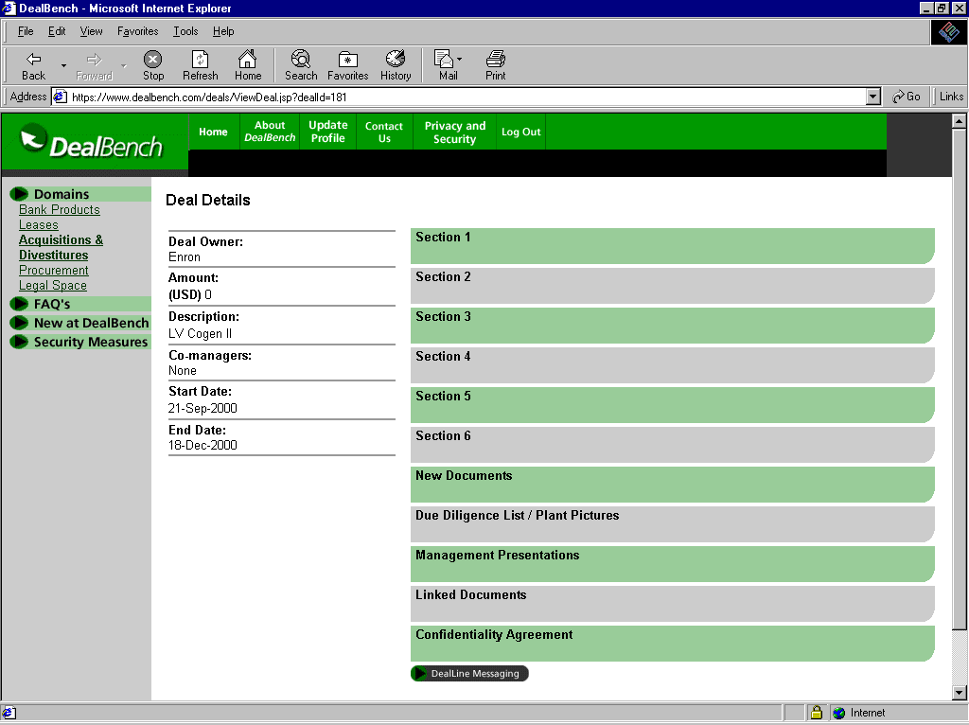

Viewing Documents

To view a document click on the document name. The appropriate reader (Acrobat, Excel, Word, etc.) will be opened to view or print the document.

Each project page has the following sections

Section 1 - Section 6
This is the location of all project documents. Refer to the Due Diligence Lists provided for a complete index of documents in these Sections.

New Documents
Any new documents added to the Due Diligence Index will be posted here and in the correct location in Sections 1-6. The Due Diligence List will also be updated.

Due Diligence List / Plant Pictures
The most recent version of the complete Due Diligence List will be found here. Also look for color plant pictures here.

Linked Documents
Provides a link to the Enron home page

Confidentiality Agreement
Not Applicable

2.
Site Visit Procedures

- Scheduling a Site Visit
- Access to the various project sites is strictly limited and is available only by appointment.
- Appointments to visit the project sites you are interested in must be made through the Project Site Visit Coordinator, Don Miller of Enron (713) 853-0492.
- Project site visits are limited to one day per company.
- Prior to your project site visit, Enron must be provided with a list of your team members, their titles, and their employer (for any outside consultants, etc.) as well as the designated Company Leader. Please fax all lists to Don Miller of Enron at (713) 646-8863.
- Project Site Access and Check-In
- Documentation will not be available for review during the project site visit. All review of documentation is to be completed by accessing DealBench™.
- When your group arrives, please proceed as a group to the security desk where the individual Project Site Visit Coordinator will greet you.
- You will be provided the name of the Project Site Visit Coordinator for the project or facility at the time of scheduling your visit.
- Project site visits will be scheduled from 8:00 a.m. to 5:00 p.m.
- During check-in, all members of your team will be required to sign in. In addition, a Company Leader must be designated who will represent your company on all questions and requests submitted during your visit.
- Your company must have previously executed a Confidentiality Agreement with Enron North America Corp. prior to admission to a project site. In addition, any members of your team who are not employees of your company (i.e., outside consultants, engineers, etc.) must also execute a Confidentiality Agreement or agree that they will comply with the terms of the Confidentiality Agreement executed by you. Extra Confidentiality Agreements will be available at the project site for execution. No member of your team will be admitted to the project site until he or she is covered by an executed Confidentiality Agreement.
- After check-in, the individual Project Site Visit Coordinator and other Enron staff members will accompany your team on the site visit.
- Presentations
- On the day of your visit, your company may be provided with a site overview presentation by the staff of Enron at the sites, if appropriate.
- Check-Out
- Team members must sign out at the end of the project site visit.
- Confidentiality
- You are reminded that any information obtained during the project site visit is to be used by you and your company solely for the purpose of the evaluation of a possible transaction between your company and Enron with respect to the proposed sale of the subject generating assets and may not be used in any way directly or indirectly detrimental to Enron or its affiliates, as defined in detail in the previously signed Confidentiality Agreement.
Appendix
Data Room Indices
I.
Gleason Power I, L.L.C.
II.
West Fork Land Development Company, L.L.C. (Wheatland)
III.
Brownsville Power I, L.L.C.
IV.
Des Plaines Green Land Development, L.L.C. (Wilton Center)
V.
Las Vegas Cogeneration Limited Partnership
VI.
Las Vegas Cogeneration II, L.L.C.
VII.
Pastoria Energy Facility, L.L.C.

