DATA CUBE MODS.

Please consider modifying the cube access to include the additional data that we have from this one area on the fundies site. We have a ton of information that is not being used due to a poor interface. I’m ok with the canned view but we need to add a global directory to take advantage of all of the capability that we have.

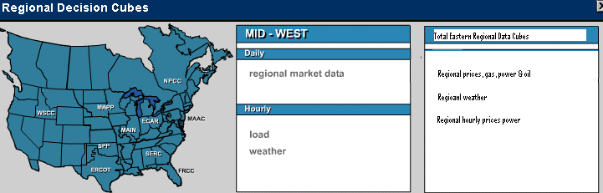

Please add a yearly regional, gas, power & oil link that looks like the display below. Please also consider changing the existing daily format to look the same way.

Please add hourly prices for Ercot, PJM, NY, CALISO & Nepool to the data cubes and make available from the selection box above.

