Appendicies A – D for the Rosevile Risk Assessment and Control Deal Approval Sheet

Appendix A – ERCs Optioned or Purchased:

Spreckels Woodland Facility

Pollutant | Total Tons | Purchase Price/Ton | Total Purchase Price
PM10 | 72 | $30,000 | $2,160,000
NOX | 89 | $30,000 | $2,670,000
SOX | 2 | $30,000 | $ 60,000
VOC | 2 | $30,000 | $ 60,000
 |  | TOTAL | $4,950,000
 |  | Bankruptcy Auction Contingency | $1,500,000
 |  | Woodland Total | $6,450,000

Spreckels Tracy Facility

Pollutant | Total Tons | Purchase Price/Ton | Total Purchase Price
PM10 | 33 | $30,000 | $ 990,000
NOX | 29 | $30,000 | $ 870,000
SOX | 2 | $30,000 | $ 60,000
VOC | 2 | $30,000 | $ 60,000
 |  | TOTAL | $1,980,000
 |  | TOTAL FOR BOTH FACILITIES | $8,430,000

ENA has been selected as the winning bidder for these credits and is currently in negotiations with Spreckels. However we have also included an additional $1.5MM as a contingency related to this purchase due to uncertainty regarding whether we will be required to participate in a bankruptcy auction for these credits. Spreckels is currently in bankruptcy proceedings and had selected ENA as the highest bidder at $30,000/ton. Although we are finalizing contract terms with Spreckels, the final contract will require bankruptcy court approval and it is possible that other bidders could force an auction of these credits in the bankruptcy proceeding. See further discussion of the risk mitigants surrounding the bankruptcy proceeding in the Supplemental Risk Matrix included in Appendix D.

The other identified credits to be purchased at this time are summarized in the tables below:

Georgia Pacific

Pollutant | Total Tons | Purchase Price/Ton | Total Purchase Price
PM10 | 101 | $32,157 | $ 3,247,857
NOX | 10 | $32,157 | $ 321,570
VOC | 67 | $32,157 | $ 2,154,573
SOX | 46 | $ 6,000 | $ 276,000
 |  | TOTAL | $6,000,000

Lauppe Farms

Pollutant | Total Tons | Purchase Price/Ton | Total Purchase Price
PM10 | 11 | $30,000 | $ 247,500
NOX | 6.6 | $30,000 | $ 148,500
VOC | 8 | $25,000 | $ 150,000
SOX | 2 | $ 6,000 | $ 8,100
 |  | TOTAL | $740,100

Lincoln Brand Feeds

Pollutant | Total Tons | Purchase Price/Ton | Total Purchase Price
PM10 | 14.8 | $30,000 | $444,400
 |  | TOTAL | $444,400

Appendix B:

Development Costs:

Development Costs | Cost ($ in 000s)
Environmental Consultants | $1,800
Technical Services | $1,200
Pre-financial Closing Legal Fees | $2,000
Internal Development Costs | $1,000
Contingency | $5,000
Other miscellaneous costs | $1,614
TOTAL | $12,614

Total Costs at Risk by Milestone:

Milestone | ERC Dollars Spent | Development Dollars Spent | Contingency Dollars Spent | Total
Signing Ground Lease/Development Agreement  7/1/2001 | $6,900 | $ 100 | $0 | $7,000
AFC Filing  7/31/2001 | $6,750 | $1,400 | $0 | $8,150
Data Adequacy  9/30/2001 | $8,400 | $500 | $0 | $8,900
CEC Approval  9/30/2002 | $9,930 | $5,614 | $5,000 | $20,544
TOTAL | $31,980 | $7,614 | $5,000 | $44,594

Appendix C – Transferability of ERCs:

The ERCs that ENA is attempting to purchase from Spreckels are credits generated from the shutdown of two Spreckels plants, one located in Woodland, CA and the other in Tracy, CA. The Woodland plant is located within the Yolo-Solano Air Quality Management District (“YSAQMD”) and the Tracy facility is located within the San Joaquin Valley Unified Air Pollution Control District (“SJVUAPCD”). See a map of the various air districts at the end of this appendix.

Both sets of credits have significant value and are remarketable. While the Tracy credits may not be used on the Project, as the SJVUAPCD is outside of the Sacramento region non-attainment zone, they are located within one of the largest Air Districts in terms of square miles with a large number of major source users of ERCs. Additionally, ENA is investigating other potential sites for generation plants within this Air District and has leftover credit from Pastoria Energy Facility (“PEF”) to apply/accumulate toward a larger project.

Of the other identified ERCs, both the Georgia Pacific and the Lincoln Brand Feeds ERCs are located in the PCAQMD while the Lauppe Farms ERCs are located in the Feather River Air Quality Management District (“FRAQMD”). All of these ERCs are located within the Sacramento region non-attainment zone. See a detail of the types of ERCs for each of these sources in Appendix A.

In the event that the Project does not proceed, ENA has already identified several potential parties that are interested in and are aggressively pursuing ERCs within the Sacramento region non-attainment zone. Florida Power & Light (“FP&L”) and Sacramento Municipal Utility District (“SMUD”) are both pursuing generating projects within the Sacramento Metropolitan Air Quality Management District (“SMAQMD”) and it appears that Calpine is pursuing several peaker projects throughout the Sacramento area. As all of the credits in this DASH are within the Sacramento region, our preliminary analysis indicates that they can be utilized on all of these potential generating projects. Additionally, the University of California at Davis, NEC Corp., Hewlett Packard and others are also interested in purchasing credits and are also located within the non-attainment zone. Given the extreme shortage of available ERCs in this non-attainment zone (and throughout California), it is highly likely that ENA will recover at least the purchase price of the these credits in a sale to any of these projects or entities. For a summary of comparable ERC transactions, see the table below:

Comparable ERC Offers and Sales

Air District | Buyer | Seller | Pollutant | Cost/Offer
Sacramento | None | Proctor & Gamble | VOC | Offer - $35K/ton
Placer | SMUD | Formica | VOC | Sale - $25K/ton
Placer | NEC | Builder’s Pre-Stain | VOC | Offer - $25K/ton
Sacramento | FP&L | Lauppe Farms | PM10  NOX | Offer - $28K/ton  Offer - $25K/ton
Sacramento | Enron | Lauppe Farms | PM10  NOX  VOC  SOX | Sale - $30K/ton  Sale - $30K/ton  Sale - $25K/ton  Sale - $6K/ton
Yolo-Solano | FP&L | Wallace Ranches | NOX, PM10, VOC | Offer – $28 - $30K/ton
Yolo-Solano | Enron | Wallace Ranches | PM10 | Sale - $30K/ton
Yolo-Solano * | FP&L | Rec District 108 | PM10  NOX  VOC  SOX | Sale - $25K/ton  Sale - $22K/ton  Sale - $25K/ton  Sale - $6K/ton
Yolo-Solano * | FP&L | River Garden Farms | NOX, PM10, VOC | Sale - $22K/ton

* Note that these credits are agricultural burning credits that the EPA has expressed concerns about. Hence, Enron and others did not bid for these credits thereby depressing the price.

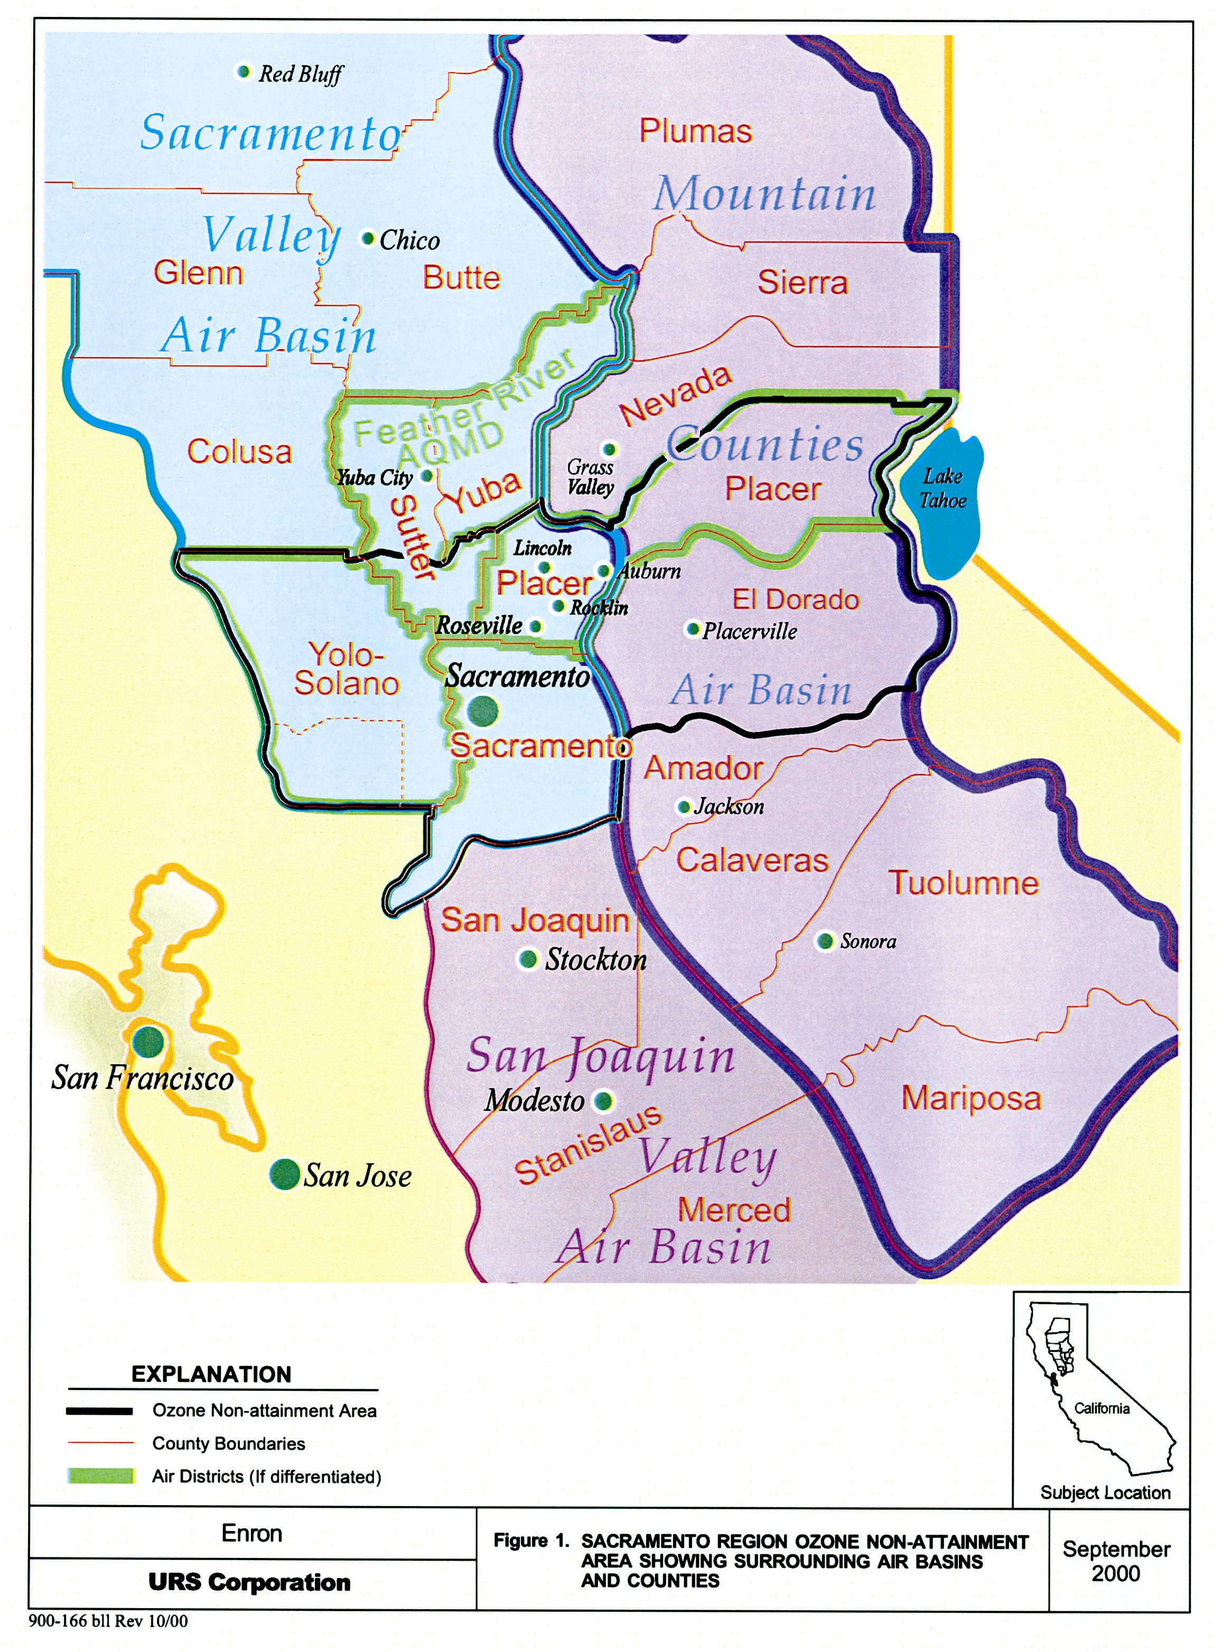

Appendix D – Supplemental Risk Matrix:

DESCRIPTION | MITIGATION/COMMENTS
Merchant/Commodity Risk  - Risk of volatile or low market prices in the future | The overall supply/demand picture mitigates this risk. According to ISO forecasts, the state is still short (2001 peak load + reserve – in state generation) between 4,700MW and 8,600MW of its power needs depending upon weather, outages, etc. The ISO is forecasting import capacity of only 4,500MW, which leaves the remainder to be filled by load curtailments or emergency generation. This picture does not improve much, given load growth forecasts of 2% a year for the next 10 years and a minimum of 4 years to construct a new merchant facility. One strategy that may be pursued is to sell forward the plant capacity under long-term PPAs to further mitigate merchant/commodity risk.
Water Supply Risk | Water will be supplied by the City of Roseville’s new Pleasant Grove Wasterwater Treatment facility, which is located next to the plant. Until the new treatment facility is able to produce enough gray water for the Project, the City will supplement with potable water.  Discharge is not an option for the Project given temperature and environmental restrictions in the neighboring creek. Therefore a zero discharge system at a cost of $9MM has been included in the proforma.
Spreckels Bankruptcy Risk  - Risk that ENA does not emerge as the successful purchaser of these ERCs | Spreckels filed for bankruptcy on January 16, 2001. After negotiating with other parties (Calpine and FP&L), we were selected by Spreckels as the winning bidder. We are working through contract terms with Spreckels now, and hope to finalize a contract in the near future. Once finalized, the contract will have to be approved in the bankruptcy proceedings; it is possible that during the approval process, other bidders may surface and force an auction process, which could result in us not obtaining the credits, or obtaining the credits at a higher price. In order to mitigate the risk of having to increase our bid in an auction process, we are negotiating with Spreckels to include both a cost reimbursement provision and a break-up fee that should help prevent non-serious bidders from running prices up too quickly in the auction. However, if we are not selected as the high bidder in an auction, we are making plans to secure alternative sources of ERCs to replace these Spreckels credits.
Legislative Risk  - Risk of any of the regulatory agencies changing rules related to ERC transferability or application to a new major source such as the Project | ERCs are governed by several regulatory bodies including the EPA, California Air Resources Board (“CARB”), and the local Air Districts. There is a risk that any or all of these agencies could change the rules regarding: resale of credits, amount of credits needed for polluting sources, retirement of credits, transfer of credits from one District to another or price caps on ERCs  While these risks could significantly impair the use of the ERCs that ENA intends to purchase, it will most likely increase the value of existing credits. Additionally, all of the state agencies are under direction from the governor’s office to cooperate with power development projects. More flexibility in interpretation of air regulations is the more likely outcome, rather than further restrictions.

California Political Risk  - Risk that the current energy crisis could impact the use of ERCs | The energy crisis in California has created some confusion as to what type of environment will exist once the situation is resolved. As of now, it appears that the following could occur:  - The state purchases the transmission system from the investor owned utilities (“IOUs”)  - Continued and increased legal and regulatory scrutiny of generators  - The possibility of bankruptcy for the remaining IOUs (Sempra and SCE)  - Fundamental changes to the current deregulated environment  While these risks exist, they should also increase the value of ERCs. Underlying the rhetoric surrounding the crisis, the fact remains that the overall supply/demand picture remains out of balance. The state is still short generation and import capacity is limited. With demand showing no signs of slowing (load growth has been forecasted at 2% over by the California Energy Commission) new generation must be built. Given federal law, new generators will likely be forced to purchase more ERCs in order to run their plants. All of these factors suggest an increase in the market value of ERCs. In fact, firms taking significant positions in the California ERC market will exert significant influence over the development of all new generation, if not influence over general development in the state.

