Software Description

Turbine curtailment software stops and starts wind turbines for the following conditions: energy output for a group of turbines, wind direction, wind speed, and time of day.

Curtailment parameters are protected by passwords where each user can be given different capabilities. One user could be given authority to modify the energy curtailment parameters and not allowed to modify direction curtailment values, while another user allowed to change the direction curtailment values and not allowed to modify the energy curtailment parameters.

The curtailment software is made up of two parts, a user interface program and a service program. The service program receives data from the turbines, decides if any turbines should be curtailed, and sends the curtailment commands to the turbines. The user interface program communicates to the service program and allows the user to view and modify the conditions of when curtailment occurs.

This software is designed to function with the Visupro software. It receives turbine and met tower data from Visupro, and issues the turbine curtailment message to Visupro. Visupro then stops or starts the turbine based on what it receives from this program.

On computer reboot the program will wait 10 minutes before sending any curtailment commands. This is done so that the program has time to calculate the 10-minute average wind speed and direction that is needed to make a curtailment decision.

Status Screen

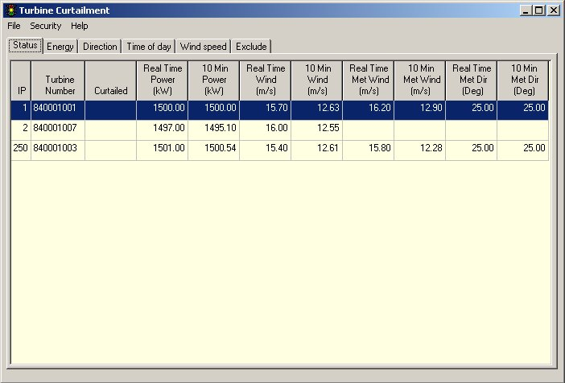

Status screen shows the turbine’s curtailment status, real-time power output, ten minute average power output, real-time wind speed, ten minute average wind speed, and if a met tower is connected to the turbine then it shows the real-time and ten minute average wind speed and wind direction data for the met tower.

The curtailed column will be one of the following:

Blank Turbine is not curtailed
Energy Energy curtailed
Direction Wind direction curtailed
Time Time of day curtailed
Wind Wind speed curtailed
Com Loss Turbine not communicating to program

Energy Curtailment

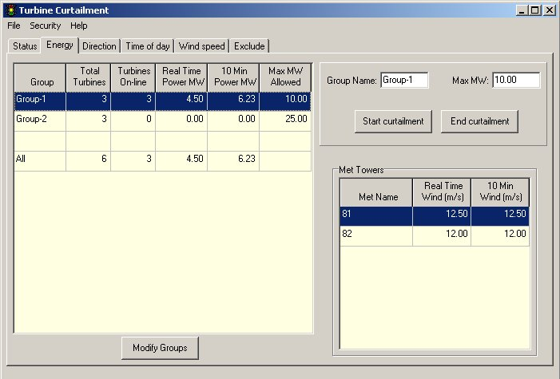

Energy curtailment occurs when the 10-minute average MW and real time MW readings for the group are above the set point. When a group needs to be curtailed, turbines are randomly selected for curtailment.

Energy curtailment ends when the 10-minute average MW and real time MW readings for the group are 1 MW or more below the set point, and the turbine has been curtailed for at least 10-minutes.

To change the energy curtailment set point for a group: Click on the group to be changed, enter the new set point in the “Max MW” box, and click the “Start curtailment” button. The max MW for a group can not be less then 10 MW.

To end energy curtailment for a group: Click on the group, then click the “End curtailment” button.

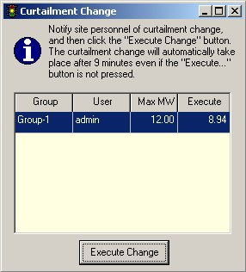
After clicking either the start or end curtailment button, the following screen will appear asking you to notify the site of the curtailment change.

After notifying the site click the “Execute Change” button to activate the new curtailment setting. If the “Execute Change” button is not pressed the change will take place after nine minutes.

To add, change, or delete turbine groups click on the “Modify Groups” button on the energy curtailment screen.

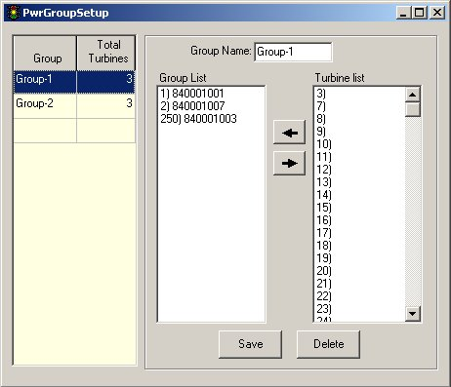
To change a existing group of turbines: Click on the group, add or remove turbines from the group, and click the “Save” button.

To delete a group: Click on the group, and then click the “Delete” button.

To create a new group: Click on the blank group line, type in a new group name into the “Group Name” box, add turbines to the group, and then click the “Save” button.

Direction Curtailment

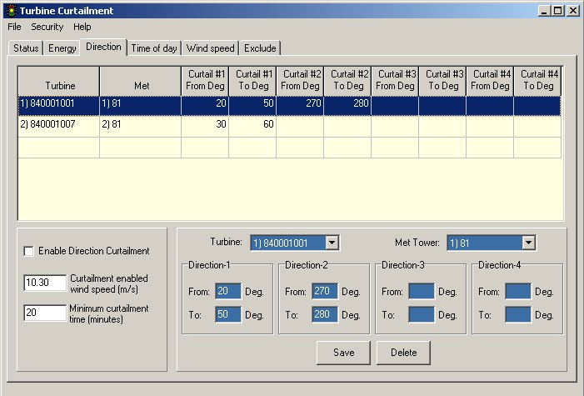

A turbine is curtailed when the 10-minute average wind direction measured from a nearby meteorological tower is within the specified curtailment direction range, and the 10-minute average wind speed measured from the nacelle anemometer is above the minimum wind speed set point value. Once a turbine is curtailed it will remain curtailed for at least the minimum curtailment time.

To enable the program to do direction curtailment the box “Enable Direction Curtailment” must be checked.

“Curtailment enabled wind speed” box sets the value at which the wind speed must be above for direction curtailment to be allowed.

“Minimum curtailment time” is the number of minutes that a turbine must stay curtailed once it is curtailed for wind direction.

To add a turbine to the direction curtailment list.

- Select a turbine from the drop down list “Turbine”.

- Select a Met. Tower from the drop down list “Met Tower”.
The Met. Tower is used to determine when the turbine should be curtailed for wind direction.

- Enter the direction ranges that this turbine should be curtailed.
The direction ranges run in a clockwise direction. (If you enter 350 in the “From” box and 10 in the “To” box, then the turbine would be curtailed for directions from 350 to 360 degrees, along with the direction 0 to 10 degrees).

- Click the “Save” button to add the turbine to the curtailment list.

To delete a turbine from the direction curtailment list.

  - Click on the turbine to be removed from the curtailment list.
  - Click the “Delete” button.

To change the values for a turbine on the direction curtailment list.

        - Click on the turbine to be modified in the curtailment list.
        - Make changes to the direction ranges or met tower number.
        - Click the “Save” button.

Time of Day Curtailment

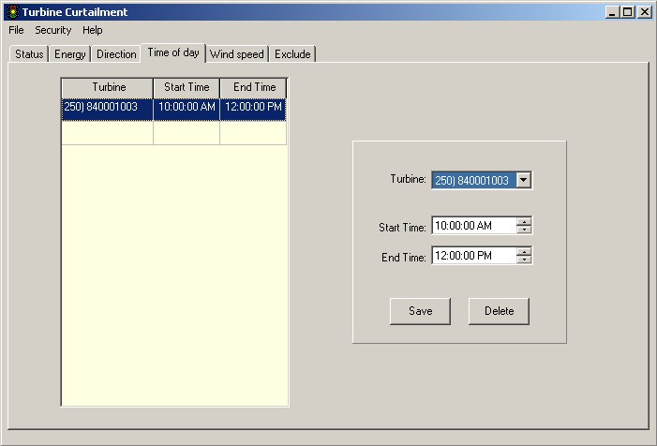

Time of day curtailment curtails turbines based on the time of day.

To add a turbine to the time of day curtailment list

- Click on the blank line in the “Time of day curtailment” list.
- Select a turbine from the “Turbine” drop down list.
- Select the time that the curtailment should start from the “Start Time” box.
- Select the time that the curtailment should end from the “End Time” box.
- Click the “Save” button.

To change the curtailment time for a turbine on the time of day curtailment list

- Click on the turbine in the “Time of day curtailment” list to be changed
- Modify the start and end curtailment time
- Click the “save” button

To delete a turbine from the time of day curtailment list

- Click on the turbine in the “Time of day curtailment” list
- Click the “Delete” button

Wind Speed Curtailment

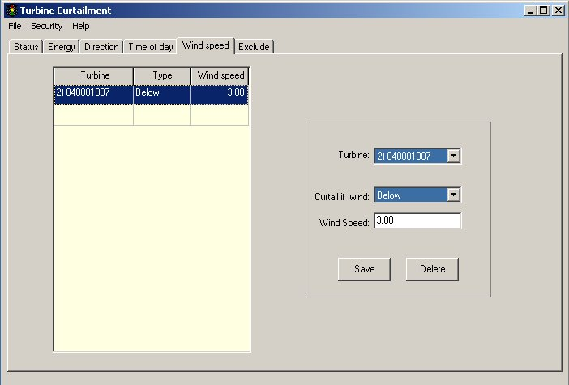

Wind speed curtailment curtails a turbine when the 10-minute average wind speed measured from the turbine anemometer, is either above or below the specified value.

To add a turbine to the wind speed curtailment list

- Click on the blank line in the “Wind speed curtailment” list.
- Select a turbine from the “Turbine” drop down list.
- Select whether the turbine should be curtailed above or below the wind speed
- Enter the curtailment wind speed
- Click the “Save” button.

To change the curtailment values for a turbine on the curtailment list

- Click on the turbine in the “Wind speed curtailment” list to be changed
- Modify the curtailment values
- Click the “save” button

To delete a turbine from the curtailment list

- Click on the turbine in the “Wind speed curtailment” list
- Click the “Delete” button

Exclude from Curtailment

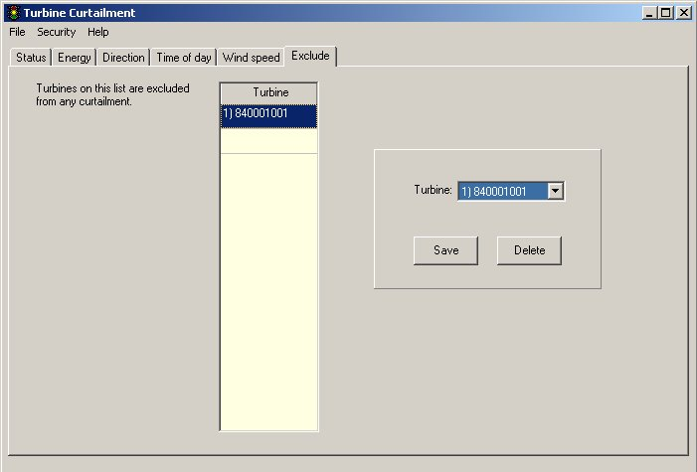

The curtailment exclude list is to be used for turbines that are under testing, or other temporary conditions where you currently do not want a turbine to be curtailed.

To add a turbine to the exclude list select it from the “Turbine” drop down list, and click the “Save” button.

To remove a turbine from the exclude list select it from the list, and click the “Delete” button.

Program Configuration

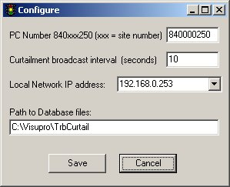

Enter the program configuration screen by clicking on the “File” menu item and selection “Configure”.

PC number 840xxx250” (xxx = site number)
The first 3 digits of this number is the country code that this site is located in, 840 is the country code for the United States. The second group of 3 digits is the site number, and the ending 3 digits of this number is the final part of the computer’s IP address. Example: If this site is in the U.S., the site number is 7, and the IP address of the computer is 192.168.0.250, then the PC-number would be 840007250.

Curtailment broadcast interval (seconds)
Enter the number of seconds between each curtailment broadcast message.

Local IP address
Select from the drop down list box the computer’s IP address that is part of the turbine network. This box normally has only 1 choice, but there will be more then one choice if multiple network cards are installed in the computer.

Path to Database Files
Enter the location of where the database files should be saved.

Security

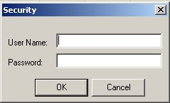
Logon screen

To make changes to the program settings you must be logged in. Click on the “Security” menu item, and select “Logon”.

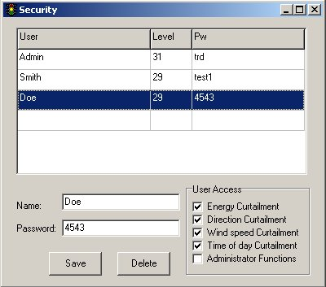
User accounts

To add, remove, or modify a user’s access click on the “Security” menu item and select “User List”

To add a new user.

  - Enter a user name in the “Name” box.
  - Enter the user’s password in the “Password” box.
  - Select the user’s access rights.
  - Click the “Save” button to add the user.

To remove a user.

- Click on the user to be removed.
- Click the “Delete” button.

To modify a user’s password or access rights.

  - Click on the user to be modified.
  - Make the needed changes.
  - Click the “Save” button.

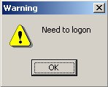
You will receive this message if you try to make a change, but are not logged in.

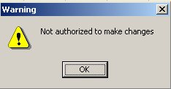
You will receive this message if you are attempting to change an item that you have not been authorized to modify.

About

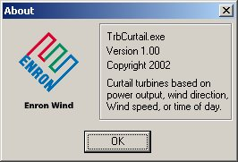
Program’s “About” screen

To see the program’s version level, click on the “Help” menu item and select “About”

Program Files

Curtailyyyymm.db Logbook of program activity (yyyy = Year, mm = Month)
CurtailDbPwr.db Power curtailment parameters
CurtailParms.db Direction, Time of day, and wind speed curtailment parameters
UserAccts.db User access list
TrbCurtail.ini Screen position and size

Logbook Entries in Curtailyyyymm.db file

Message | Message Description
TrbCurtail Service Started | TrbCurtail Service software started. Curtailment software is now able to curtail turbines as needed
TrbCurtail Service Stopped | TrbCurtail Service software stopped. Curtailment software is no longer able to curtail turbines
Dir Curtail Met: xx) yyy | Turbine assignment changed to use this met tower for determining when to perform direction curtailment – Turbine name stored in the “SystemNumber” field
Dir Curtail #x: yyy - zzz | Direction curtailment range changed for turbine – Turbine name stored in the “SystemNumber” field
Dir Curtailment removed | Turbine removed from direction curtailment list – Turbine name stored in the “SystemNumber” field
xxxx group max MW Changed: yyy | Maximum MW for group changed
xxxx curtailment ended | Energy curtailment for group ended
Added to group: xxxx | Turbine added to energy curtailment group – Turbine name stored in the “SystemNumber” field
Removed from group: xxxx | Turbine removed from energy curtailment group – Turbine name stored in the “SystemNumber” field
Added to curtailment exclusion list | Turbine added to curtailment exclusion list – Turbine name stored in the “SystemNumber” field
Removed from curtailment exclusion list | Turbine removed from the curtailment exclusion list – Turbine name stored in the “SystemNumber” field
Wind speed curtailment disabled | Wind speed curtailment for turbine disabled – Turbine name stored in the “SystemNumber” field
Wind speed curtailment set to curtail below setpoint | Wind speed curtailment for turbine set to curtail turbine when wind speed is below set point – Turbine name stored in the “SystemNumber” field
Wind speed curtailment set to curtail above setpoint | Wind speed curtailment for turbine set to curtail turbine when wind speed is above set point – Turbine name stored in the “SystemNumber” field
Wind speed curtailment set to x m/s | Wind speed curtailment set point for turbine changed to a new value – Turbine name stored in the “SystemNumber” field

Time curtailment x:x – y:y | Time curtailment for turbine changed – Turbine name stored in the “SystemNumber” field
Time curtailment disabled | Time curtailment for turbine disabled – Turbine name stored in the “SystemNumber” field
PC Number changed to: xxx | The pc number used in the curtailment software has been changed
Local IP changed to: w.x.y.z | The IP address that the curtailment uses to communicate to the turbine network has been changed
Broadcast rate changed to: x | The rate at which the curtailment software sends out the curtailment messages to the turbines has been changed
Min dir curtail time changed to: x | The amount of time that a turbine must stay stopped once curtailed for direction has been changed.
Min Pwr curtail time changed to: x | The amount of time that a turbine must stay stopped once curtailed for energy has been changed.
Min dir curtail WS changed to: x | Direction curtailment enable wind speed changed.
Dir curtail enabled changed to: x | Direction curtailment Enabled / Disabled
Data file path changed | Path to data files changed
Turbine Com Loss | Communication loss to turbine – Turbine name stored in the “SystemNumber” field
Met Com Loss | Communication loss to Met Tower – Met Tower name stored in the “SystemNumber” field
Turbine Com Established | Communication established to Met Tower – Met Tower name stored in the “SystemNumber” field
Met Com Established | Communication established to Met Tower – Met Tower name stored in the “SystemNumber” field
Energy curtailed | Turbine curtailed for energy – Turbine name stored in the “SystemNumber” field
Direction curtailed | Turbine curtailed for direction – Turbine name stored in the “SystemNumber” field
Wind speed curtailed | Turbine curtailed for wind speed – Turbine name stored in the “SystemNumber” field
Time curtailed | Turbine curtailed for time of day – Turbine name stored in the “SystemNumber” field
Energy un-curtailed | Turbine un-curtailed for energy – Turbine name stored in the “SystemNumber” field
Direction un-curtailed | Turbine un-curtailed for direction – Turbine name stored in the “SystemNumber” field
Wind speed un-curtailed | Turbine un-curtailed for wind speed – Turbine name stored in the “SystemNumber” field
Time un-curtailed | Turbine un-curtailed for time of day – Turbine name stored in the “SystemNumber” field

Database File Layouts

Curtailyyyymm.db
Logbook of Program Activity (yyyy = Year, mm = Month)

Item | Field Name | Field Description | Field Type
1 | Index | Sequential number | Auto increment
2 | IP | Turbine ID (Last part of IP address. (IP=192.168.0.1 then IP would be 1) | Integer
3 | SystemNumber | Turbine name | String 10 bytes
4 | Date | Local Date | Date
5 | Time | Local Time | Time
6 | TimeOffset | Number of seconds between Local time and UTC time | Integer
7 | User | User Name | String 20 bytes
8 | Msg | Message | String 40 bytes

CurtailParms.db
Direction, Time of day, and wind speed curtailment parameters

Item | Field Name | Field Description | Field Type
1 | Index | Sequential number | Auto increment
2 | TrbID | Turbine ID (Last part of IP address. (IP=192.168.0.1 then TrbID would be 1) | Integer
3 | ExcludeFlg | Turbine on curtailment exclude list | Integer
4 | MetID | Met tower ID (Last part of IP address. (IP=192.168.0.1 then MetID would be 1) | Integer
5 | FromDir1 | Direction #1 From direction | Float
6 | ToDir1 | Direction #1 To direction | Float
7 | FromDir2 | Direction #2 From direction | Float
8 | ToDir2 | Direction #2 To direction | Float
9 | FromDir3 | Direction #3 From direction | Float
10 | ToDir3 | Direction #3 To direction | Float
11 | FromDir4 | Direction #4 From direction | Float
12 | ToDir4 | Direction #4 To direction | Float
13 | WsCurtFlg | Curtail for wind speed (0=No, 1=Below, 2=Above) | Integer
14 | WsCurtail | Wind speed curtailment value | Float
15 | STmCurtail | Time of day curtailment -start time | Time
16 | ETmCurtail | Time of day curtailment -end time | Time

CurtailDbPwr.db
Power curtailment parameters

Item | Field Name | Field Description | Field Type
1 | Index | Sequential number | Auto increment
2 | TrbID | Turbine ID (Last part of IP address. (IP=192.168.0.1 then TrbID would be 1) | Integer
3 | GroupName | Name of energy curtailment group | String 10 bytes
4 | MaxMW | Maximum MW | Float

UserAccts.db
User access list

Item | Field Name | Field Description | Field Type
1 | Index | Sequential number | Auto increment
2 | User | User Name | String 20 bytes
3 | Pw | User password (encrypted) Maximum password size 10 bytes | String 20 bytes
4 | AccessLevel | User’s access level (bit waited) | Integer

Visupro to Turbine curtailment program communication

Curtailment Network port: '7200' udp

Structure of data received from turbines:

TCurtailPlantData = packed record
MsgType : LongWord; // Message type
MsgVersion : BYTE; // Message version (1)
IDNo : String[10]; // Plant ID
StateBits : LongWord; // Status
Para1 : Double; // Parameter 1
Para2 : Double; // Parameter 2
Para3 : Double; // Parameter 3
Para4 : Double; // Parameter 4
Para5 : Double; // Parameter 5
Para6 : Double; // Parameter 6
Para7 : Double; // Parameter 7
Para8 : Double; // Parameter 8
end;

Message Type:
Plant = $01001001
Met = $01001002

StateBits
Bit 0 // Para1 Valid
Bit 1 // Para2 Valid
Bit 2 // Para3 Valid
Bit 3 // Para4 Valid
Bit 4 // Para5 Valid
Bit 5 // Para6 Valid
Bit 6 // Para7 Valid
Bit 7 // Para8 Valid
Bit 16 // PlantState Ok (1) / Error (0)
Bit 24 // Curtailment On (1) / Off (0)

Structure of data for curtailing turbines:

TCurtailCtlData = packed record
MsgType : LongWord; // Curtailment TAC
MsgVersion : BYTE; // 1
LiveCounter : Word;
IDNo : String[10];
State : LongWord; // free
Mode : LongWord; // Free
Command : LongWord; // Curtailment
Data : array[0..127] of Byte;
end;

MsgType = $01001003;

Data = Bit weighted specifying if turbine is curtailed. (Bit on = turbine curtailed)
8 turbines per byte, 32 bytes to control 256 turbines.
Remaining 95 bytes spare.

Byte = x x x x x x x x
| | | | | | | |
| | | | | | | Turbine-1
| | | | | | Turbine-2
| | | | | Turbine-3
| | | | Turbine-4
| | | Turbine-5
| | Turbine-6
| Turbine-7
Turbine-8

Curtailment Service Program

TrbCurtailSvc /Install Installs the curtailment service
TrbCurtailSvc /Uninstall Un-installs the curtailment service

DcomCnfg Configure the service security

