PLENARY SESSIONS
March 19  9:00 a.m. – 10:15 a.m.  Opening Plenary Session:  Leadership in the Global Power Industry – Lessons Learned |  |  | March 19  10:30 a.m. – 11:45 a.m.  Mid – Morning Plenary Session:  From Conflict to Reconciliation – Resolving the Power Demand and Effects on the Environment |  |  | March 20  8:30 a.m. – 9:45 a.m.  Plenary Session:  Centralized v/s Distributed Generation – What Market Share Might DP have in 10 Years? |  | March 21  8:30 a.m. – 9:45 a.m.  Plenary Session:  Asset Executives Roundtable

ELECTRIC POWER STRATEGIC TRACKS
March 19  2:00 P.M. – 4:00 P.M. |  |  | March 20  10:00 A.M. – 11:30 A.M. |  |  | March 20  2:00 P.M. – 4:00 P.M. |  | March 21  10:00 A.M. – 11:30 A.M. |  |  | March 21  2:00 P.M. – 3:30 P.M.

Track 1: Risky Business: The 21st Century Energy Company
Hummer or Clunker? Evaluating Plant Asset Value Risk |  |  | A Real Cliffhanger: Managing Trading/Financial Risk – Part 1 |  |  | A Real Cliffhanger: Managing Trading/Financial Risk – Part 2 |  | Afraid of the Dark? Managing Retail Distribution Risk |  |  | The Missing Link: Customer Base to Increased Earnings
Track 2: Generating Asset Portfolio Management
Balancing a Portfolio:  *Financial Risk Mgmt in Asset Acquisition  *Developer Perspective  *Strategic Acquisition Issues |  |  | Central Generating Plants  *Coal *Gas  *Nuclear |  |  | Managing Fuels for Profit  *Coal & Gas Co-Firing  *Coal Mixing & Blending  *Fuel Price Forecasts  *Opportunity Fuels  *Fuels Handling: Barge Unloading |  | Portfolio Management Tools  *Reliability Measurement  *Risk Management Tools & Techniques  *Portfolio Economic Optimization |  |  | Geographically Dispersed Asset Management  *Plants in Multiple Markets  *Small Generators in Multiple Locations

Track 3: Environmental Issues and Strategies
Environmental Issues in Context of National Energy Policy  Panel Discussion  *Discussion of Multi-Pollutant Legislation and Agency Initiatives  *Other Environmental Issues Confronting Power Generation |  |  | Turning Environmental Investments into Profit  “3 Successful Case Studies Documenting Untapped Revenue Streams” |  |  | Proven Ways of Managing Criteria Pollutants  *Boiler Performance Optimization Using Neural Networks and Advanced Control Techniques  *Combustion Modifications  *Overfire Air for Cyclone-Fired Boilers  *SNCR Fuel Technology  *SCR on Powder River Basin Coals |  | Breakthrough Technologies  *Advanced Mercury Control in Wet FGD  *Update on the ECO Process for Multi-Pollutant Control of Coal Fired Utility Boilers  *Lowering the Cost of PM_{2.s} Compliance with a New Design Wet Membrane ESP |  |  | Environmental Issues with Distributed Generation, Combustion Turbines and Renewables  *Air, Water, Waste Issues  Case Study & Panel/Presentations
Track 4: New Technologies for Power Generation
Gas Based:  *Gas Turbine/Combined Cycle  *Fuel Cells, *Coal Bed Methane |  |  | Coal Based:  *Gasification  *PFBC  *CFB  *Supercritical Boilers |  |  | Nuclear Based:  *Pebble Bed  *Advanced Reactors  Joint Session with the Nuclear Renaissance Tactical Meeting |  | Balance of Plant Considerations |  |  | Opportunity Fuels
Track 5: Stealth Capacity – Leveraging Your Existing Assets
Strategic Overview: Generating Assets  *Re-Powering SCR Catalyst Testing *Alternative Fuels  *Fuel Conversion/Fuel Switch  *Re-Powering |  |  | Plant Culture and Staffing  *Risk Based Asset Management  *Getting More Operators in the Classroom and on the Simulator  *Defining Asset Management  *How a Central Training Organization Can Meet a Customers’ Needs |  |  | Getting the Maximum Return from IT and Automation  *Optimizing Startup Management Systems  *Real Time Combustion System Optimization  *Optimizing Financial Performance |  | O & M Strategies and Best Practices  Part 1  *Laser Ablation for PWR  *Selecting an Optimum Solution to Boiler Tube Failures |  |  | O & M Strategies and Best Practices Part 2  *Short Bed Demineralization  *Fly Ash Embankment  *Thermal Imaging
Track 6: Moving Power to Market – Transmission and Interface Issues
Adapting the Interconnected Grid for a National Electricity Marketplace |  |  | New Concepts for Transmission Infrastructure |  |  | Regional Reports on RTOs, ISOs, States and Countries  “What’s Working, What’s Not” |  | Technology and New Ideas to the Rescue

ELECTRIC POWER TACTICAL MEETINGS
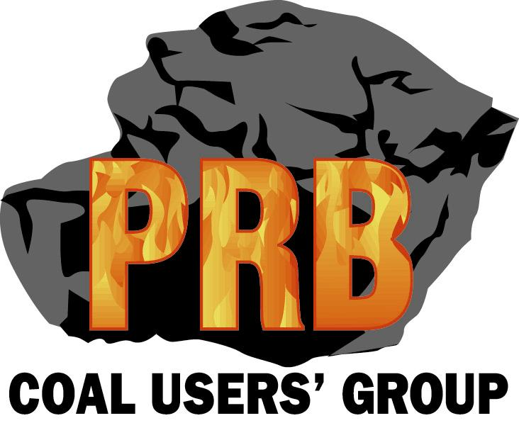 PRB Coal User’s Group
March 19  8:00 – 9:15 a.m.  PRB Coal Overview  *History *Reserves *Projections | March 19  9:30 – 10:15 a.m.  Rotary Dump Dust Collector Upgrades | March 19  10:45 – 11:45 a.m.  Dust Collector Operational Procedures |  | March 19  1:30 – 2:30 p.m.  PRB Plant – of – the-Year  Virtual Tour | March 19  3:30 – 4:45 p.m.  What has been seen in Fire Protection Audits |  | March 20  8:30 – 9:45 a.m.  Comparison between a 1980 and a 2002 PRB Coal-Fired Plant |  | March 20  10:15 – 11:30 a.m.  Boiler Optimization through cleaning methods, cameras, temperature sensing | March 20  1:30 – 2:45 p.m.  Case History – Lessons Learned from a fire explosion in an Electric Utility Generating Station |  | March 20  3:15 – 4:45 p.m.  History of Utility Coal-related Incidents | March 21  9:00 – 11:45 a.m.  Open Panel Discussion  PRBCUG Board of Directors
March 19  2:00 P.M. – 4:00 P.M. |  | March 20  10:00 A.M. – 11:30 A.M. |  |  | March 20  2:00 P.M. – 4:00 P.M. |  |  |  | March 21  10:00 A.M. – 11:30 A.M. |  |  | March 21  2:00 P.M. – 3:30 P.M.
Bituminous Coal Users Group
The New Playing Field for Eastern Coal – Fuel Supplier CEO Roundtable |  | Plant Improvements – Becoming A Flagship Facility |  |  | Fuel Upgrading – Blending and Beneficiation |  |  |  | Characteristics of New Coal Based Projects |  |  | Open Forum
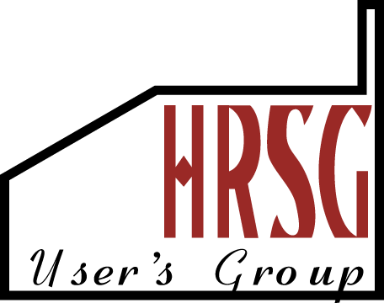HRSG Users Group
Improving HRSG Availability and Repairability |  | Operating Flexibility and Risk-Based Inspections |  |  | Boosting Efficiency through Cold-End Heat Recovery |  |  |  | Commissioning Requirements for New HRSG’s
 Natural Gas Infrastructure
Overview of the Gas Fueled Power Industry Demand/Supply  *Since 1990  *New gas-fired generation on-line since 1995  *Queue for gas turbines |  |  | Pipelines, Storage & LNG  * New supply sources  *De-bottlenecking existing infrastructure  *Importance of storage vs. reliance on pipeline connectivity  * LNG – a new role in North American supply? |  |  | Power Plant Fuel Delivery Issues  *Changing quality specs – today’s turbines are much more sensitive to gas quality issues  *Pressure reliability – impact to gen units with varying fuel pressures  *Transportation scheduling – firm vs. interruptible vs. other transport  Fuel contract issues |  |  | Fuel Energy Management  *To outsource or not outsource  *Evaluating potential outsource providers
 Nuclear Renaissance
The Future Isn’t What It Used to Be: Reasons for the Nuclear Renaissance  *NEI Overview  *Project Financing for a Merchant Nuclear Plant  * New Licensing Framework Impact on Project Schedule  *Public Acceptance/Public Policy |  | Competing for the Limited Resources in the Electric Power Industry  *Nuclear Equipment Supply Infrastructure  *Human Resource Needs and Strategies to Meet them  *Craft & Technician Labor for New Plant Construction  *Managing a Skilled Workplace Through Peaks & Valleys |  |  | Characteristics of New Nuclear Projects Nuclear Based:  *Pebble Bed  *Advanced Reactors  Joint Session with Track 4, New Technologies in Plant Concepts |  |  |  | Nuclear Asset Management – Maximizing Value  *Generating Asset Value  *Implementing the Standard Business Process Model  *Benchmarking & Process Improvement  *Investors View of Nuclear Assets
ELECTRIC POWER TACTICAL MEETINGS
March 19  2:00 P.M. – 4:00 P.M. |  | March 20  10:00 A.M. – 11:30 A.M. |  |  | March 20  2:00 P.M. – 4:00 P.M. |  |  |  | March 21  10:00 A.M. – 11:30 A.M. |  |  | March 21  2:00 P.M. – 3:30 P.M.
 Alternative Power

Integration of Alternative Power with Traditional Supply Side Resources  *Emissions Permitting *Grid  *Asset Optimization |  | Case Studies – Energy Storage  *CAES *Battery  *Hydro (pumped storage) |  |  | Case Studies – Distributed Generation  *Micro-Turbines *Fuel Cells  *Recips |  |  |  | Case Studies – Renewables  *Wind *Photo Voltaic  *Biomass |  |  | Summary Session – Projecting the Future  Debate on Different Views  of Alternative Power  (Panel Discussion)
Energy Management Forum
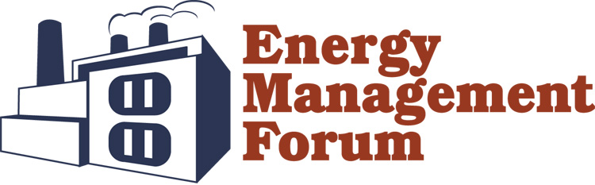
Overview and Self-Assessment:  Knowing Your Energy Profile  *Introduction  *How Much Energy Do You Use?  *How is Energy Used?  *What is the Cost of Energy? |  | Reliability At What Price?  *Minimize Energy Costs  *Interruptibility  *Shifting Load  *Participating in Competitive Power Markets  *Power Quality |  |  | Behind the Meter  Case Studies:  *New Technologies  *Performance Contracting  *Power Quality  *Advanced Storage Devices |  |  |  | To Outsource or Not to Outsource?  *What Energy Management Needs can be Outsourced?  *What are the Pro’s and Con’s of Outsourcing?  *Is Outsourcing Cost Effective and Reliable? |  |  | How Do I Buy (Sell) Energy?  *The RFP Process  *Seeking Market Knowledge  *Contracting for the Energy Supply  *Risk Management
 Global Energy Forum
Coordinate w/ International Buyer Program

Engineering, Procurement & Construction (Business & Technology)
Purchasing/Supply Chain Management  (Joint session with Track 2 of e-ProCom) |  | EPC Project Management |  |  | Global Sourcing and Partnering  (Joint session with Track 2 of e-ProCom)
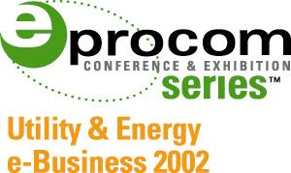 e-Pro Com for Utility & Energy e-Business
Track 1: Integrating e-Commerce & Technology Benefits into the Enterprise
Executive Perspectives in Maximizing Returns  Here C-Level Executives discuss the successes and failures on specific projects. |  | Transforming the Enterprise with e-Business  Case Study presented by Enron  *Business Case for Transformation  *Technology to Achieve Transformation  *Change Management and People Issues |  |  | Getting Closer to Your Customers  Panel Discussion  *Billing  *CIS Metering  *CRM  *Regulated vs. De-Regulated Customer Contact |  |  |  | Achieving Integrated Business Flows  How do you connect the different parts of the enterprise in an e-business implementation and successfully connect the related data channels and process flows?  *Business Process Engineering  *Planning & Implementation  *Utility Customer Testimony |  |  | Business Intelligence to Optimize Generation
Track 2: Purchasing/Procurement/Supply Chain Management
Purchasing/Supply Chain Management  (Joint Session with EPC Business & Technology) |  | Current State of Procurement Exchanges |  |  | Global Sourcing and Partnering  (Joint Session with EPC Business & Technology) |  |  |  | B2B Doesn’t Mean Buyer to Buyer- The Supplier Perspective  “What’s In It For Us?” |  |  | Private Marketplace Strategies

