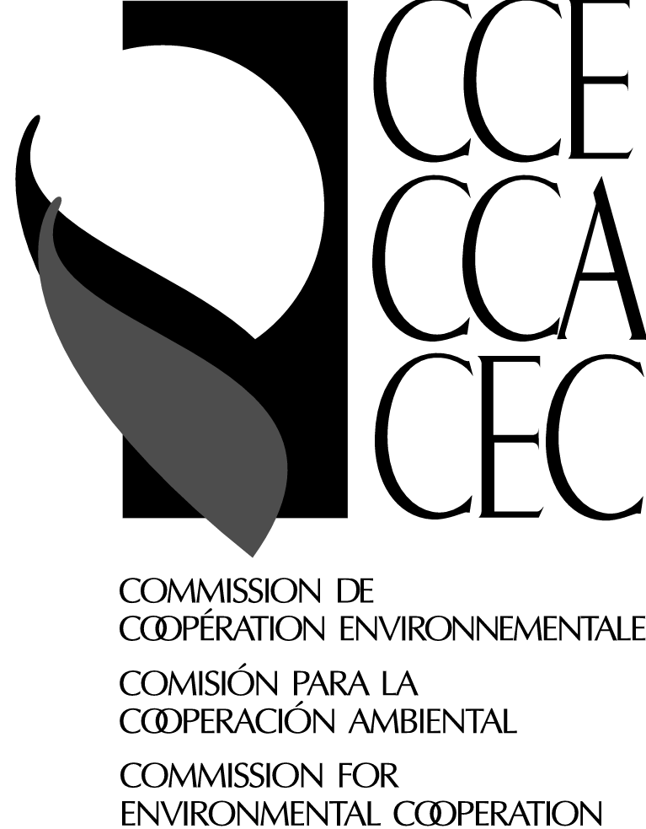 | The Electricity Restructuring Advisory Board Meeting  CEC, January 16,2001  393 St-Jacques Street West, Suite 200, Montréal,  Please complete and send by FAX to (514) 350-4345 or e-mail lvillene@ccemtl.org no later than Dec. 18

 | Confirmation of participation
Leticia Villeneuve  Cordinadora, servicios a reuniones/ Coordonnatrice, services aux réunions /  Meeting Services Coordinator  Tel.: (514) 350-4313  FAX: (514) 350-4345  E-mail : lvillene@ccemtl.org | I WILL ATTEND  Languages understood  Languages spoken | YES  English  English | NO  French Spanish  French Spanish

Identification
Name
First name Last name
Title
Organization
Address |  |  |  |  |  |  | City
Province / State |  |  |  |  | Country |  |  |  | Postal / Zip Code
Tel.(Res)  ( ) |  |  |  | Tel. (Off.)  ( ) |  |  |  | FAX  ( )
E- mail :

Travel Arrangements

Would you like our Travel Agency to make your travel arrangements? This applies only to participants for whom the CEC will pay for travel expenses. Please refer to your invitation letter for conditions. When possible, preferences will be taken into consideration for the preparation of the itinerary.For participants from Ottawa, please book your train ticket; the CEC will reimburse the equivalent of an economy class ticket.
YES | City of Departure - date | - Early am early evening  - AM evening  - Afternoon red-eye
 | City of Return - date | - Early am early evening  - AM evening  - Afternoon red-eye

Hotel Reservations
HOTEL DELTA CENTRE-VILLE – 777 University Street, Montreal (514) 879-1370; fax (514) 879-1831
Type of room requested |  |  |  |  | Check-in date | / / Day Month Year

 |  |  |  |  |  |  |  | Check-out date | / /  Day Month Year
Date |  | Signature

