Colonial Heights English Charmer!
1914 SE 24th Avenue
For Sale by Owner—Matt Motley 503.232.1787
Schools: Abernethy, Hosford, Cleveland Taxes: $2,970.00

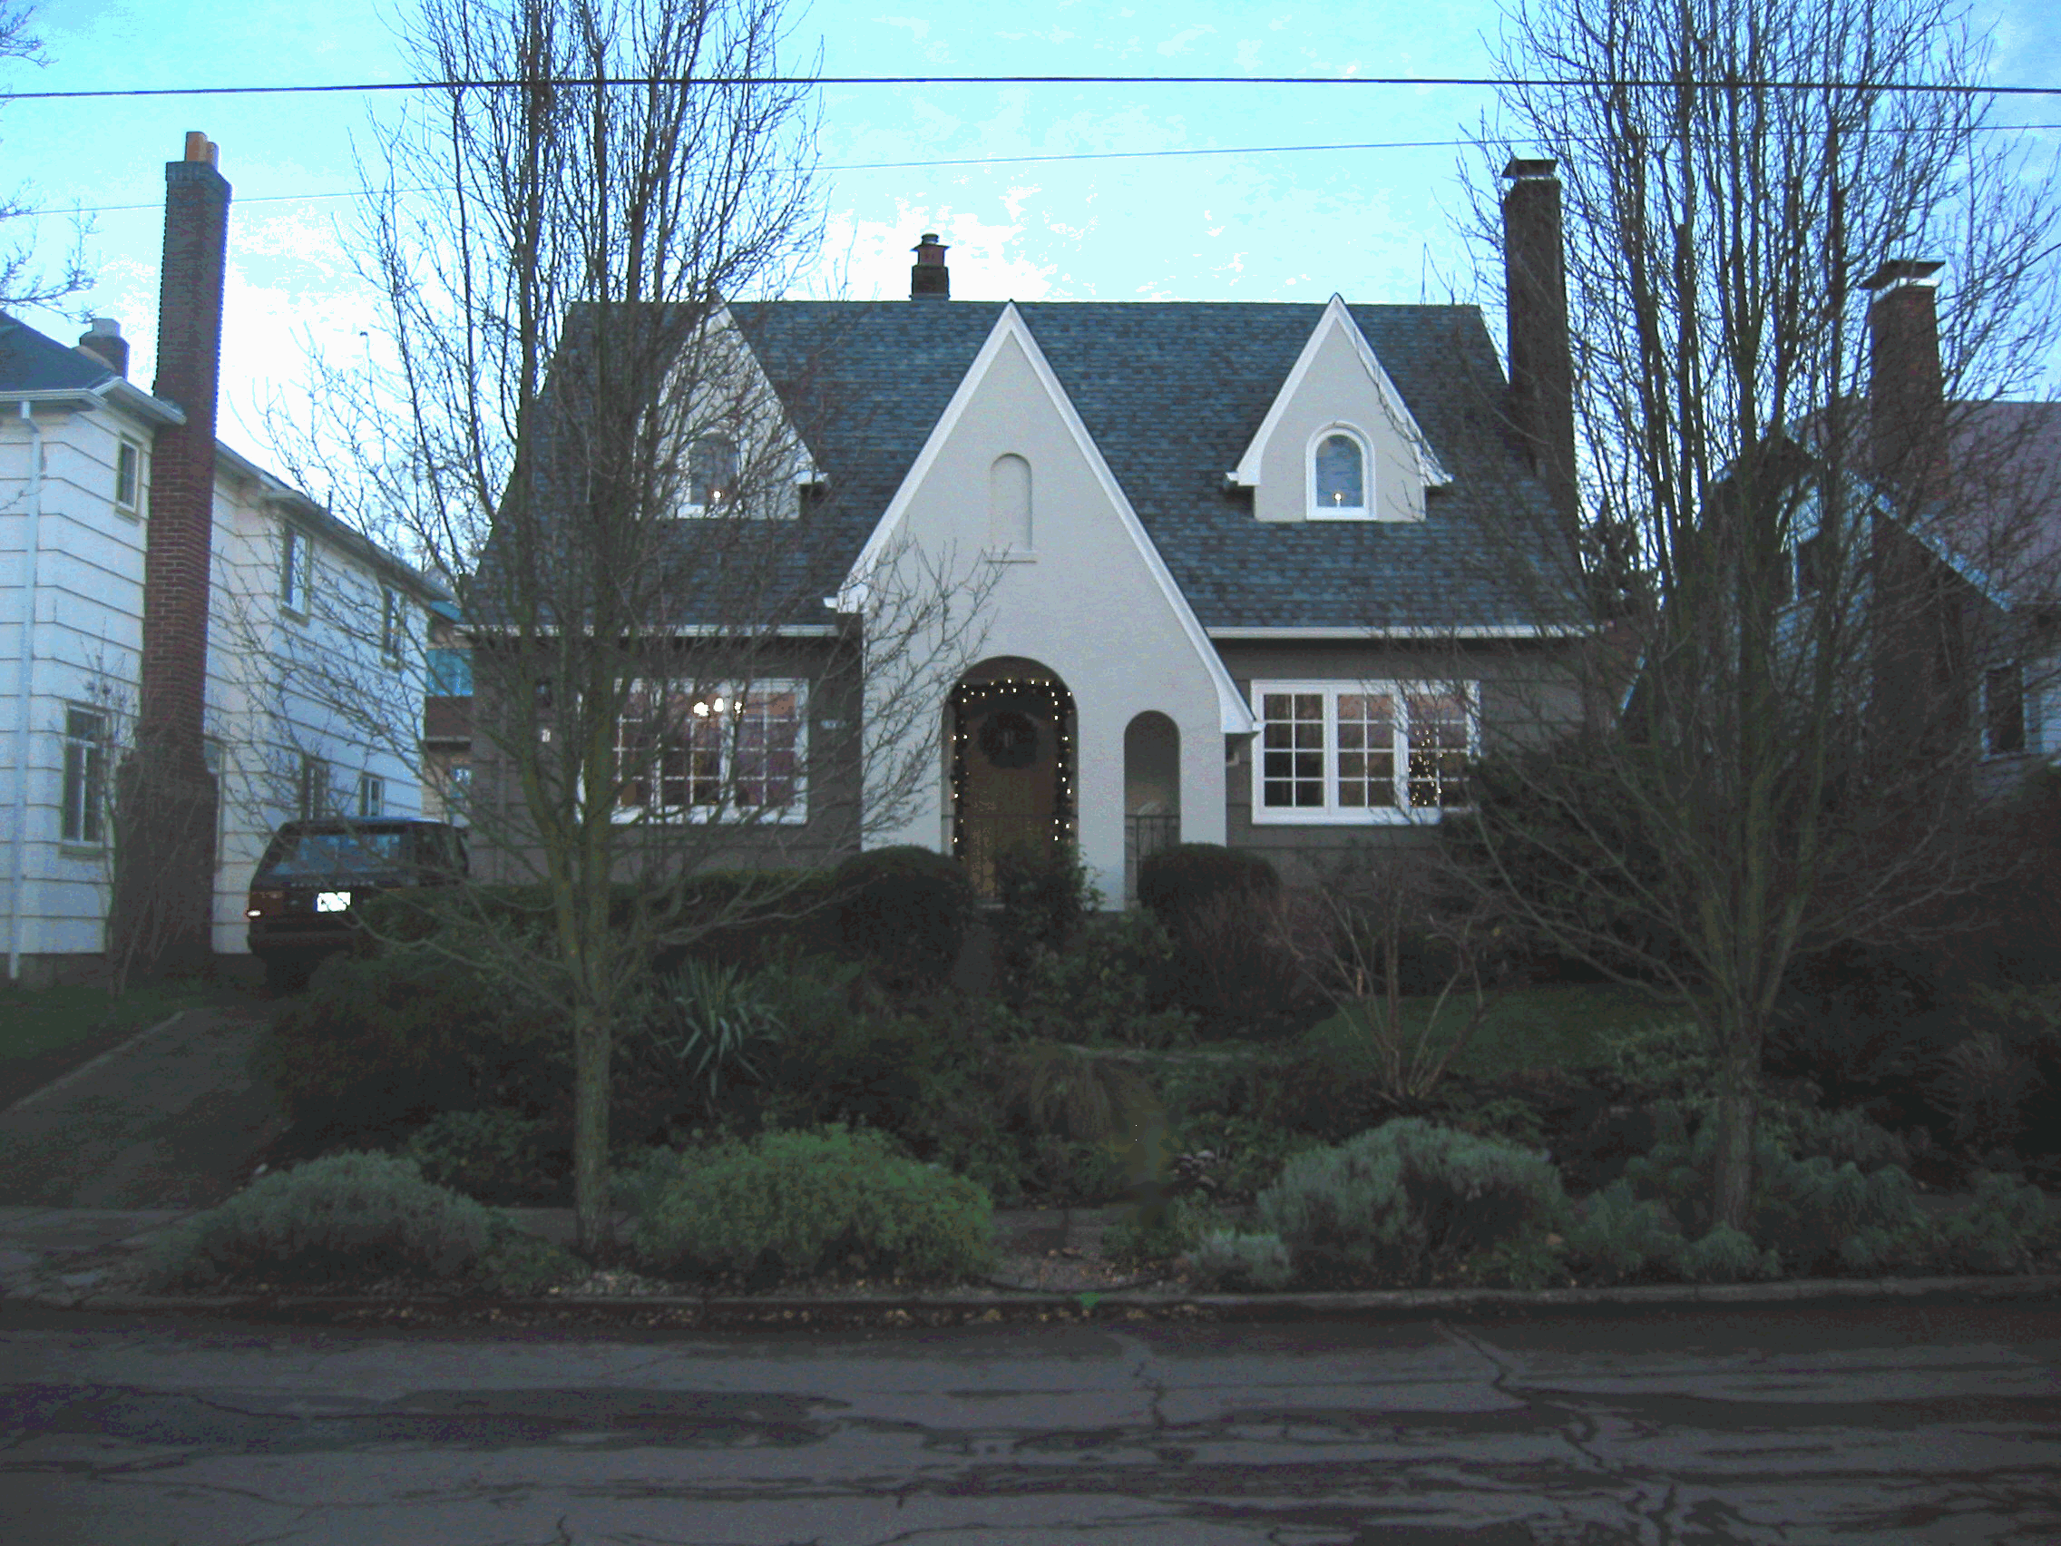

Charm and Character with lots of updates!
- Built in 1929.
- 3 bedrooms, 2 baths. 1707 square ft.
- Full basement – 1050 ft.
- Oak hardwood floors throughout.
- Walk-in Closets in every bedroom
- Gourmet Kitchen with cherry wood cabinets, Pratt & Larson tile splash-back, imported German linoleum, Rejuvenation light fixtures and eating-bar (1999).
- Built-in Gas Range, Convection Oven, Amana Refrigerator with cherry door front, dishwasher and disposal.
- Custom Marvin double-paned wooden windows and screens (2001).
- Beautifully landscaped English garden with lots of perennials, fenced backyard, rose-covered trellis, pond and running waterfall.
- Dry-set bluestone and basalt patio with Marvin double-paned French doors. Rejuvenation outdoor lighting (2001).
- Convenient to Hawthorne shops and downtown.
- New Sewer Line (2002).
- New gas heater (1992). Old oil tank removed.
- New 200 amp electrical rewire (1993).
- New exterior paint and interior decorator colors throughout.
- New tear-off architect roof with drain spouts and gutters (1998).
- Cable wiring.
- Mahogany fireplace with original Crater Lake tiling. New chimney cover (2001).
- Detached Garage with opener—324 sq. ft.
- Tile baths with pedestal sinks. Upstairs bathroom remodeled (2001); glass shower, tile flooring and wainscot.
- Refinished front door. Custom built front and back screen doors (2001).
- FA-Gas heat, gas water & cooking.
- Coved ceilings

