«Title» «Firstname» «Lastname»
«legal_entity_name»
«Address_1»
«Address_2»
«Address_3»
«Postcode»
«Country»

July 2000

Dear Sir / Madam,

We are pleased to announce the launch of International Coal as the newest commodity available on EnronOnline. EnronOnline is a Web-based system that is completely free of charge and enables you to buy and sell commodities throughout the world with Enron as principal.

These International Coal products allow users to buy and sell coal free on board at ARA ports and compliment the North American coal products that have been available through EnronOnline since January 2000.

Enron will be using the Standard European Coal Agreement (SECA) as a contractual basis offering the coal in small 5000 mt lots. This will enable less traditional and smaller players to enter into the coal trading market, with reduced transaction costs. It allows the more traditional physical producers and consumers of coal to better manage short term physical needs and provides better price transparency in a changing marketplace using standard contract terms and specifications.

In order to apply for access to EnronOnline you simply need to complete and return the Registration form and Password Application form for your trading location. For more information about registering please go to the “How To Register” link on our website, located at www.EnronOnline.com. The enclosed marketing information will provide general guidelines on how to use the site.

We hope you will find that EnronOnline provides an easy and more efficient way to do business with Enron and we look forward to transacting with you online.

Sincerely,
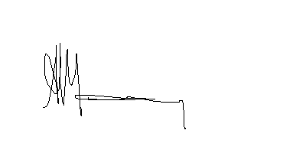
Nick Mooney
Director, European Marketing
EnronOnline

Registered Office: 40 Grosvenor Place, London SW1X 7EN

Registered in England, Reg No. 3368625

